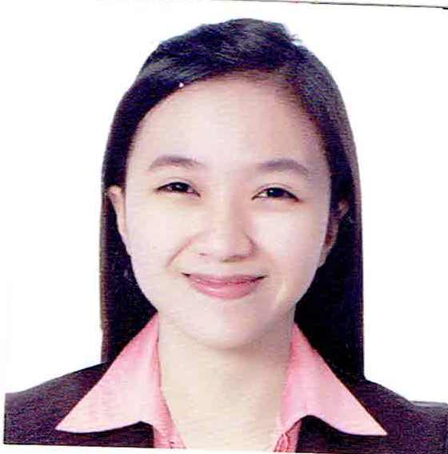
Sharmane C. Dungca

Occupation: Radiologic Technologist/ Radiographer

Specialty: CT Scan Technologist
General Sonographer

Gender | Female
Date of Birth | January 12,1992
Nationality | Filipino
Current Address (including post code) | Block 16, Lot 4, Phase 4, Terraverde Residences, Brgy. Bancal, Carmona Cavite 4116, Philippines
Marital Status | Single
Qualification/Degree | BS Radiologic Technology
Total number of years of recent clinical Experience | 7 years and 8 months
Passport No. | P7727532B
Passport Expiry date | 29 September 2031
Telephone Number | +639263891246
Email address | shasharmane@gmail.com

Summary/Personal Statement:
I am Sharmane C. Dungca, a graduate of Bachelor of Sciences on Radiologic Technology at University of Perpetual Help System Dalta Las Pinas. I’m a Senior Radiologic Technologist at Silang Specialists Medical Center, trained and skilled professional with 7 years and 8 months of experience in the field of different special diagnostic imaging like ultrasound, CT scan and xray. I believe that my strong technical experiences and education along with my dedication to provide optimal patient care will make me a very competitive candidate for this position. As an institution with the highest of standards, I am confident that I will be an asset to your radiography team. I am a well-rounded professional with skills and qualities in performing diagnostic procedures including special imaging like ultrasound, CT scan and Xray. I can manage heavy volume of examination with Emergency, Out-patient, In-patient, pediatrics and geriatrics while working independently. Demonstrating proficiency in equipment usage and maintenance, quality control, and regulatory compliance. Utilizing superior communication skills to fully explain imaging procedures and calm anxious patients. With my expertise in the field of diagnostic imaging, along with my commitment to superior patient-focused care, I am prepared to put my knowledge and experience to work for you.
PROFESSIONAL QUALIFICATIONS:
Name of Qualification | University Name and address | Course start date | Course End Date
Radiologic Technologist | Silang Specialists Medical Center | May 2, 2016 | Up to present
BS Radiologic Technology | University of Perpetual Help System Dalta | June 2011 | April 2015
Senior Internship | University of Perpetual Help Medical Center | October 2014 | March 2015
Junior Internship | Jose R. Reyes Memorial Medical Center | April 2014 | October 2014

PROFESSIONAL REGISTRATION:
Registered with: |  | Date/Valid till:
Professional Regulation Commission |  | January 12, 2024
HCPC registered | February 29, 2024

Awards and Recognitions:
May 5, 2021 | Certificate of appreciation for dedication, commitment and superior performance for the year 2020-2021 | Silang Specialists Medical Center, San Vicente II, Silang Cavite
May 5, 2021 | Loyalt award – 5 years of superior performance, dedication, and valuable contributuin to SSMC | Silang Specialists Medical Center, San Vicente II, Silang Cavite
July 14, 2020 | Certificate of recognition for consistent and exemplary performance during COVID-19 surge | Silang Specialists Medical Center, San Vicente II, Silang Cavite

Trainings and seminars attended:
Date | Topic | Address
August 21-22, 2023 | Radiology Technologist Intravenous Therapy Education  “Infusion Therapist” | Training Hall A,4/F Medical Arts Bldg., Brgy. Dona Josefa, Quezon City, Philippines
August 10-11, 2023 | 1st Medical Ancillary Services Division Postgraduate Course of Chong Hua Hospital | via ZOOM platform
October 6-7, 2022 | Quality assurance / quality control workshop on Digital & Computed radiography | Great Eastern Hotel, Quezon City, Philippines
August 27, 2022 | Breaking Bounderies: An International Conference in Radiologic Technology | via hybrid platform
December 11, 2021 | Stress Management of Healthcare workers during COVID-19 pandemic | via ZOOM platform
Aug. 31, 2018 | Basic Infection Control Seminar for Healthcare Provider | San Juan de Dios Educational Foundation, Inc. – Hospital, 5th Flr, JCLS Bldg.
Jan. 25- Jan. 26,  2018 | Venipuncture for Radiologic Technologist and Basic Life Support with Automated External Defibrillator series III | Research Institute for Tropical Medicine Training Center, Alabang Muntinlupa City
Jan.24- Jan. 26,2018 | Basic Life Support Training for Radiologic Technologist | Research Institute for Tropical Medicine Training Center, Alabang Muntinlupa City
Oct. 4, 2017 | Clinical Audit for Diagnostic Radiology  De La Salle Health Science Institute | De La Salle Health Science Institute
Mar.11- Mar.12, 2017 | GOTTA CATCH 'EM ALL - The Top Five must know from Vertex to Sole | St. Luke’s College of Medicine, Quezon City
May 5, 2016 | CT Application Training of Brivo 385 | Silang Specialists Medical Center

Professional Experience
Employment History
CURRENT EMPLOYMENT
May 2, 2016 – up to present
Position: Radiogpraher/CT Scan Technologist/General Sonographer
Name of Hospital: Silang Specialists Medical Center
Hospital Address: San Vicente 2, Aguinaldo Hi-way Silang, Cavite

Hospital Profile:
Silang Specialists Medical Center is a modern tertiary hospital in Silang, Cavite with a total population of 248,085 in 2015 census. It is established dated May 2, 2016 with a bed capacity of 100. It is committed to provide the patients with safe, accepted and high quality care services using the state of the art facilities.

Type of patients: emergency,out-patient, in-patient, pediatrics, and geriatrics
Hours worked per week: 48 hours (Shifting)

Duties and Responsibilities:
I am a pioneer and currently employed as Registered Radiologic technologist in Silang Specialists Medical center. it is my responsibility provide our services with the utmost compassion, the most innovative and advanced techniques, and in the most cost effective manner.

In Ultrasound (7 years and 8 months experience):
- Performs general ultrasound examination such as whole abdomen, upper abdomen, lower abdomen, HBT, KUB, Thyroid, FAST, in a hospital setting.
- Converse with radiologist regarding gathered patient history and result from previous exams to aid the physician in finding the correct diagnosis.
- Differentiate normal and abnormal sonographic anatomy
- Assisting the radiologist in in performing thoracentesis, paracentesis, IJ catherization, and different biopsy procedure.
- Assisting OB sonologist in in performing procedure

In CT scan and Xray (7 years and 8 months experience)
- Performs different radiographic examination such as chest, abdomen, upper and lower extremeties, spine, head and neck.
- Can perform CT scan plain and with contrast procedures
- Manage heavy volume of patients examination while working independently
- Reporting important information to the physician
- Prepares examination room using aseptic technique to ensure quality patient care standards.
- Apply radiation safety ALARA principle and protection standards.
- Documenting information with computers

In Xray procedures (7 years and 8 months experience)
- Performing diagnostic x-ray procedures of bones and soft tissues.
- Explaining procedures to patients and answering questions.
- Preparing equipment for use as needed.
- Preparing examination rooms for patient exams.
- Prepares patient for radiological procedure by positioning patient; adjusting immobilization devices; moving equipment into specified position; adjusting equipment controls to set exposure factors.
- Monitoring patients during exams.
- Documenting information with computers.
- Reporting important information to the physician.
- Ensuring safety of patients during exams.
- Minimizes radiation to patient and staff by practicing radiation protection techniques, using beam restrictive devices, patient shielding, and knowledge of exposure factors.

Equipments Used:
Digital Machine
- Toshiba Listem, LTM-25
- Flexavision Hybrid Flouroscopy

Portable X-ray Machines
- Shimadzu,R-20, A Portable Machine

Ultrasound
- Sono-acer R5
- Siemens
- Toshiba

Computed Tomography
- General Electronic Brivo385
- GE Brightspeed Edge 8 slice

Magnetic Resonance Imaging
- GE Signa Profile Excite 0.2 T

Mammography
- Philips Microdose Mammography System

Dual Energy Xray Absorptiometry
- Lunar Prodigy Advance Bone Densitometer

Character Reference:
Available upon request.

