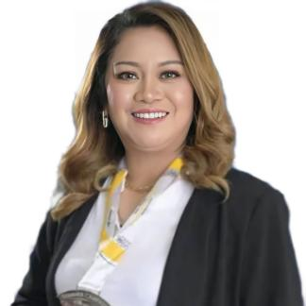
MELANIE LUARDO-ZAPANTA
Purok Pag-asa Tres De Mayo, Digos City
- mail Address: mlz.sunlife.sardonyx@gmail.com
Mobile Number: 0945-099-8712

OBJECTIVE: To broaden my skills and ability in my area of specialization and expand my experience and views in different learning grounds that can help me grow my professional and personal value.

PERSONAL:

Birth Date : November 16, 1984
Age : 38 years old
Sex : Female
Height : 5’4
Religion : Roman Catholic
Citizenship : Filipino
Civil Status : Married
Father Jesus D. Luardo
Mother : Guillerma L. Luardo

EDUCATIONAL ATTAINMENT:

COLLEGE: University of Southern Mindanao
BSAgECON- Bachelor of Science in Agricultural Economics
Kabacan North Cotabato
2004-2008

HIGH SCHOOL: Digos City National High School
Rizal Avenue, Digos City
1998-2002

ELEMENTARY: Ramon Magsaysay Central Elementary School
Magsaysay Street, Digos City
1992-1998

WORK EXPERIENCES:

Marketing Staff
USPD-SCC, Malita Satellite Office
June 2012- July 2021

Marketing Incharge
July 2021- September 2022
USPD-SCC, MAIN OFFICE
San Jose Highway, Digos City

Licensed Insurance Advisor
Sun Life of Canada Philippines Inc.,
October 2020- present

SEMINAR PARTICIPATED:

Strategic Planning
November 17-18,2012
USPD-SCC Conference Room, San Jose Highway, Digos City

Credit Union Trainers for Empowerment (CU-TE) batch 24
November 24-26, 2015, the Royal Mandaya Hotel Davao City

ACHIEVEMENTS/EXCELLENCE AWARDS:

SILVER Medallion Awardee Summer Campaign (DAU Branch)
April-June 2022
Sun Life of Canada Philippines Inc.,

Top 5 in APPS submission entire DAVAO ISO
Top 7 in APPS submission entire MINDANAO ISO
August 2022
Sun Life of Canada Philippines Inc., (DAU Branch)

GOLD Medallion Awardee August Champions ( DAU Branch)
July-Sept. 2022
Sun Life of Canada Philippines Inc.,

BRONZE Medallion Awardee Presidents Months( DAU Branch)
December 2022
Sun Life of Canada Philippines Inc.,

SKILLS:

- Good verbal and written communication skills
- Knowledgeable in Basic Computer Applications (Word, Excel)
- Intrapersonal and interpersonal skills
- Dedicated team player
- Having creative approach and initiative
- Client-oriented
- Detail-oriented
- Strong work ethic
- Honesty and Integrity

REFERENCE PERSONS:

ARCHELYN A. LORESCA
Officer-in-charge (OIC)
USPD-SCC, Sta. Maria Satellite Office
0946-085-2778

NIKKI R. DE TORRES ALONA S. DOCEO
Unit Manager Jeremiah Movers Satellite Head
Lapu-lapu Extension, Digos City USPD-SCC, Malita Satellite
0920-732-0055 0965-884-1360

