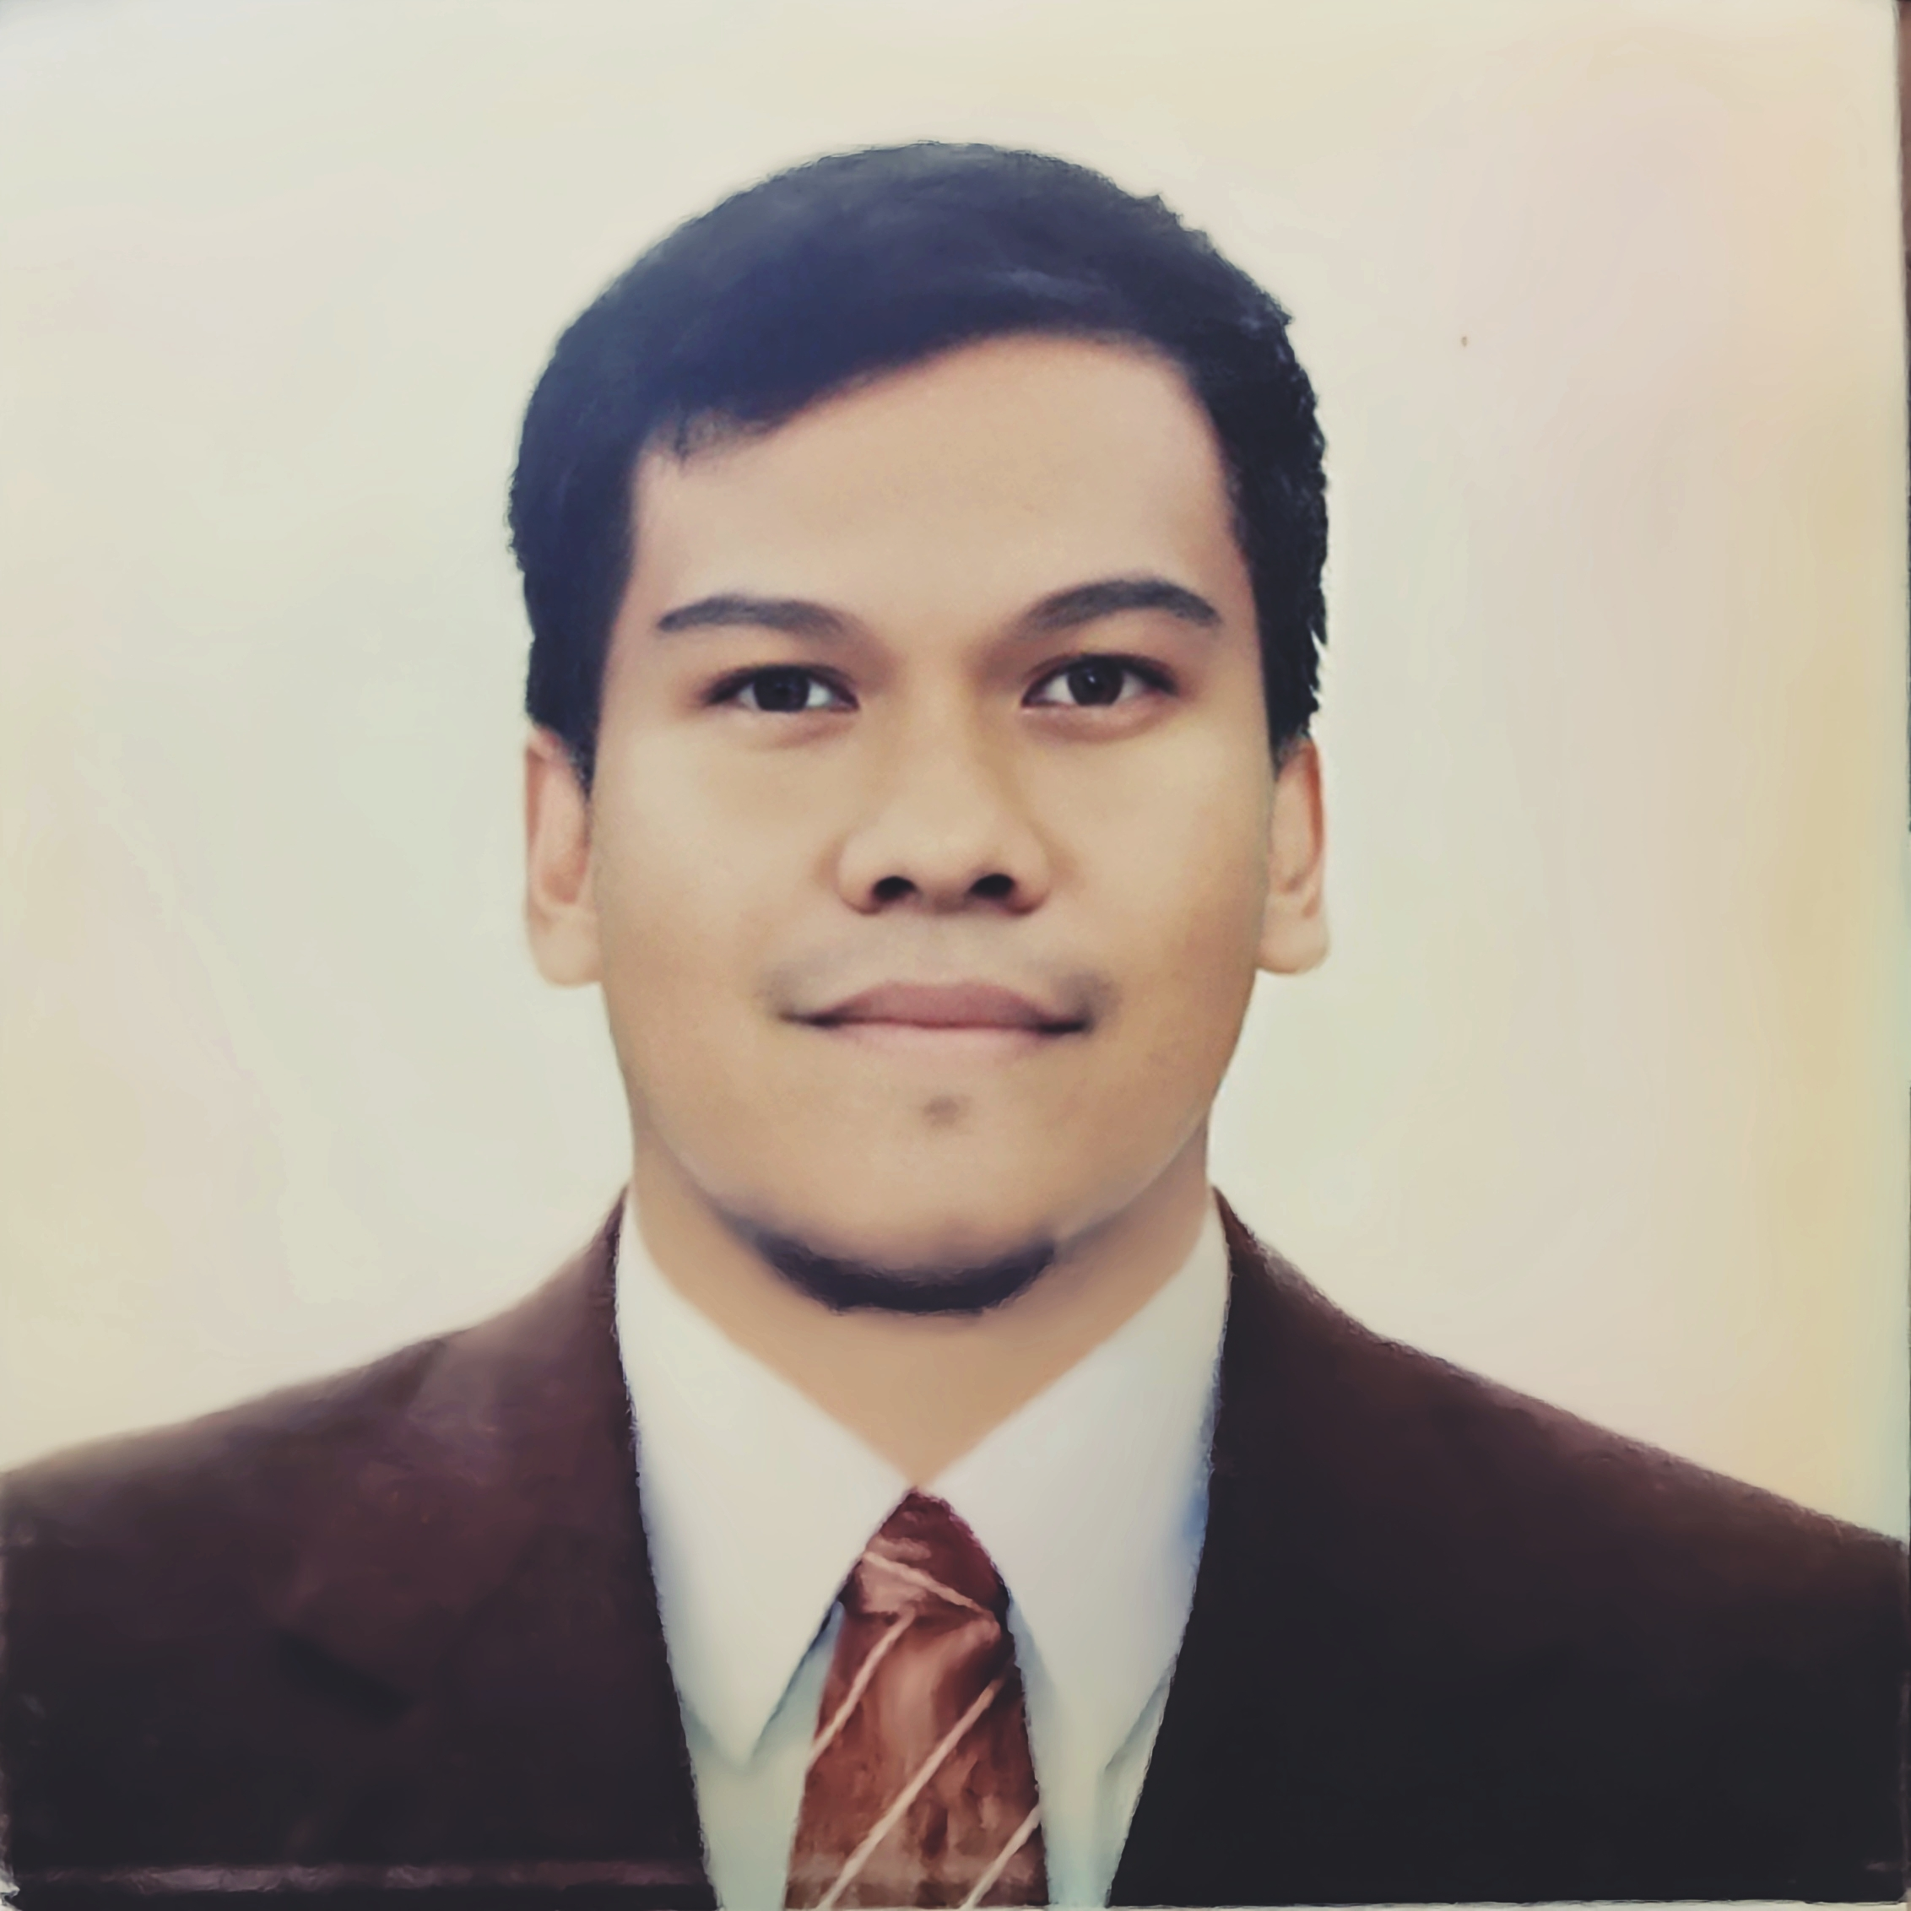
GUISEPPE JOB E. FLORES
guiseppejob@gmail.com
09165625778

Objectives:
Seeking an enriching role that enables professional development and contributes to the growth of the organization.

Educational Attainments:

College Graduate
University of San Carlos – Talamban Campus Associate of Computer Technology(MT)
2003 – 2009 Multimedia Technology

Personal Information: Skills:
Height: 159 cm FCAW Certified Welder(NCII)
Weight: 72 pounds Welding Symbols and Drawing Interpretation
Birthday: Oct. 16, 1986 Willingness to adopt in any situation
Civil Status: Live In Law Communicate well with others
Address: Blk 10, Lot 14 Purok Computer Literate
Modena, San Vicente, Listening Comprehension
Lilo-an, Cebu, 6002 Job Oriented Person

GMAW Certified Welder(NCII)

Relevant Experiences:

ANYTHING TIMBER
Subangdaku, Mandaue City, Cebu Design and Drafting Personnel (2012 to 2013)

- Provide perspective for clients, a better view as to what the designs would be once it is completed.
- Responsible in designing interior designs fit to customer’s needs.
- Manage the build site ensuring the design has no flaws or if any changes needed we would take of it right away.
- Sales representative, we present our designs to possible clients and make sure to close the deal as much as possible.

TESDA Scholarship Program
Calero, Lilo-an, Cebu Training for FCAW(NCII )Competency Sept. to Nov. 2023

- Able to perform Fillet weld(1F,2F, 3F and 4F positions) on a 3/8” plate.
- Able to perform Grove weld(1G, 2G, 3G and 4G positions) on a 3/8” plate.
- Able to perform 1G, 2G, 5G and 6G positions on a pipe.

Tiger Car Surplus Trading
East Binabag, Consolacion, Cebu Welder/Fabricator
Date Started: January 30,2024 to Present

- Fabricate specific truck body parts needed to be replace
- Weld using MIG or SMAW
- Notching and build truck body frame
- Trouble shooting and problem solving when issues may arise in work place, basically, alignments are the most common problem that I encounter.

Character References:

Mitchael Del Rosario Bebelito P. Bibat
09177120672 09163627456
Naval Architect/Surveyor Tesda Assessor

