maricel c. oncog
78 A J.A Clarin Street, Poblacion III, Tagbilaran City, Bohol
09505413885
maricel.oncog@gmail.com/castano.maricel@yahoo.com
Compassionate and hard-working registered nurse seeking for growth in the medical practice while providing the best care to patients of all needs and backgrounds.
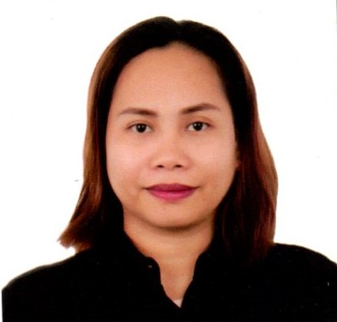

MARCH 2022- present

staff nurse, tagbilaran community hospital
• Assess the patient’s overall condition. Carries Doctor’s order with proper documentation.
• Performed various nursing interventions such as wound dressing, vital signs monitoring and specimen collection.
• Attended trainings that can improve skills and knowledge.

february 2018 – march 2023

administrative officer i, city government of tagbilaran
• Created, prepared and delivered reports to various departments.
• Managed files and records for clients and adhered to safety procedures to prevent breaches and data misuse.
• Standardized office structures and promotes collaboration to increased performance.
• Oversaw office inventory activities by ordering and requisitions and receiving supplies.

january 2014 – february 2018

community nurse, city government of tagbilaran
• Conducted individualized patient assessment to report patient’s immediate condition to the attending physician.
• Performed treatments as ordered by physicians and documented actions.
• Attended educational trainings to maintain and improve current competency.
• Developed a plan of care for patient and assess for an immediate collaboration with members of the healthcare team.
• Maintained confidentiality in matters related to patient, family and client facility staff.

NOVEMBER 2011 – DECEMBER 2012

CONTRACTUAL nurse, GOVERNOR CELESTINO GALLARES MEMORIAL HOSPITAL
• Assessed physical, psychological, physiological and cognitive status of patients.
• Performed various nursing interventions such as wound dressing, vital signs monitoring and specimen collection.
• Performed Doctor’s order like medication and IV administration, catheter insertion as well as airway management.
• Establishing rapport to patients and family members to identify patients need.
• Learned new skills and applied to daily tasks to improve skills and efficiency.
• Updated patients charts with accurate data such as medications and treatment given.
• Directed patients care by following with the plan of care, continuing care and discharge instructions.
• Participated in continuous improvement through attending workshop and various trainings conducted by accredited health institutions.

Education

march 2006

bachelor of science in nursing, university of bohol

license

PROFESSIONAL REGULATION COMMISSION OF THE PHILIPPINES

NURSING LICENSURE EXAMINATION

DECEMBER 2008

RATING- 79.6

Skills

- Patient and family advocacy
- Healthcare ethics
- Preventive health education for patients and family
- Clinical documentation
- Assessment skill
- Communication skill
- Teamwork and flexibility

references

- RUTH A. COTO
Public Health Midwife
09502270211

- FRITZ DENNIS B. RUYERAS
LDRRMO II
City Disaster Risk Reduction and Management Office
09190693613

- ZANDAE ALLYNE N. PABLO
Micro and Ana Laboratory Assistant
Holy Name University
09561604516

