
ESPINOSA HENRY JAMES
Address: Purok 4, San Vicente, San Juan (Cabalian) So. Leyte
Contact: 09700885554
Email: Hj46espinosa@gmail.com

CAREER OBJECTIVES

To work for challenging and stimulating environment with good scope of growth and career development with a total communication
For excellence this changes my caliber.

PERSONAL DATA
Date of Birth : October 10,1996
Gender : Male
Height : 170.28 cm
Weight : 60 kg
Civil Status : Single
Nationality : Filipino

LANGUAGE YOU CAN
Speak and Write : Filipino and English
Religion : Roman Catholic
Primary : San Juan Central Elementary School
Year (2011-2012)
Secondary : San Juan National High School
Year (2015-2016)
Southern Leyte State University
With NC1 Automotive (Sr. High School)
Year (2017-2018)

WORK EXPERIENCE
Factory Worker (COMFOODS)-(2018-2019)
- Merchandiser (MEGASOFT)-(2019-2022)
2nd floor Megaono Bldg. España Boulevard Corner Mayon St. Sta. Teresita, Quezon City
- Mereado Catering Services
Sta. Cruz, San Juan So. Leyte (2013-2014)
J&T Delivery Raider
Hinunangan So. Leyte (2022-2023)
REFERENCES

Alma E. Nuez
09948845343
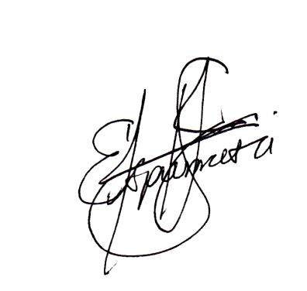
- I hereby attest that to the best my knowledge and under standing the information provided above is true and accurate.

HENRY JAME ESPINOSA
Applicant’s Signature

