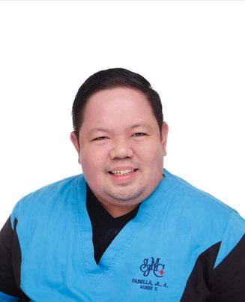
JOHN LEON A. FABELLA, RM, RN, MAN (u.e.)
HEAD NURSE
09178275695
Competent, flexible and a decisive nurse with years of hospital experience providing comprehensive medical care in a variety of specialties: Adult Intensive Care Unit, Emergency Room, Papa Charlie Ward (CoVid-19 Patients), Medical- Surgical Ward & Operating Room/Recovery Room. A nurse with effective teaching skills and vast experience in collaborating with other healthcare professionals to ensure optimum care delivered to client.
HOSPITAL EXPERIENCE
ADULT INTENSIVE CARE UNIT
San Juan Medical Center, San Juan City, Philippines
January 1, 2022 up to present
Performs professional nursing activities as Adult Intensive Care Unit Headnurse delegated by the Nursing Service Office.

EMERGENCY ROOM HEADNURSE
San Juan Medical Center, San Juan City, Philippines
July 1, 2020- December 31, 2021
Performs professional nursing activities as Emergency Medicine Headnurse delegated by the Nursing Service Office.

PAPA CHARLIE WARD
San Juan Medical Center, San Juan City, Philippines
April 16, 2020-July 1, 2020
Performs professional nursing activities to positive CoViD-19 patients as Papa Charlie Headnurse delegated by the Nursing Service Office.

MEDICAL-SURGICAL WARD HEADNURSE
San Juan Medical Center, San Juan City, Philippines
Januray 2017-April 16, 2020
Performs professional nursing activities as Medical-Surgical Headnurse delegated by the Nursing Service Office.

ENSOCOPY/OPERATING ROOM/RECOVERY ROOM HEADNURSE
San Juan Medical Center, San Juan City, Philippines
August 2015-January 2017
Performs professional nursing activities as Endoscopy/ Operating Room & Recovery Room Headnurse delegated by the Nursing Service Office.

ENDOCOPY/OPERATING ROOM/RECOVERY ROOM STAFF NURSE
San Juan Medical Center, San Juan City, Philippines
February 2015-August 2015
Assists with operations and deliveries by preparing rooms, sterilizing instruments, equipment and supplies and handling them in order to use to surgeon or another medical specialist.

MEDICAL WARD STAFF NURSE
San Juan Medical Center, San Juan City, Philippines
February 2013-August 2015
Basic nursing care for critically ill patients and geriatric cases.

SURGERY WARD STAFF NURSE
San Juan Medical Center, San Juan City, Philippines
July 2007-February 2013
Basic nursing care for pre-operative and post-operative patients.

EDUCATION
MASTER OF ARTS IN NURSING- MAJOR IN ADMINISTRATION AND NURSING SUPERVISION & MEDICAL SURGICAL NURSING (units earned)
Arellano University, Legarda, Manila
2009-up to present

BACHELOR OF ARTS IN NURSING
Arellano University, Legarda, Manila
2006

THIRD HONORABLE MENTION
Fabella Institute
2002

San Andres Central Elementary School, San Andres, Romblon
1998

NURSING SKILLS ENHANCEMENT PROGRAM

STANDARD FIRST AID TRAINING
CDRMMO-San Juan
Training for layman rescuers in response to emergencies like burn, trauma and accidents before the arrival of the proper health care response to an individual.

BASIC LIFE SUPPORT PROVIDER
ECARU-Marikina
A licensure training for healthcare provider in response to emergency cases, which includes lecture about emergency medication, equipment and proper care for patients experiencing a life threatening situation in both hospital and community setting.
LICENSURE
MIDWIFERY LICENSURE EXAMINATION:
Professional Regulation Commission of the Philippines, November 2009
PASSED
NURSING LICENSURE EXAMINATION:
Professional Regulation Commission of the Philippines, November 2009
PASSED

