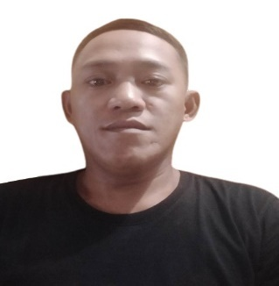

JAYSON R. ALVAREZ
jayson5422@gmail.com Sales Marketing
Block 1 lot 6 Purok Santol 1 Brgy. Mayao Crossing Lucena City
Mobile number: +639301263591/+639916945009

OBJECTIVES:
To be able to work in an institution that will Enhance my knowledge and sharpen my skills thereby giving me motivation and confidence to work at excellent performance.

Personal Details:
Name: Jayson R. Alvarez
Place of Birth: Lucena City, Quezon Province
Date of Birth: June 5, 1989
Age: 34
Nationality: Filipino
Gender: Male
Religion: Members Church of God International (MCGI)
Father’s Name: Marcelo N. Alvarez Sr. (Decease)
Mother’s Name: Luzviminda R. Alvarez
Occupation: Housewife

Educational Attainment:
Vocational Short Course: Informatics Institute
Course: Computer Programming
Granja St. brgy. 7 Lucena City, Quezon Province
2010-2011
Secondary: Lucena City National High School
2004-2008
Primary: Elvira Razon Aranilla Elementary School Ibabang Dupay Lucena City
2002-2004
Reymar Compound Elementary School Gulang - Gulang Lucena City
2001-2002
Zaballero Subdivision Elementary School Gulang- Gulang Lucena City1997-2000

WORK HISTORY:
Fiber Optic Technician/Splicer (FTTH)
@Convera Business Management Services-OPC
Block 1 Lot 4 Calmar Land Subdivision Brgy. Kulapi Lucban Quezon
• Senior Salesman
@Optimized Costumer Solution Inc. (OCSI)
Brgy. Mahabang Parang D.I Calihan San Pablo City Laguna Province
Work Duration August 16,2016 to July 07,2022
• Production Operator
@House Technology Industries PTE. LTED.
Philippines Economic Zone Authority
Work Duration Oct. 21, 2011, to April 5, 2012,
• Service Crew
@ World of Fun Amusement Corp.
Pacific Mall Ibabang Iyam Lucena City
Work Duration Feb 5, 2011 – July 5, 2011,
• Service Crew
@ Jollibee Food Corp.
Quezon Ave. Lucena City
Work Duration March 5, 2010 – August 5, 2010,

SKILLS:
Sales Marketing
Fiber Optic Wire Splicing, Cabling, Troubleshoot, Repair & Installation
Interpersonal Skills
Communicational Skills
• Trained in English Proficiency
• Basic Computer Literacy
• Adaptability & Flexibility
• Public Relation

CHARACTER REFERENCE:

Arvin Moncada
+639477433155
San Pablo City, Laguna Province
Works as Operation Manager (OM)
@Optimized Costumer Solution Inc. (OCSI)
Cristopher Cadelino
+639695175860
San Pablo City, Laguna Province
Work as General Trade manager (GTM)
@Optimized Costumer Solution Inc. (OCSI)

I hereby certify that above information is true and correct through the best of my knowledge and belief.

JAYSON RODRIGUEZ ALVAREZ
Applicant

