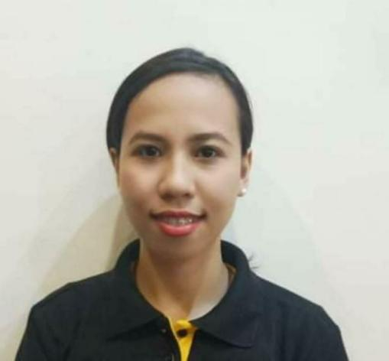
GENEVA D. GARCIA
772 Bohol St. Pitogo Makati City
Contact #: +639456225820
E-mail: garciageneva1026@yahoo.com

OBJECTIVE:
To gain knowledge and skills to complement those that I have learn from my previous work and in an actual job environment and to attain high level of performance and to be able to work in a career oriented and challenging environment that promotes personal growth and professional developments.

WORK EXPERIENCE
On the Job training 480 Hours @ City Garden Hotel Makati
June 13, 2017- September 6, 2017 -Cashier/Food Attendant
July 08, 2018- July 27, 2022 - Cashier/Dinning Staff @Pepper Lunch Ayala Malls The 30th
July 28, 2022- Up to Present - Captain Supervisor @ Pepper Lunch Food District
- Overseeing repair maintenance of workplace
- Supervise monthly inventory of stocks
- Supervise the works of the staff
- Organize and supervise shift schedules
- Prepares daily, weekly sales report
- Estimate ordering of goods and other supplies
- Train new and current employees on proper service practices
- Deliver superior service and maximum customer satisfaction

EDUCATIONAL ATTAINMENT
2013-2017 Central Philippines State University (Victorias University Campus)
Hda. Estrella Brgy. XIV Victorias City Negros Occidental
(Bachelor of Science in Hotel and Restaurant Management)

2009-2013 E.B.Magalona National High School

2003-2009 Rita Lovino Elementary School

PERSONAL INFORMATION

Age : 26 Y/O
Nationality : Filipino
Sex : Female
Civil status : Single
Date of Birth : October 26, 1996
Height : 5”2”
Weight : 50kg.
Language Proficiency : Tagalog, English, and Hiligaynon
Special skills : Baking, Cooking, Basic Computer Skills, Flexible,
Hardworking,

CHARACTER REFERENCES

Cristina S. Yap
Operational Management@ Pepper Lunch
Gab Group of Companies
+639916403638

Alvin Parcon
HR Manager @ Pepper Lunch
Gab Group of Companies
+639497226877

I do hereby certify that all information are true and correct in the existence of my knowledge.

GENEVA D. GARCIA
Applicant

