Marco Fernandez Antonio 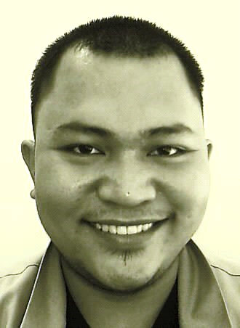marcoa947@gmail.com
Current Address: 73 Zone 4, Lourdes, Lubao, Pampanga(Philippines) Contact # +639661304492
Objectives
A career with progressive organization that will use my skills, abilities and
Experience in an executive capacity where I can effectively contribute to
Operations in any capacity that matches my skilled and experience.

Also to bring to your organization enthusiasm, dedication, responsibility, and
Good work ethic, combined with a desire to utilize my skills obtained through
Experience in the following areas:

Education
School: Don Honorio Ventura Technological State University
Address: Bacolor Pampanga
Course: Electrical Engineer
Year: 2004 – 2006 (Undergrad)

High School
School: Sta. Cruz Academy
Address: Bona St. Sta. Cruz Lubao, Pampanga
Year: 2000 – 2004

Elementary
School: Lauc Pao Elementary School
Address: Lourdes, Lubao Pampanga
Year: 1995 - 2000

Current job: Caregiver
Job Description: Stay in Caregiver
Giving assistance to my patient needs
Cooking food
Giving medication on time
Taking vitals time to time as order of attending physician
Give proper hygiene
12 hours duty and more

World Class Paper Corporation [Philippines]
March 2006 – September 2008

Position
Mechanical Maintenance

Job Description
Responsible for maintaining Hi-Con Pulp per , Pressure Screen, Fiberizer, Reject Sorter , Double Disk Refiner (DDR),Low Density Cleaner (LDC),Vacuum Pump, Felt Roll Adjuster, Turbo Separator and checking all kind of Motor pump and always maintain the good flow of Steam Fit Oil Line.

Ibn Sina National College for Medical Studies [Jeddah KSA]
August 2009– December 2022

Position
Hospital Cleaner

Job Description
Responsible for maintaining the cleanliness of all clinics and follow all the orders of the doctors and nurses and giving full assistance to the patient when needed.

Other skills
- Welder
- Pipe Fitter
- Fabricator
- Alignment of Motors to Pump
- Fork Lift Driver
PERSONAL DATA
- Nickname: Jun - jun
- Date of Birth December,16, 1986
- Place of Birth: Lubao, Pampanga
- Age: 37
- Civil Status: Single
- Citizenship: Filipino
- Height: 5’9”
- Weight: 231 lbs
- Language Spoken: Tagalog / English
- Religion: Catholic
- Father: Marcial R. Antonio Jr.
- Mother: Imelda F.Antonio

