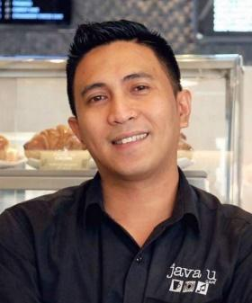
DENRED SAN JOSE
48 Salerno Drive, Clayton NC 27527
Phone: 949 506 7824
Email: denredsanjose20@gmail.com

OBJECTIVE
To work in a new environment and get myself out of the box to showcase my prowess and expertise in the prestigious company which I could contribute my very best to show off the different level of customer service, leadership and how to apply effectively to raise the company to the next stage of success.
PERSONAL INFORMATION
- Date of Birth December 23, 1986
- Age 37
- Citizenship Filipino
- Civil Status Married
- Gender Male
- Languages Spoken English, Filipino & Arabic
Education
Elementary:
Liceo De Calauan Elementary School, 1999
Calauan Laguna, Philippines

Secondary:
Liceo De Pila National High School, 2003
Pila Laguna, Philippines

Tertiary:
Bachelor of Science in Marine Transportation
Laguna Maritime Academy, 2007
Pangil Laguna, Philippines

WORK EXPERIENCE
Dietary Aide and Housekeeping Staff - November 2022 – to present
Barbour Court Nursing and Rehabilitation Center
Smithfield NC

Construction Worker
June 2019 - May 2022
Philippines

Barista, December 12, 2013 – March 3, 2019
Java U Café
Doha, Qatar

Employee, June – October 2009
Bal Asia, Inc.
Dayap, Calauan, Laguna Philippines

TRAINING AND SEMINAR ATTENDED

- Hazard Assessment & Personal Protective Equipment Training Document 8/5/2024
Smithfield North Carolina USA

- Electrical Safety Basics 7/31/2023
Smithfield North Carolina USA

- Principle Food Safety 4/5/2024
Smithfield North Carolina USA

- Food Safety, 2017
Presented by Java U Café
Doha, Qatar
- Barista, 2016
Presented by Java U Café
Doha, Qatar

- Hospitality, 2015
Presented by Al Bandary food & beverage
Doha, Qatar

- Advance Training in Firefighting, 2012
Southern Institute of Maritime Studies Manila, Inc.
Ermita, Manila Philippines

- Basic Shipboard Food Service Management, 2012
Southern Institute of Maritime Studies Manila, Inc.
Ermita, Manila Philippines

- Ship Security Awareness, 2011
Southern Institute of Maritime Studies Manila, Inc.
Ermita, Manila Philippines

- Basic Safety Training, 2007
The Maritime Training Center of the Philippines
Ermita, Manila Philippines


I hereby justify that the above-mentioned information is truly veracious.

___________________
Applicant Signature

