MARICRIS T. LANDICHO 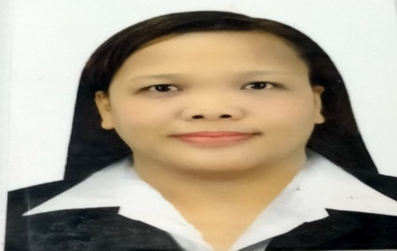
Mailing Address: 714 Dillard Circle Cedar Hill Dallas Texas
Email Address: maricrislandicho98@gmail.com
Mobile #:(+1) 4699826022
Objectives: To secure a position as special education teacher in a reputable educational institution, where I can apply my passion for teaching to create a positive learning environment for students.

SUMMARY OF EXPERIENCES:

- Dallas ISD Texas USA – Special Education Teacher
Subject taught: Functional Living Skills Self Contained
- Classroom Adviser/FLS Special Education Teacher
- Prepared Individual Educational Plan and Instructional Materials.
- Facilitated Annual ARD
- Implements grade-appropriate course work to meet the academic of students in Special Education classroom setting and responsible in monitoring the classrooms.
- Communicate with parents regarding student’s progress
- Participate in seminars training and school activities

- Public School Philippines – Special Education Teacher
- Subject taught: Special Education Self Contained
- Classroom Adviser/Special Education Teacher
- Prepared Individual Educational Plan and implements grade-appropriate course work to meet the academic of students in Special Education classroom setting;
- Responsible in monitoring the classrooms
- Communicate with parents regarding student’s progress
- Participate in seminars and in-service trainings mandated by the school and the Departments of Education

- Private School Philippines
- Subject taught: Reading and Writing- Grade 3
- Classroom Adviser/Homeroom Teacher of Grade 3 students
- Adapted, trained and executed lesson plan based on school curriculum standards;
- Improved student’s literacy through reading writing, and speaking;
- Diagnosed disorders and took the extra time needed to work with students working to overcome reading difficulties;
- Responsible in monitoring the classrooms and communicating with parents regarding student’s progress;
- Handled administrative duties and supervision of teacher’s and participated in seminars and in-services through the school or educational partners.

ACADEMIC QUALIFICATIONS
- Bachelor of Science in Elementary Education from Alejandro Colleges Philippines
- Master of Arts in Education Major Special Education from Eulogio Amang Rodriguez Institute of Science and Technology

PROFESSIONAL TEACHING EXPERIENCES
- Full-time Special Education Teacher
Start and end date: June 6, 2009 – present Teaching Children with special needs

TEACHING LINCENSE: Licensure Examination for Teacher, September 2013 Passer, Philippines

AWARDES AND ACHIEVEMENTS
- Deans Lister 2012 - 2015
- Awarded as an Outstanding teacher
- Grade Level Coordinator at San Agustin Elementary School

MARICRIS T. LANDICHO
Special Education Teacher Applicant

