  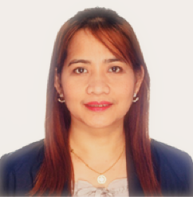
  Contact Information
   Muntinlupa City, National Capital Region, 1772
   09167574031
   cel_evangelista28@yahoo.com
  Career Objective
  Proven success in leadership, operational excellence and organizational development with keen understanding of elements of Engineering business, recognized for inspiring management team members to excel and encouraging creative work environments.
  Maricel E. Valera
  Experience
  Senior Manufacturing Equipment Technician
  Allegro Microsystem Philippines Inc., Paranaque City, Metro Manila
  1999- Current
  - Reports issues and concerns affecting machine uptime and the quality of product.
  - Implements/Contribute ideas for continuous improvement.
  - Implements corrective actions to quality and machine performance
  - Drove operational improvements, which resulted in savings and improved profit margins.
  - Data gathering of FOL PM Checklist, PM Schedule, PM Efficiency, PM Backjob and Camstar.
  - Worked with different semiconductor customers to understand needs and provide exceptional service.
  - Compiled data and generated graphs to interpret results and suggest key operational improvements.
  - Completed projects by effectively applying engineering, technical and maintenance procedures.
  Skills
  - Manufacturing process tracking
  - Equipment set up
  - Equipment care
  - Electronic equipment repair
  - Equipment fine-tuning
  - Application installations
  - Data recovery
  - Technical issues analysis
  - Operational improvement
  - Knowledge in MS Office
  Education
  Bachelor of Science: Industrial Engineering
  University of Batangas
  Batangas City 2013

