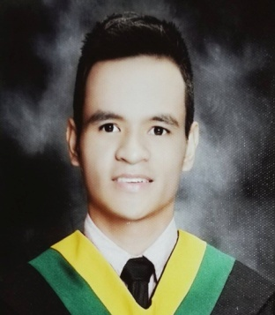

PHILIP STA.ANA ZALAVARRIA
ADD: 31 Liberation st. Brgy. San Isidro Galas Q.C
ADD: 710 Mrr St. Brgy. Pineda Pasig City
CELL: 09068958060/09854881300
Email: zalavarriaphelepe@gmail.com

CURRICULUM VITAE

Date of Birth : January 30, 1993
Place of Birth : Pasig city
Age : 30 years old
Sex : Male
Status : Single
Nationality : Filipino
Height : 5’6”
Weight : 70 kgs
Mother : Miraflor C. Sta. Ana
Father : Ismael D. Zalavarria
Religion : Roman Catholic
Language spoken : Filipino and English

EDUCATION

Tertiary
2009 – 2014 Jose Rizal University
Shaw Blvd., Mandaluyong City
Bachelor of Science in Nursing

Secondary
2005 – 2009 Kapitolyo Highschool
Kapitolyo, Pasig City

Primary
1999– 2005 Pineda Elementary School
Pineda, Pasig City

JOB EXPERIENCE

Mariveles, Bataan EMS Treatment Officer (Municipal Health Office)
January 4,2016 – May 31, 2017

Jose Rizal University Disaster Management Instructor
October 2016 – March 2017

David Mercado Events Spinner/DJ
December 2018 – April 9 2023

Stat Med Ambulance Service Treatment Officer
July 1 - Nov 15 2019

Armed Ambulance Services Treatment Officer
Dec 01 2019- March 12 2020

San Isidro Galas EMS Treatment Officer
March 14 2020 – Present

Quezon City Health Department
Epidemiology and Surveillance Division Disease Surveillance Officer
July 03 2020 – Present Field Contact Tracer
(Public Health)

Far Eastern University College Instructor
April 3 2023- Present NSTP-CTWS
(Cpr, BLS, First-aid, disaster management)

TRAINING/SEMINAR

Basic Life Support
Advanced Care Life Support
Bleeding Control
Shock management
Disaster Management
First aid training
Disease Surveillance
Swabbing and Collecting of Specimen
Dopping and donning of Personal Protective Equipment
Philippine Integrated Disease Surveillance and Response
Epidemic-Prone Case Surveillance Information System
Rapid Heath Assessment
Surveillance in Post Extreme Emergencies and Disaster
Managing Leprosy
Epidemiology and Surveillance

Conducted Lecture/Training

-Re-Emerging and Emerging Non-Communicable and Communicable Disease
-Revitalized Police at Barangays (R-PSB) kasimbayan Course
-Nursing Disaster Management
-Emergency Nursing
-Pre-Hospital Management
-Basic Life Support
-Advanced Life Support
-Cardio Pulmonary Resuscitation
-Disaster Preparedness

AFFILIATION

Emergency Response Association of the Philippines (Medic)
Lord Baden Powell Fire Communication Rescue Volunteer (Chief EMS)
Knights of Columbus Catholic Organization (2ND DEGREE)
The Fraternal Order of Eagles Philippine Eagles

SPECIAL SKILLS

- Can work with minimum supervision
- With good interpersonal and communication skills
- Computer literate (power point, word, excel)
- Cooperative and hard working
- Good Leader and self-motivated

I certify that the above information are true and correct to the best of my ability.

__________________________
Philip S. Zalavarria
Applicant

