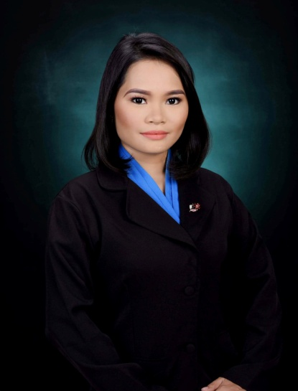

Abina, Lorenz Joy C.
Registered Midwife

creation.lorenzabina@gmail.com
Brgy. Luac Culion Palawan

OBJECTIVE:
To be an active employee in an institution where I can share my knowledge and skills.Also to enhance my abilities that can be used as an advantage in the near future.

WORK EXPERIENCE
- CULION SANITARIUM AND GENERAL HOSPITAL. In neonatal intensive care unit. 2020-2021
- Work at Staff Midwife, Neonatal Intensive Care Unit (NICU)
Culion Sanitarium and General Hospital.
August 2020
- OJT (June 2018 – April 2019)
San Pablo District Hospital
San Pablo Laguna
- Laguna Medical Center
Sta, Cruz Laguna
August 2018–April 2019
Monday, Friday and Saturday

SEMINARS ATTENDED:
- General Assembly of Midwifery Students Sustainable Development
Goals (SDG): Emilio Aguinaldo College-Cavite Dasmarinas Cavite February 8, 2017
- 1st National Midwifery Profession in the 21st Century
Student’s Assembly (The Road map to midwifery Profession in the 21st Century) Manila Grand Opera Hotel May 10, 2017
- RED CROSS Basic Life Support Laguna University Barangay Bubukal Sta. Cruz Laguna June 28-30 2019
- NC II in Health Care Services August 14, 2019

CHARACTER REFERRENCES
- Mrs. Babylinda Agra RM, BSM
Clinical instructor
Laguna University
- Mrs. Nessa L. Morilo
Department Chair
Laguna University
- MR. Yves Angeles
Clinical Instructor
Laguna University

+639973778720

+=
PROFILE
Date of Birth: 4/21/1996
Age: 25
Sex: Female
Marital Status: Single
Nationality: Filipino
Languages: English & Tagalog
Religion: Roman Catholic

Laguna University
RECS Village Brgy.Bubukal, Sta. Cruz, Laguna
Diploma in Midwifery
2016-2019

EDUCATIONAL BACKGROUND

Elpidio Quirino High School
Bacood Sta. Mesa Manila
2012-2014
Luac Elementary School
Brgy. Luac Culion Palawan
2007-2012
SKILLS
- Good verbal and written communication skills
- Remain Calm and Professional throughout critical incidents
- Relate well to the people from variety of culture
- Basic Computer literate
- Willing to try new things and interested in improving my skills.

I hereby certify that all the information here are all true and correct.
LORENZ JOY C. ABINA. RM.

