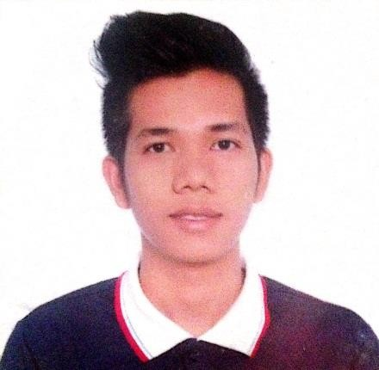
ERIC G. CABANGON

BS Civil Engineering in Technological Institute of the Philippines, Quezon City (TIP-QC)
Address: B4 L30 VSM7 Dulong Bayan 2 San Mateo Rizal
Email Address: erhiccabangon@gmail.com
Contact No.: 09066621029 / 09214123896

OBJCTIVE
To establish a career in engineering where I can demonstrate the learning outcomes of the Civil Engineering program of the Technological Institute of the Philippines. A program accredited by the US-based outcomes-oriented ABET (Accreditation Board for Engineering and Technology.) Engineering Accreditation Commission also to learn more about actual work.
WORK EXPERIENCES:

POSITION: Sales Clerk
COMPANY: FUBU Brand (Parttime)
DURATION: DEC.2018

POSITION: SITE ENGINEER
COMPANY: PCI CONSTRUCTION
PROJECT: UNDER TELECOM.COMPANY BACKBONE,MANHOLE,HANDHOLE, ROAD WIDENING, AND REBLOCKING,
DURATION: August 2019 – November 2022

POSITION: SITE ENGINEER/SUPERVISOR
COMPANY: PRIVATE CONTRACTOR
PROJECT: 6TH FLOOR BUILDING ELEVATOR, RELOCATION OF 8 UNITS T&B.
DURATION: FEBRUARY 2023 – JUNE 2023

POSITION: SITE ENGINEER
COMPANY: CRIO CONSILIUM (PRIVATE CONTRACTOR)
PROJECT: RESEDENTIAL BUILDINGS

EDUCATIONAL BACKGROUND:
Primary  Pagal Elementary School (Pangasinan) | 2006 -2007
Secondary  San Carlos College (Pangasinan) | 2007 -2012
Tertiary  Technological Institute of the Philippines (TIP-QC) | 2013-2019

PERSONAL INFORMATIONS:
Age: 29 Years Old
Date of Birth: April 23, 1994
Place of Birth: San Carlos City Pangasinan
Height: 5’8”
Civil Status: Single
Religion: Roman Catholic

KNOWLEDGE, SKILLS, AND ATTITUDE
- Knowledgeable in Construction Materials
- Analyze complex problems and identify the defined engineering requirements appropriate for solutions.
- Use modern techniques, skills, and tools of engineering practice in complex computing activities.
- Knowledgeable in Basic AutoCAD
- Proficient in Excel and PowerPoint

SEMINAR/S AND TRAINING/S ACTIVITIES
- Philippine Institute in Civil Engineering (PICE)
(TIP-QC - 1ST Sem 2017)

- Solignum Seminar
(TIP-QC – 1ST Sem 2019)

REFERENCES
Engr. Torralba, Ezekiel  (Cainta Rizal) | Administrative Officer IV | 09279210697
Diaz, Antonio  (Caloocan City) | Site Engineer | 09453263534
Melanie Llabres  (San Mateo Rizal) | Public Teacher | 09674671467


ERIC G. CABANGON

Applicant

