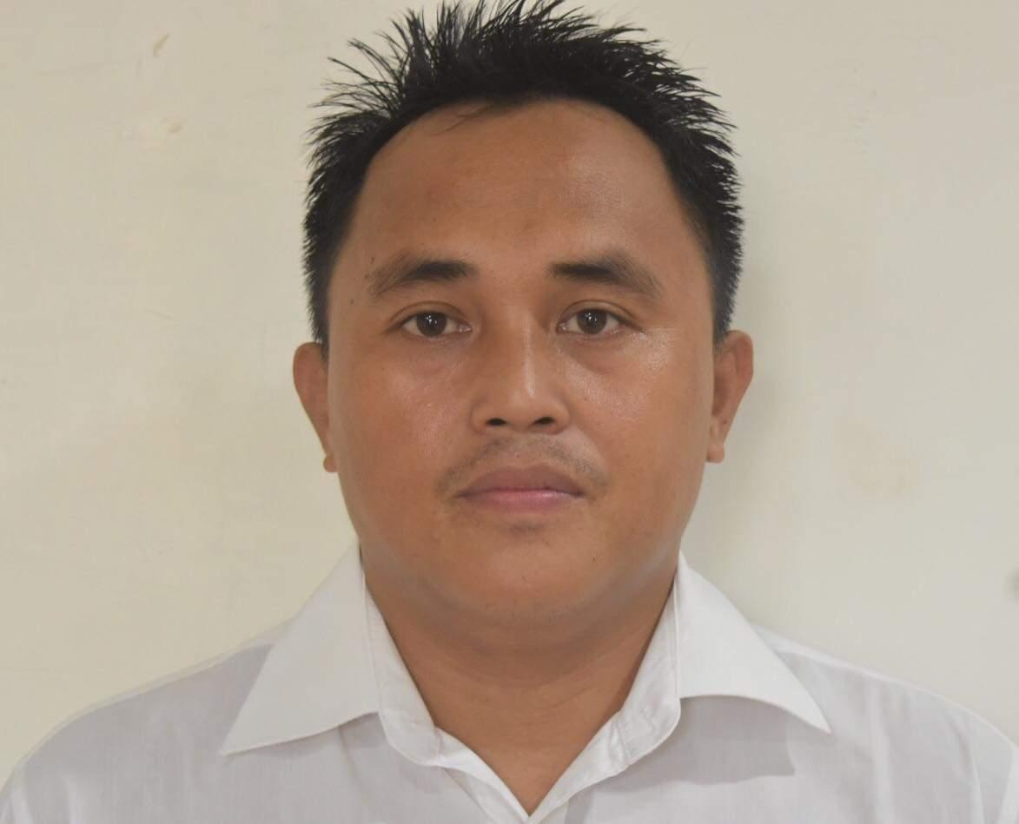
Dexter Jalang Astillero
dexter.astillero@gmail.com
Present Address:
2-228 jibori,hashihama imabari-shi,ehime-ken,JAPAN
ko sanbancho mansion#303
Contact #
+817085824644

Work objectives

Self starter who excels in auto didactic training with a scientific mindset to watch any given technology,task position,or environment with proven competency in driving projects or assignments to succesful completetion,coupled with commitment and dedication.11 years of service with the same global oeganization proves an extraordinary type of loyalty,combined with in-depth business process design,management,and leadership experience.Always open to new challenges,I am reliable ,trusthworthy,hardworking and eager to learn,and have a genuine interest in everything within production and development,I try to learn something new from every experience because I believe there is Always room for self-improvement both personally and professionally

Work experience

Kamada Gumi Company (Japan)

Welder fabricator in
SHIN KURISHIMA SHIPYARD
Work with different variety of material from thin to thick metal use in ship building
Welding in ship from block pipe and all accessories of the ship

January,31,2023 to present

Fabrication Welder
Daitoh Unlimited Company (JAPAN)
Manufacturing / Production

I’m a welder fabricator, I work a conveyor frame
, step by step, from assemble to finish
All my projects are all in autocad program my manager give my details work project thru usb
and study all parts of the conveyor from the metal ,the dimension.length,width,caster,or even the topped process.
Aug.19.2015-AUG.19,2018

Casting Ferrous Metal (welder)
United Casting Foundry Inc.
Manufacturing / Production
Tayud, Liloan, Cebu
I work her around 7 years as a core maker/welder of non-ferrous metal, and
casting of marine propeller -
Jan.8,2008- May 2015

Educational Attainment:
2000-2004
TAYUD NATIONAL HIGH SCHOOL
GRADUATED

Jun 2007 - Dec 2007 Don Bosco Training Center
Vocational Diploma / Short Course Certificate
welding course

Licenses / Certifications
Jul 01, 2016 General Welding Association
D160349

Government Documents:
Passport ID Number: P2892363B
Place of Issue: cebu philippines
Date of Expiration: Aug 28, 2029

Trainings / Seminars:

Aug 18, 2015 - Aug 19, 2018 Welder semi-automatic
NEVIKA HUMAN RESOURCES INTERNATIONAL, INC.

Languages
Cebuano,English, Tagalog | Japanese

CHARACTER REFERRENCES

Aljun Maglasang WELDER FABRICATION
DAITOH UNLIMITED COMPANY, INC
+819018256761
Maglasangaljun663@gmail.com

