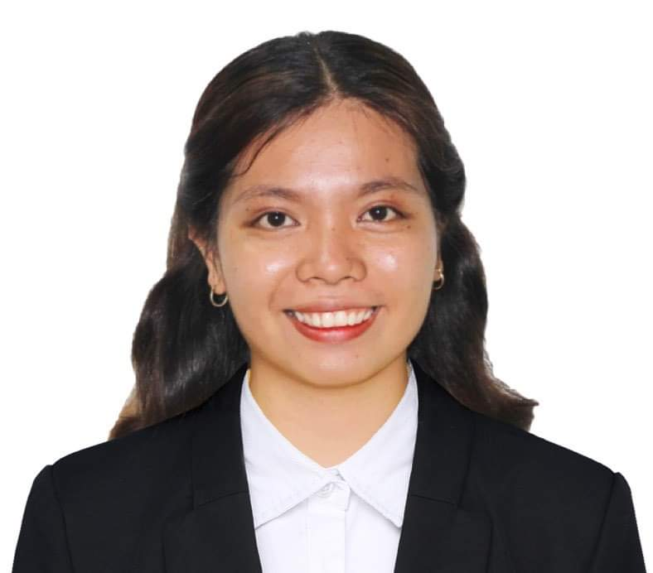
NIKKA JANE D. BALBAS
Brgy. 20-B Gabut Sur, Badoc, Ilocos Norte
Cell no.: 0935-347-3027
Email Add: niknikjanebalbas31@gmail.com

OBJECTIVES: To establish a career in a thriving organization where I can show my ability by accepting challenges, achieving organizational goals, and climbing the professional ladder through lifelong learning and commitment.

PERSONAL INFORMATION

Date of Birth: March 31, 2000
Place of Birth: Brgy. 20-B Gabut Sur, Badoc, Ilocos Norte
Gender: Female
Age: 23
Nationality: Filipino
Religion: Iglesia ni Cristo
Weight: 58 kg.
Height: 5’2
Father’s Name: Narciso D. Balbas
Mother’s Name: Janelyn D. Balbas

EDUCATIONAL BACKGROUND

Master Degree: Mariano Marcos State University-Graduate School
Master of Arts major in Guidance and Counseling
Apolinario Castro, Laoag City, Ilocos Norte
2023-present

College: Mariano Marcos State University-College of Teacher Education
Bachelor of Secondary major in Values Education
Apolinario Castro, Laoag City, Ilocos Norte
2018-2022
Cumlaude

Senior High School: Juan Luna Memorial Academy Inc.
Brgy. 3 Alogoog Badoc, Ilocos Norte
2016-2018
With Honor

Junior High School: Juan Luna Memorial Academy Inc.
Brgy. 3 Alogoog Badoc, Ilocos Norte
2013-2016
With Honor

Elementary: Gabut Elementary School
Brgy, 20-A Gabut Norte, Badoc Ilocos Norte
2005-2012

EXPERIENCE

SPES 2016- Accounting Office
SPES 2018- RHU Office
SPES 2019- Accounting Office
SPES 2021- PNP and BFP Office
Work Immersion- Accounting Office
Private School Teacher- Badoc Junior College Incorporated

ELIGIBILITY
- Licensure Examination for Teachers (LET), a national examination administered by the Philippine Professional Regulations Commission, May 2023

SKILLS AND INTEREST

- Willing to learn
- Flexible in time
- Dedicated to the work assigned
- Having good in Oral and Written Communication
- Can work effectively and efficiently individually or in group

REFERENCE

- Prof. Mignon Cecilia Diego
Head Teacher
MMSU-Laboratory High School- Batac
- Mr. Dave Malan G. Dahilig
Instructor I
College of Industrial Teacher-Mariano Marcos State University
- Mr. Rosito G. Francisco
Paint Technician
TOYOTA-Ilocos Norte

I hereby certify that the above information is true and correct to the best of my knowledge.
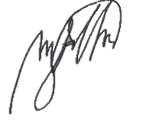

NIKKA JANE D. BALBAS
Applicant

