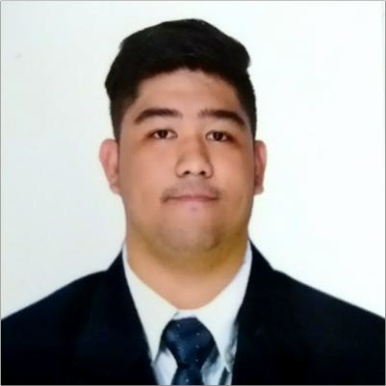
JED MANLALANGIT CRUZ

Contact Information
Block 7, Lot 1, Mandarin Homes 2, Malagasang 2-b Imus Cavite jedmada@gmail.com
+639914091154

Objective:

To hone my skills, as where extensive experience and skills will be utilized and develop. Furthermore, my contribution would mutually benefit my institution, In return. I will offer my service in helping your company.

Skills and Qualifications:

- Knowledgeable in OSP Design
- Knowledgeable in Microsoft Office, AutoCAD.
- Open to all ideas, eager to learn
- Relates to do practical use of machine or electronic gadgets
- Can work under pressure
- Team player
- Computer Literate
  - Installation of software and hardware
  - Troubleshooting

Work Experience

EDS Manufacturing Incorporated - Yazaki

Technical Specialist
October 2017 - April 2018
Worked as Technical Specialist under Preparation and Planning Department, Standard section.

LBP Service Corporation.

Project Designer
April 2018 – November 2018
Worked as Project Designer for Union Sunny Technology and Exponents Inc. Designing FBTS and FTTH under PLDT/SMART and GLOBE Project for Fiberhome.

BSPT CONSTRUCTION CORPORATION.

DESIGN & ENGINEERING ASST.
March 2019 – Present
Worked as Design and Engineering Assistant. Designing FBTS and FTTH under PLDT/SMART/GLOBE and Project for Huawei.

- Conducts site surveys, field verification, and test fit plans.
- Aid in project design and development activities based on client’s requirements.
- Develop design documentations, technical specifications and other project related documentations as needed.
- Attend project meetings to discuss about any issues and new design ideas.
- Analyze design issues and suggest corrective actions.
- Oversee change order management and document filing activities.
- Prepare design layouts and sketches according to client design standards.
- Address design related queries and concerns in a timely manner.
- Help and conduct trainings to team members when required.
- Work with design team in prioritizing, planning and executing several projects efficiently.
- Propose effective design solutions to meet project goals.
- Review and recommend improvements to existing designs.
- Follow company policies and design standards.
- Knowledgeable in OSPMS

Education

Tertiary

LYCEUM OF THE PHILIPPINES UNIVERSITY- CAVITE
BS in Electronics and Communications Engineering Major: Electronics (Microelectronics)
2012-2017

Secondary

MARANATHA CHRISTIAN ACADEMY
Malagasang 2D, Imus Cavite June 2008-March 2012

Primary

MARANATHA CHRISTIAN ACADEMY
Malagasang 2D, Imus Cavite June 2002-March 2008

Personal Information:

- Date of birth : August 18, 1995
- Place of birth : Bayan luma, Imus Cavite
- Age : 29
- Status : Single
- Nationality : Filipino
- Religion : Roman Catholic

Seminars and Trainings:

- YOUnique: Understanding Others by Understanding You (Personality Development Workshop)
Held at Lyceum of the Philippines University Cavite February 18, 2016
- Image and Skill Enhancement Training: BUSINESS ETIQUETTE
Held at Lyceum of the Philippines University Cavite February 22, 2016
- Project Management and Scheduling Held at Lyceum of the Philippines University Cavite February 14, 2017

Credentials will be provided upon notice.

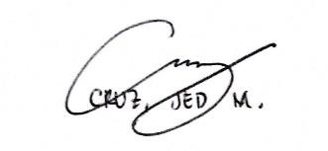
I hereby certify that the above information is true and correct to the best of my knowledge and belief.

Applicant’s Signature

