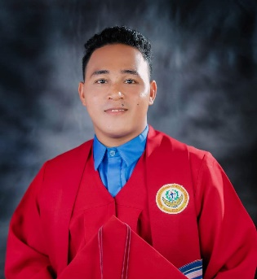

ERICK JOHN REY S. ENERLAN
Area 1, 004 Malambing Street, Pinalagad
Brgy. Malinta Valenzuela City
09307619957
erickjohnrey07@gmail.com

OBJECTIVE

A graduate of Bachelor of Arts in Political Science seeking a growth-oriented profile in a company where my skill knowledge is effectively used for the success of the organization.

PERSONAL DATA

Age: 26
Sex: Male
Civil Status: Single
Citizenship: Filipino
Height: 5’5 ft.
Weight: 75 kg
Religion: Pentecostal
Date of Birth: December 07,1997
Place of Birth: Siay, Zamboanga Sibugay

EDUCATION BACKGROUND

Primary Monching Elementary School
Monching Siay, Zamboanga Sibugay
2011-2012

Junior High Monching National High School
Monching Siay, Zamboanga Sibugay
2015-2016

Senior High
Sibugay Technical Institute Inc.
Lower taway, Ipil Zamboanga Sibugay
Tech-Voc Industrial Art’s
2016-2018

Tertiary Western Mindanao State University
Dacanay Siay, Zamboanga Sibugay
Bachelor of Arts in Political Science
2018-2022

SPECIAL SKILLS

- Good Communication Skill
- Computer Maintenance
- Microsoft Word/Excel/PowerPoint/Publisher

EMPLOYMENT HISTORY

2018-2023
- Elected as SK CHAIRPERSON EX-OFFICIO BRGY. KAGAWAD

- Implementing projects, program and activities

- Disbursing/liquidation of funds

2022
- Municipal Planning Development Council Office

- Drafting Project Proposal
- Paper works

REFERENCES:

ENGR. ELPEDIO SUAN HON. MICHAEL ENOCH GANDI
HEAD DEPARTMENT SK FEDERATED PRESIDENT EX OFFICIO- SB MEMBER
Siay Municipal Hall SK Federation Office
Region IX Poblacion, Siay Zambonga Sibugay

