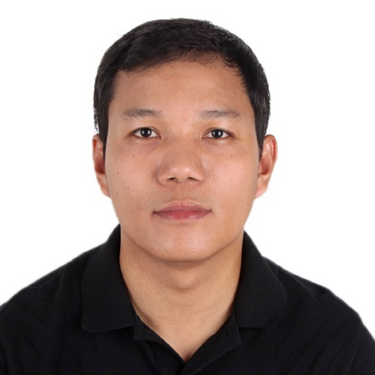
JEFFREY A. CASTILLANO
Block 07,lot 20,Daisy Street Tivoli Garden Subd.
Mawaque Road,Sapang Biabas
Mabalacat City, Pampanga,Philippines
Mobile No.: +639494472359/09392861107
Email: jeffreycastillano16@yahoo.com
Gmail:jeffreycastillano0216@gmail.com

OBJECTIVE:

To learn and adopt new task and to enhance work experience, experience in field coordination works, hardworking, initiative and effective in monitoring job accomplishments.

EDUCATIONAL BACKGROUND

2016-2017 Bachelor of Science in Electrical Engineering
Manuel S. Enverga University Foundation
Commission on Higher Education under ETEEAP (Undergrad)
Lucena City, Philippines
May 19th 2017

2001– 2003 Computer and Electronics Technology
Development for Advanced
Technology Achievement College
Capitol Blvd., Palawe, City of San Fernando, Pampanga.Philippines
March 28, 2003
Applied Electronics
Mobile Power Technical Training Center
Dau, Mabalacat, Pampanga.Philippines
November-May 27 of 2007

1997 – 2001 SAN MATIAS HIGH SCHOOL
San Matias, Sto.Tomas, Pampanga
Secondary Education
April 06, 2001

1991– 1997 SAN MATIAS ELEMENTARY SCHOOL
San Matias, Sto.Tomas, Pampanga
Primary Education

PROFESSIONAL EXPERIENCE

- SFA SEMICON PHILIPPINES CORPORATION
Panday Pira Avenue Corner Creek side Road
Clark Freeport Zone Pampanga Philippines
Equipment Engineer -Engineering Front of line Assembly Department
March 07, 2011 to Present

- AMERTRON INCORPORATED –Semiconductor Company
Clark Special Economic Zone, Clark Field, Pampanga
Line Technician - Front of Line (Integrated Circuit Department)
March 12, 2004 to March 03, 2011

Duties and Responsibilities:

- Primary job is to maintain our equipment/machine running in good condition and Conduct troubleshooting and repair on machines in case of abnormalities and malfunctions under my supervision
- Perform regular preventive maintenance and lubrications.
- Provide technical assistance and guidelines operators on machine operations.
- Support Process Engineers (PE) and Quality Control and production personnel during materials and engineering evaluations.
- Conduct troubleshooting and repair on machines in case of abnormalities and malfunctions.
- Update parameter log sheet in every machine qualification and any alterations made on parameters during repair to obtain smooth machine operations.
7.Maintains absolute cleanliness of equipment and surrounding area of equipment.

SEMINARS / TRAININGS ATTENDED

- ASM AD8312 plus Machine Training
- KNS Istack Die Attach Technical Course
- SAMSUNG SDB series(Board on chip Devices)
- HITACHI CM700 Die Sip Mounter
- SHINKAWA SPA 400(Micro SD Device)
- HITACHI DB700 Die Sip Mounter
- SFM2/Yamaha Flip chip technical course
- Basic Wire Bonding Technical Course
- Basic Die Preparation Technical Course
- Work Attitude & Values Enhancement
- Leadership training
- Die Attach Technical Course
- Basic Support Utilities(CDA/DI Water/Clean room/Air conditioning
- Electric Circuits
- Pneumatics And Hydraulics
- D/A,W/B,3/0 Criteria Review Process Flow Chart
- ESD Training (Ground strap)
- ESD & Clean room Awareness Training
- Environmental Management System(ISO 14001)
- 5S+1 Reactivation Training
- Equipment Calibration-Eng’g & Production Intensive Training
- Electrostatic Control Monitoring Procedure
- Fire Safety Seminar

PERSONAL INFORMATION

Nickname : Jeff
Date of Birth : November 16, 1984
Age : 39
Height : 5’11”
Weight : 175 lbs.
Gender : Male
Civil Status : Married
Citizenship : Filipino
Religion : Roman Catholic
Language Spoken : English, Pampango and Filipino

CHARACTER REFERENCES

Mr. Allen Canlas
Equipment Engineering Manager
SFA Semicon Philippines Corporation.

Mr. June Cabalo
Field Service Engineer
Aurotech Corporation.

Mr. Albert Pascual
Equipment Engineer
SFA Semicon Philippines Corporation.

I hereby certify that the above information are true and correct to the best of my knowledge and belief.

_________________________

Jeffrey A. Castillano

