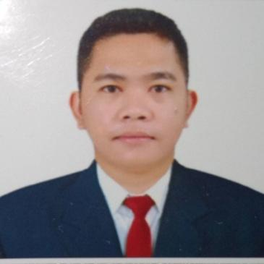
ROMAR P. RUBRICO
Address : Timaru city, 11 wai-iti road, Mauri Hill, New Zealand
Contact No. : +64223493558
Email add : romarrubrico@gmail.com

Position : BUTCHER
______________________________________________________________________________
OBJECTIVE

To obtain a butcher position in the company where I can contribute to what I have learned and also to be part of a growing successful company. I would also like to utilize my skills, ability and knowledge with this growing company to become more successful in any position that I perform.
_________________________________________________________________________________________________________
PROFESSIONAL EXPERIENCE

Date : January 27-2023 up to present
Position : BUTCHER
Company Name : Silver Fern Farm Pareora
Location : 111 Pareora 7912

Job Description:

- Make sure that all Standards and Procedures are in place and followed
- Follow all safety and security policies
- Follows up with rules, regulations and other relevant laws guiding livestock production and sales in the geographical area.
- Negotiates and confirms orders from customers
- Before entering inside the slaughterhouse is to make sure that knives are already sharpen
- Cleans the meat preparation counter to avoid contamination of the meats
- Cut, Trim meat and carcasses into primal and standard cuts.
- Apply good hygiene practices into the workplace.
- Perform hygienic slaughtering procedure for hogs with the group.
- Prepare various cuts of meat as required including correctly preparing beef and pork
- Cleaning of all equipment including disinfection.

SKILLS

- Able to keep a clean and sanitary station
- On time and reliable
- Energetic, friendly and enthusiastic
- Net and Clean Appearance
- Willing to work nights and weekends

________________________________________________________________________________________________________

EDUCATIONAL BACKGROUND

Inclusive Date. : 2017 - 2021
Course : Bachelor of Science in Biology
College School : Sultan Kudarat State University
Location : Tacurong City

Inclusive Date : 2007 - 2011
High School : Banaybanay National High School
Location : Davao Oriental
________________________________________________________________________________________________________
PERSONAL DATA

Date of Birth : March 21, 1995
Place of Birth : Purok 26, Poblacion, Banaybanay Davao
Oriental
Citizenship : Filipino
Height : 5'5
Weight : 68kls
Marital Status : Single
Religion : Roman Catholic
Languages Spoken : English, Tagalog
SSS No. : 0111-6855298-1
Pag-ibig No. : 1211-8247-1912
Philhealth No. : 16-050733083-2
TIN No. : 331-924-476
Vaccination ID No. : J38-5292
Passport Number : P0271576C
Expiry Date : May 26, 2032
Driver’s License (Ph, Int’l etc) : M07-22-302074
E-registration No. : 2022070421099
PEOS Certificate No. : 0001242406
NBI No. : R162CRUR59-KC142300
Expiration date : August 03, 2023

________________________________________________________________________________________________________
SEMINARS AND TRAININGS ATTENDANCE

Course : Slaughtering Operation (Swine) NCII
Training Center : D'New Orleans Training Center Phils, Inc
Location : Buayan M'Lang North Cotabato
Date : March 13, 2022 - April 8, 2022

Course : (GMP) Good Manufacturing Practices
Training Center : M'lang Municipality Hall Rooftop, North Cotabato
Location : Buayan, Mlang North Cotabato
Date : May 4, 2022

ROMAR P. RUBRICO APPLICANT

