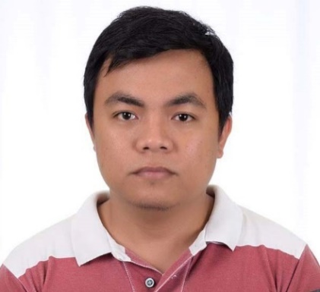
JASHPER Q. ESTEBAN
Sadaan, Midsayap North Cotabato, 9410 Philippines
Mobile Number: PH(+63) 9491878587/ (+63) 9761710488
Email Address:Underboneking022689@gmail.com

CAREER OBJECTIVE

To work for a company that encourages its personnel to use her knowledge, skills and experience to secure a position which will lead to personal and professional growth.

WORK EXPERIENCE

NETWORK ENGINEER L2(TELECOM)
ViewQwest Pte. Ltd. Based in Singapore
Certification: Certified CATO Support Engineer
February 15, 2021 to Present
Job Description: 24/7 Managed Services, AP’s, modems, switches and firewalls.
-Technical Support Using calls and Emails to customer.
- Configure SD-WAN and firewall rule (Cato SDWAN, Palo Alto Firewall, Palo Alto Prisma SDWAN)
- Identify, troubleshoot and resolve technical problems based on pre-established
Guidelines, document, track and monitor problems to ensure a timely resolution.
- Troubleshoot VPN client connectivity and tunneling issue
- Monitor alerts and looks into suspicious activity using security monitoring tools.
- Provide phone and email support to end users on network connectivity or security related issue.
CUSTOMER SERVICE/ TECHNICAL SUPPORT REPRESENATIVE (TELECOM)
VXI GLOBAL SOLUTIONS (Philippines) Davao City
November 2013 – February 2015
Job Description: 24/7 Monitoring of Services, Receiving Calls and Inquires, providing statement, Technical Support, Admin task, Customer service

INSIDE PLANT TECHNICIAN/SERVICE DESK SUPPORT (TELECOM)
Midsayap Communications Systems Corporation/PLDT
May 2012 to June 2013
Job Description: 24/7 Monitoring of Services, Receiving Calls and Inquires, Technical support, Activation of new lines
SELLING CLERK (Retail Store)
SM Supermarket Manila, Philippines
April – September 2010
Job Description: Providing Stocks in the Supermarket, Customer Service

HEAD CASHIER (Retail Store)
Ever Supermarket Manila, Philippines
October 2009 - January 2010
Job Description: Receiving and exchanging money from the Customers

Sex: Male
Age: 35
Date of Birth: February 26, 1989
Height: 5’3”
Weight: 62 kls
Citizenship: Filipino
Languages: English, Pilipino
Civil Status: Married
Interest & Activities: Driving, Video Games, Network Troubleshooting
PERSONAL DATA
SUMMARY OF SKILLS AND CERTIFICATE

*CERTIFIED CATO SUPPORT ENGINEER
- Knowledgeable in Computer Application and Database Management
- Adobe Photoshop
- Customer Service
- Proficient in MS office
- Desktop Support
- Networking
EDUCATIONAL BACKGROUND

College: June 2005 – March 2009
Notre Dame of Midsayap College
Bachelor of Science in Computer Science
Midsayap, North Cotabato, Philippines

Secondary: June 2001-2005
Saint Mary’s Academy
Midsayap, North Cotabato, Philippines

Elementary: June 1995-2001
Southern Christian College
Midsayap, North Cotabato, Philippines

I HEREBY CERTIFY that the above affirmation is true and correct to the best of my knowledge and belief.

JASHPER Q. ESTEBAN
Applicant

