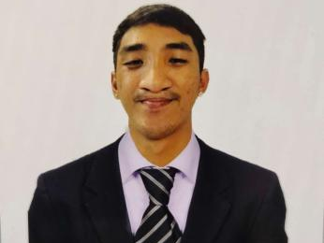
HALLARE, RALPH GABRIEL A.
Blk 6, lot 31, Lessandra, Camella Homes, Del Rosario, Naga city
09560149062
gabbelizabeth18@gmail.com

CAREER OBJECTIVE:
To work in a position wherein I can enhance my knowledge and skills, boost my confidence, and be a better version of myself with regard to my studies. Be an essential part of the organization to which I can share the freshest ideas I have learned from my Alma Mater.

PERSONAL INFORMATION
Date of birth : January 6,1998
Age : 26 years old
Gender : Male
Civil status : Single
Occupation : Slaughterer/ Butcher
Father’s name : Ariel lito R. Hallare(+)
Occupation : Former Supervisor Engineer
Mother’s name : Mary Grace A. Hallare
Occupation : Agent/ Broker/ Realtor
Religion : Roman Catholic
Place of birth : Naga city

EDUCATIONAL BACKGROUND
COLLEGE: Aeronautical Academy of the philippines
Aircraft Mechanic Technology
Baras, Canaman, Camarines Sur
2017- 2019
SECONDARY: Alternative Learning System (ALS)
2016-2017

PRIMARY:. St. Joseph’s College of Quezon City
Quezon city, Manila
2009-2011

WORK EXPERIENCE

SLAUGHTERER AND BUTCHER
LEHMANN’S QUALITY MEATSHOP
June to January 2023
• Can perform all slaughtering operations in swine and shackling, sticking, evisceration, removal of organs, splitting and quartering carcass, washing, and weighing.
• cutting, grinding, and preparing meats.
• can perform primal cuts.
• Learn Safety protocols for using tools and equipment.

SAMSAMLEXIE’S MEATSHOP
>Can perform deboning
>Primal cuts&preparing meats for display

TRAINING
• Shielded Metal Arc Training ( NC| )
• Slaughtering Operation (Swine) NC||
( November- December 2021 )

RELEVANT SKILLS
>Meat cutting
> Excellent Customer Service
> Excellent Knife Skills
> Slaughtering
> Driving
>Team communication

CHARACTERISTIC REFERENCES

• Rodresha Asico Torallo
Camsur Peso
09498888717

• Imelda Glenn Bersabe-Cemitara
Branch Manager at Lehmann’s Meatshop
09998895793

• Samuel Salvino
Owner at SamSamlexie’s Meatshop
09059783263

I hereby certify that the above information is true and correct to the best of my knowledge and belief.

Ralph Gabriel A. Hallare

