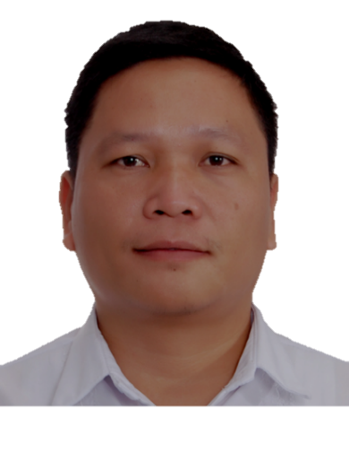
PONSENTTIA ST. VIA VERDE VILLAGE, BRGY SAN AGUSTIN 2,
DASMARINAS CITY, 4114 CAVITE
MOBILE NO. GLOBE: 0995-5089-570 SMART: 0920-6874-676
Facebook: Nino Evangelista
Email: Nino.evangelista.737@gmail.com,, ninofernando.sandiego001@deped.gov.ph.com
Niño FERNANADO EVANGELISTA. SAN DIEGO
Skills & Abilities |  | - Oral and written communication (Filipino, English)  - Microsoft Office application (Word, Excel, and PowerPoint)  - Sketching  - Cooking  - Friendly and open-minded; committed to work in service of the profession
personal data | PPersonal | Birthday: February 6, 1979 Nationality: Filipino  Place of Birth: San Pablo City, Laguna Religion: Roman Catholic  Gender: Male Dialects: Filipino, English  Height: 5’5” Civil Status: Married  Weight: 72 kg
Awards and citation | A | Finalist “Makata ng Taon 2018” by Komisyon ng Wikang Pambansa  Champion Division Level sa Pagsulat ng “Balagtasan” para sa Buwan ng Wika 2018  Pinamagatang: “Kasangkapan ng Bagong henerasyon saan ka sa darating na Panahon?  City Schools Division of Dasmarinas  Champion coach para sa Balagtasan para sa Buwan ng wika 2018  City Schools Division of Dasmarinas
Experience |  | CONGRESSIONAL INTEGRATED HIGH SCHOOL  Via Verde Vilage, Ponsettia St Brgy. San Agustin II, Dasmariñas City, Cavite  Teacher- Grade 7 and Grade 8  May 13 2013- up to present  PNTC COLLEGES - DASMARINAS  Zone III Lt. Cantimbuhan St. Poblacion, City of Dasmarinas, Cavite  Part-time Teacher/Instructor  May 2019-December 2019- !st semester  FAR EASTERN COLLEGE - SILANG  Metrogate Subd, Bypassroad Silang, Cavite  Teacher- Second year to Third Year high school  May 2012-March 2013  THE SISTERS OF MARY SCHOOL (BOYSTOWN)  Brgy. Adlas, Silang Cavite  Teacher 3rd to 4th year high school and Post-Secondary  April 13 2009 - February 2012  SAN PABLO CENTRAL ELEMENTARY SCHOOL  Rizal Ave. San Pablo City, Laguna  Substitute Teacher Grade 2 - 6  April 13 2007 - March 2009  LICEO DE SAN PEDRO  Brgy. Poblacion, San Pedro, Laguna  Teacher 2nd year – 3rd year  April 2006 - March 2007  OPEN DOOR CHRISTIAN ACADEMY  Fule Sahagun St. San Pablo City  Teacher 2nd year – 3rd year  April 2005 - March 2006  CREST CHRISTIAN SCHOOL  Brgy. San Gregorio. San Pablo City  Teacher 1st year – 3rd year  April 2002 - March 2005
Education |  | Government Licensure Examination for Teachers (LET) Passer  Date: November, 2012  Graduate Studies WESTERN COLLEGES– Dasmariňas Campus  Brgy. Paliparan 3, Dasmariňas  Master of Arts in Education major in Filipino  Complete Academic Requirements  36 units  LAGUNA STATE POLYTECHNIC UNIVERSITY  (San Pablo City Campus)  Master of Arts in Teaching Filipino  Brgy. Del Remedio, San Pablo City, Laguna  18 units  Tertiary LAGUNA COLLEGE  Bonifacio Ave, San Pablo City  Bachelor of Secondary Education  Major in Filipino  June 1996 – April 2000  Secondary SAN PABLO CITY NATIONAL HIGH SCHOOL  Mariño Subd. San Pablo City, Laguna  June 1991 – March 1996  Primary FULE ALMEDA ELEMENTARY SCHOOL  Fule Shagun St. San Pablo City  June 1986 – March 1991
References |  | MRS. JOSEFINA A. BRIŃAS  Former Principal IV  Congressional Integrated High School  Via Verde Village, San Agustin 2, Dasmariñas  MS. FRAGILYN B. RAFAEL  Education Supervisor  City Schools Division of Dasmarinas  Area C, Burol 2, Dasmarinas  MRS. RUCHELLE A. BAYSAN  Former Principal II  Langkaan II National High School  City Homes, Brgy. Langkaan II Dasmariñas  I hereby certify that the above information is true and correct to the best of my knowledge and belief.  ______________________________  MR. NIŃO FERNANDO E. SAN DIEGO  Teacher Applicant

