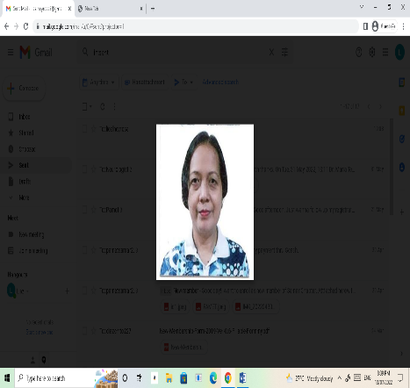
LIEZL TOCMO – HEYROSA, RMT
License no. 0035576
Phone: 0916-186-8859 / 0981-6284609
Address: 136 Gumarao St. Zone 2, Victoria, Northern Samar
Phillipines
Email: liezlheyrosa2@gmail.com
Date of Birth: March 27, 1976
Gender: FEMALE
Civil Status: Married

WORK EXPERIENCE

Allen District Hospital
Medical Technologist: Sept. 2021 till Present
- Entertain out-patients who enter laboratory
- Accepts samples for analysis
- Prepare lab. equipment needed
- Performs quality control
- Analyze samples received
- Performs maintenance of laboratory machines
- Monitor laboratory temperature
- Verify, log and release official test results

Lifelab Diagnostics, Inc.
Medical Technologist/ Drug Analyst: Oct 2014 – Feb 2018
- Collect and receive specimen for testing
- Run QC and plot results in LJ chart
- Maintain, monitor cleanliness/temp inside the lab
- Perform drug testing
- Analyze and interpret test results for accuracy, acceptability and critical limits.
- Inform requesting physician for any abnormal or critically
low/high results.
- Ensures that TAT (Turn Around Time) of specimen is met.
- Release and validate laboratory results in LIS (Laboratory Information System).
- Keep and assure the confidentiality of results of examined
specimens.
- Participates in External Quality Assurance System.
- Maintains safe and clean working environment by complying procedures, rules and regulations.
- Protects patients and employees by adhering to infection-
control and hazardous waste policies and protocols following identification procedures.
- Maintains positive working relationship with other laboratory
staff and personnel.

S SKILLS
- Performs phlebotomy
- Perform QC
- Multitasking
- Troubleshoot machine
- Drug analyst

EDUCATION
Bachelor of Science in Medical Technology
Southwestern University S.Y 1993 – 1997
Cebu Institute of Technology S.Y 1989 1993
Victoria Central Elem. School S.Y 1983 - 1989

NMC Specialty Hospital, UAE
Laboratory Technician: May 2008 – March 2010
- Follow standardized laboratory procedures and prepare samples for analysis.
- Prepares reagents for medical laboratory testing using approved methods and means according to established standards and procedures.
- Analyze and interpret test results for accuracy, acceptability and critical limits.
- Run QC and plot results in LJ chart
- Protects patients and employees by adhering to infection-control and hazardous waste policies and protocols following identification procedures.
- Release and validate laboratory results in LIS (Laboratory Information System).

Midhnab General Hospital, K.S.A.
Laboratory Technician: May 2004 – June 2006
- Interview blood donors and performs phlebotomy.
- Run QC and plot results in LJ chart.
- Collect and receive specimen for testing.
- Analyze and interpret test results for accuracy, acceptability and critical limits.
- Participates in External Quality Assurance System.
- Maintains safe and clean working environment by complying procedures, rules and regulations.
- Release and validate laboratory results in LIS (Laboratory Information System).

Allen District Hospital
Medical Technologist: March 1998 – April 2004
- Entertain out-patients who enter laboratory
- Accepts samples for analysis
- Prepare lab. equipment needed
- Performs quality control
- Analyze samples received
- Performs maintenance of laboratory machines
- Monitor laboratory temperature
- Verify, log and release official test results

Stanford Laboratory
Medical Technologist: Feb 2012 – Sept 2014
- Collect and receive specimen for testing
- Analyze and interpret test results for accuracy, acceptability and critical limits.
- Participates in External Quality Assurance System.
- Inform requesting physician for any abnormal or critically low/high results.
- Maintains positive working relationship with other laboratory staff and personnel.

Hi-Precision Diagnostics
Medical Technologist: May 2011 – May 2012
- Performs phlebotomy
- Run QC and plot results in LJ chart
- Ensures that TAT (Turn Around Time) of specimen is met.
- Release laboratory results in LIS (Laboratory Information System).
- Keep and assure the confidentiality of results of examined specimens.

