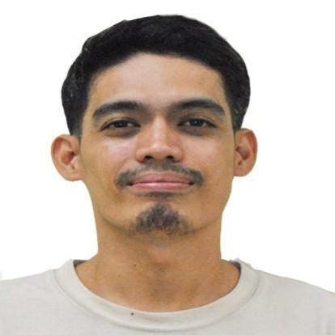

JAMEL TUBONGANUA BANIE
Block 6 Lot 13 Green Forbes City, Perez Hugo
Trece Martires City,Cavite
Mobile No:+639079866589/+639383825035
Email : jamelbanie21@gmail.com

OBJECTIVE

To obtain a career opportunity where I can apply my skills that will benefit not only myself but also to my employer.

WORK EXPERIENCE Test Solution Services Incorporated
Gateway Business Park, Brgy. Javalera
General Trias , Cavite

Position Fixture Handler ( Analog Devices Phil. Inc) as contractor
ADGT LTC Onsite services
May 11,2022 at October 21, 2023

Scope of work Responsible personnel to monitor line down especially IDL Standby status.
Updating of hardwares/ fixtures.
Performing Task in the acceptance of hardware from HCR and issuance of hardware to Technician/ Operator.

WORK EXPERIENCE Philippines Mansho Incorporated
First Cavite Industrial Estate FCIE, Bo.langkaan
Dasmarinas City,Cavite,Philippines

Position Coating Operator
March 7, 2012 to April 2022

Scope of work Can operate Molding Machine
Conduct Trial Customer Product
Set up of automatic spindle machines.
Can operate spray gun.
Can paint primer coat, basecoat and clear coat.
Already to visual or inspect the product.

WORK EXPERIENCE Suminac Philippines Incorporated
First Cavite Industrial Estate FCIE, Bo.langkaan
Dasmarinas City,Cavite,Philippines

Position Production Operator
January2011 to July2011

Employer Agency Prime Asia Manpower Resources Inc.
Lankaan 1 Dasmarinas City,Cavite,Philippines

Company under Suminac Philippines Incorporated
First Cavite Industrial Estate FCIE, Bo.langkaan
Dasmarinas City,Cavite,Philippines

Position Production Operator
Manufacturing Department
July2010 to January2011

Scope of work Tack welding and full welding.
To paint Forklift components.
Check and inspect their individual machine condition on a day to day
basis.

WORK EXPERIENCE Pilipinas Nippon Muki Incorporated
First Cavite Industrial Estate FCIE, Bo,langkaan
Dasmarinas City,Cavite,Philippines

Position Visual Operator
January 6, 2010 to June 6, 2010

Scope of work Visual inspector of a glassmat, checking of thickness of the model.
Monitoring the calender gauge of the machine.
Check the proper set up of the machine before to start of work.
Maintain 55 before and after to work.

WORK EXPERIENCE Sanwa Electric Philippines incorporated
First Cavite Industrial Estate FCIE,Bo Langkaan, Dasmarinas City,Cavite,Philippine

Position Production Operator
Rotor Assy Department
September2008 to February2009

Scope of work Set up of bench lathe machine then change the collect
Chuck jigs in either 4.0 inside diameter or 3.2 inside diameter of its
Depending of the required model for that day.
Burrying of rotor or sides cutting of thickness rotor chips.
Check the proper setting of machine for the start to work.
Maintain good housekeeping.

On the job trainee
Company Name Kou fu Color Printing Crop
MountView Industrial Complex,Bo.Bancal,
Carmona,Cavite,Philippines

Position Trainee
July2007 to January2008.

Scope of work Maintain assists and preventive on all machines.
Assign in packaging section.
Maintains good housekeeping habit and order work area.
Educational Background

College Carlos Hilado Memorial State College Alijis Branch
Brgy.Alijis Bacolod City,Negros Occidental
Bachelor of Science Industrial Technology
Major in Mechanical Technology
2004 to 2008

Secondary Binalbagan Catholic College High School Dept
Binalbagan,Negros Occidental
2000 to 2004

Primary Level San Teodoro Elementary School
Binalbagan,Negros Occidental
1994 to 2000

Scope of work
Can operate Automatic Lathe,Drilling,Radial,Surface Grinding,Milling Machine and other
Mechanical works. Can read Vernier Caliper and micro Caliper.
Can operate a spindle painting robot machine.

Qualifications College
Took up Bachelor of Science Industrial Technology
Major in Mechanical Technology

Special Skills
Computer literate
Knowledgeable in Microsoft Office Application Word,Excel,Powerpoint
High Disciplined,flexible,resourceful,hardworking,proficient worker and easily
To adapt working environment. Can work under minimum supervision.

Personal data

Birth date November 8, 1986
Birth Place Himamaylan, Negros Occidental
Height 5”8
Citizenship Filipino
Status Married
Communication Skills English,Tagalog and Hiligaynon
SSS 34-0662432-0
Pag Ibig 1020-0028-7144
Phil health 08-050706743-7
Tin 257-934-271-000

References
Name Position

Ryan Epanag
Sr. Supervisor Equipment Maintenance
Analog Device Phil. Inc.

Cherie lyn Balliton Analog Device Phil.Inc
Compendio Employee # 29193

I hereby certify that the above information are true and correct with the best of my knowledge and consent.

Jamel Tubongbanua Banie
Signature

