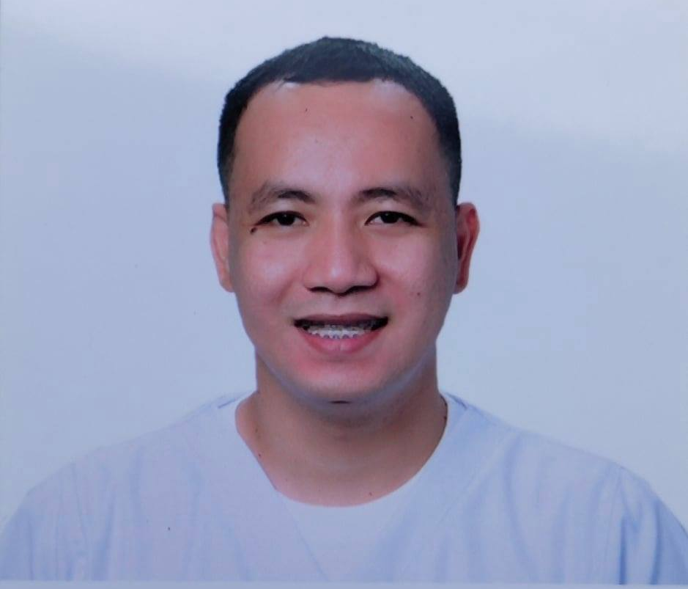

ROMMEL REYES RIMANDO
Purok 6A Buhangin, Butuan City, Agusan Del Norte
Mobile No.: 09099180802 / 09565631032
Email add.: rommelrimando13@gmail.com

NURSE JOB DESCRIPTION:

To leverage my 5 years patient focused hospital experience and expertise in the health care
industry into a new more driven environment. A high energy individual, strong organizational
and communication skills. Motivated self starter who is committed to proving hImself in a new
career.

OBJECTIVES:
To obtain a position that will enable me to use my strong skills, educational background, and ability to work well with people.

Work Experience.

BUTUAN MEDICAL CENTER
- STAFF NURSE Ward Nurse I
Ward Area (Medical Ward, Surgical Ward, Pediatric Ward and OB-GYNE Ward)
AGUSAN DEL NORTE, Km. 3 Baan, Butuan City
October 15, 2012 – September 14 , 2014

- Nurses Rounds follow-up patient’s condition raise their complaints and concerns of patient progress.
- Help /or assisted patient to keep mobile to avoid consequences of pressure sores, stiff muscles and joints.
- Coordinates with the Doctor’s Order / Carrying out Doctor’s Order.
- Performed patient evaluations, including monitoring vital signs and monitored I & O.
- Developed day-to-day nursing care plans in hospital and care before discharged.
- Accompanied patient scheduled for X-ray, CT-scan, Ultrasound, Endoscopy etc.
- Administered Per Orem Medications and IVT Medications per Doctor’s Order.
- Prepared patients and assisted physician for diagnostic procedure performed.
- Performs bedside nursing procedures.
- Renders bedside nurse care to bedridden patient’s i.e. oral care and perineal flushing.
- Prepares patient for elective and emergency surgical procedures.
- Pre-op Checklist patient is scheduled for operation.
- Post-op care patients under Recovery.
- Accompanied & assisted doctors during rounds and dressing of wounds /or operation site.
- Monitored post-partum mothers for bleeding and Vital Signs.
- Monitored newborn baby’s vital signs.
- Referred to physicians on duty any unusualities seen or verbal complaints from patients.
- Performed CPR and ambubagging.
- Document everything done to patients.
- Renders post mortem care.
- Maintain cleanliness and orderliness of the nurse station and patient’s unit.
- Adheres to the infection, prevention and waste management guidelines.
- Endorse patients and unit to incoming shift and goes with Nursing Rounds.

o ER NURSE
September 15, 2014 to Jan 15, 2018

- focus on providing care for patients suffering from trauma or other illnesses that require emergency attention.
- recognizes and effectively treats life-threatening conditions, with the ability to deploy rapid assessment and treatment of patients in highly critical situations, particularly during the initial phase of acute illness and trauma, where every second is important.
- Provided care to people across the lifespan with different conditions from infants, children, pregnant women, and the elderly.
- Independently maintained safe and effective care to patients with different acuity levels in a time-restricted and demanding environment
- Constantly communicated and collaborated with physicians and other healthcare professionals to ensure optimal care was given to patients in a timely manner.
- Serve as member of interdisciplinary healthcare teams in providing critical care and performing life-saving interventions.
- Closely monitored E.R. patients, alerted Physicians/Charge nurse with any changes in patients status.
- Interaction with patient and family members often from pain, stress, shock or grief.
- Efficiently and knowledgeably provided RN care for all ER patients, handled intubations, defibrillations, auto transfusions, Medlock insertions, splinting, conscious sedation and hypothermia protocol.
- Leverage interpersonal communication strengths to establish rapport and build trust with patients and families.
- Reacted effectively in emergency scenarios, demonstrating sound decision making that helped save patients lives.
- Worked efficiently in high stress situations of emergency department while ensuring patients were treated with dignity; provided, coordinated, documented and inputted patient care data in computer; applied strong commitment to quality control by ensuring cohesiveness through effective communication among care staff; served as liaison between patient and doctor.
- Decisively and confidently made judgments on patient conditions based on vital signs, patient presentation, and initial assessment; triaged to appropriate zone; activated specialized team when indicated (cath lab, trauma team, rapid response stroke team, etc.)
- Applied expertise in data analysis by monitoring laboratory results, blood work, urinalysis, and performed sterile procedures including catheterization, IV starts and dressing changes.
- Leveraged compassion in facilitating pain management and completing prescribed treatments and reassessing effectiveness of therapy.
- Merged empathy and strong interpersonal skills by ensuring both physical and emotional needs of patients and families were maintained.
- Effectively assimilated, interpreted and reported changing patient data to ensure optimum care.
- Demonstrate exemplary documentation skills by accurately maintaining nurses' notes and promoting sufficient communication among care staff.
- Administered IV fluids and medications including antibiotics, packed RBC's, and narcotics, while carefully monitoring for side effects or any adverse reactions.

DEPARTMENT OF HEALTH - CENTER FOR HEALTH DEVELOPMENT - CARAGA
UNIVERSAL HEALTH CARE IMPLEMENTER (UHCI)
- Duration: January 12, 2018 – December 31, 2018
- Position: Universal Health Care Implementer
- Immediate Supervisor: Engr. Sarah Jean Jumamoy, CE, MPA
- Name of Agency/Organization and Location: Department of Health Center for Health Development CARAGA / Pizarro st, Narra Road, Butuan City.

- List of Accomplishment

• Formulate Training Design
• Lobbied/ attend session on Municipal Local Health Board Meeting
• Conduct Barangay Local Health Board Meeting
• Consolidate Barangay and Municipal Roadmap

- Summary of Actual Duties
1. Localize and develop implementing mechanism of support policies for UHC in coordination with the DOH REPRESENTATIVES and the MHO; RA 10351(Sin Tax), RA 10354 (RPRH), RA 10606 (Am RA 7875 NHI Act of 1995), AO 2014-0046 (SDN for UHC), AO 2014-0044 (Installation of HRHMDS)
2. Assist the MHO to enhance and sustain the implementation of management system for UHC (governance, information, human resource, regulation, and finance)
3. Assist to increase the coverage of Philhealth insurance and recommend to the MHO mechanism to ensure the appropriate allocation and efficient utilization of capitation funds for health.
4. Assist the MHO to ensure relevance of rural health team competence.
5. Establish and maintain the SDN referral system and tracks referrals.
6. Participate in data gathering and response during health emergencies and disasters.
7. Performs other related functions as may be assigned.
8. Submit the following outputs or deliverables:
a. Shall submit to the HHRDB through the Regional Office a Strategic Annual Health Plan, Annual Calendar of Activities Plan, Monthly, Semi-Annual and Annual or Final accomplishment reports;
b. Research study/ program or project proposals and implementation plan and other health systems developed based on the priority needs of the locality.
c. Capability building projects/packages for health workers and other stakeholders;
d. Sustainability Plan with monitoring and evaluation mechanism of the program/s or project/s implemented.
e. Final Report of accomplishments including programs/ projects/ policies/ standard/ systems develop and implemented in the area of assignment.

B. Work under the direct supervision of the DOH Provincial Health Team Leader/DOH Representatives/Development Management Officer in coordination with the Municipal Health Officer or the designated officer-in-charge.

C. Submit necessary documents and records for processing of compensation, performance, evaluation, program monitoring and evaluation and other purposes as may be required by the Regional Office.

D. Report to the respective immediate supervisors, ROs, DOH ARMM or HHRDB as appropriate, any untoward events that can threaten their safety and security as well as his/her areas of assignment.

DEPARTMENT OF HEALTH - CENTER FOR HEALTH DEVELOPMENT - CARAGA
NURSE DEPLOYMENT PROJECT (NDP)
- Duration: June 19, 2019 – December 31, 2019
January13, 2020 – December 31, 2020
March 21, 2022 – up to present
- Position: Nurse II
- Immediate Supervisor: Nancita O. Urbiztondo, RN
- Name of Agency/Organization and Location: Department of Health Center for Health Development CARAGA / Pizarro st, Narra Road, Butuan City

- Summary of Actual Duties

1. Conducts regular visits to priority households with health problems
2. Prepares health status reports of families/households visited
3. Plans for appropriate interventions on the identified health concerns of families/households
4. Assists in the conduct of regular monitoring and evaluation of various health programs
5. Assists in the conduct of disease surveillance
6. Conducts health education and training
7. Prepares reports of home visits and community activities conducted
8. Coordinates with the Public Health Associates to ensure timely data collection and reporting
9. Participate in data gathering and response during health emergencies and disasters
10. Perform other related functions as may be assigned.

B. Work under the direct supervision of the DOH Provincial Health Team Leader/DOH Representatives/Development Management Officer in coordination with the Municipal Health Officer or the designated officer-in-charge.

C. Submit necessary documents and records for processing of compensation, performance, evaluation, program monitoring and evaluation and other purposes as may be required by the Regional Office.

D. Report to the respective immediate supervisors, ROs, DOH ARMM or HHRDB as appropriate, any untoward events that can threaten their safety and security as well as his/her areas of assignment.

DEPARTMENT OF HEALTH - CENTER FOR HEALTH DEVELOPMENT - CARAGA
DATA PROGRAM MANAGER
- Duration: May 29, 2021 – December 31, 2021
January 1, 2022 – March 20, 2022
- Position: HPO I
- Immediate Supervisor: HERODINA T. PRESTON, RN, MPH
- Name of Agency/Organization and Location: Department of Health Center for Health Development CARAGA / Pizarro st, Narra Road, Butuan City

- Conducts regular visits to all vaccination site
- Prepares necessary reports during RVOC and LVOC
- Update all the necessary data , template and follow-up all the returned and remaining vials in Butuan City Medical Center Storage Room
- Collate and Tallied all the vaccinated, defer and aefi clients and update it thru spreadsheet files and Butuan City Caraga Covid report.
- Submit necessary documents and records for processing of compensation, performance, evaluation, program monitoring and evaluation and other purposes as may be required by the Regional Office.
- Participate in data gathering and response during RVOC and LVOC
- Perform other related functions as may be assigned.

Seminar, Training, Workshops Attended
- Basic Life Support
Saudi Heart Association
eCertificate ID: 00400910564393
Issue Date: October 4, 2016
Date Expired: October 4, 2018

- Basic Life Support (BLS), Advanced Cardiac Life Support (ACLS), ECG Interpretation Pharmacology Training
Institute for Nursing Enrichment Training Center
Butuan City
March 15, 2013 to March 17, 2013

- Three (3) Days Basic I.V. Therapy Training
Association of Nursing Service Administrators of the Philippines (ANSAP)
Butuan City
September 20, 2012 to September 22, 2012

- Five (3) Days Family Planning Competency Based Training
Department of Health - CARAGA
November 18, 2019 to November 22, 2019

Eligibility

- Licensure Examination for Teacher (LET)
Rating: 75%
Date of Examination: March 20, 2016
Place of Examination: Cagayan De Oro

- Nursing Board Passer (NLE)
Rating: 75%
Date of Examination: December 11-12, 2011
Place of Examination: Manila

Special Skill

- Photo Editing, Photo manipulation,
- Make-Up Basic
- Microsoft word, Excel, and Power point Presentation

Educational Attainment

- Primary Education : Butuan Central Elementary School
Marcos Calo, Butuan City
1995-2001; Graduated March 2001

- Secondary Education : Agusan National High School
Marcos Calo, Butuan City
2001-2005; Gradauted April 2005

- Tertiary Education : FATHER SATURNINO URIOS UNIVERSITY
Bachelor of Science in Nursing
San Francisco St., Butuan City
2005-2009; Graduted March 2009

- Certificate of Teaching
Units : COLEGIO DE CARAGA Inc.
Bachelor of Secondary Education major in Biological Science
North Montialla St., Butuan City
2014-2015; Graduted March 2015

Personal Data

Birthdate : December 22, 1987
Age : 34 years old
Sex : Male
Height : 164 cm
Weight : 71 kg
Status : Single
Father’s Name : Alardo C. Rimando
Mother’s Name : Marilyn R. Rimando

References

- MRS. MA. CORAZON C. DE CASTRO, RN, MN, MAN
OIC Chief Nurse
Butuan Medical Center
Butuan City
+639182449164 / +639325315274/ (085)3427997

- MRS. EVAGRIA CRISMUNDO, RN, MN
NURSE III – NICU & WARD Supervisor
Butuan Medical Center
Butuan City
(085) 815-2648
+6392056400

- MRS. GWENDOLYN, RN
NURSE I – ER HEAD NURSE
Butuan Medical Center
Butuan City
+639993655962

ROMMEL REYES RIMANDO, RN,LPT
APPLICANT

