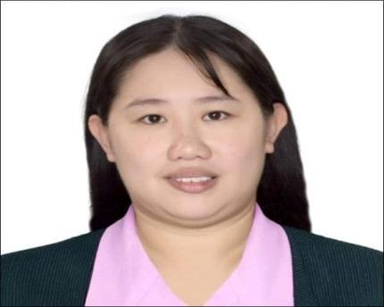
MARY JOY SINGCA DIZON
Registered Nurse in Philippines
105 Doce 36 St Barangay 156 East Bagong Barrio Caloocan City Philippines
09331915278
rhaivenluv@gmail.com
Dedicated and compassionate Registered Nurse (RN) with progressive career history in direct patient care, triage and care coordination in fast-paced environment. Proven ability to remain calm under pressure and skilfully handle difficult patients and high-stress situations. Consistently developing strong relationships with patients and families through empathetic communication, respectful attitude and excellent customer service.
Personal Information
Birth Date: March 18, 1989
Age: 34
Place of birth: Sampaloc Manila
Civil Status: Single
Gender: Female
Height: 5’4
Weight 75 kg
Religion: Roman Catholic
Citizenship: Filipino
Father Name: Ismael P. Dizon
Mother Name : Nelia B. Singca

SPECIAL SKILLS
Honest and Trustworthy
Multi-tasking and prioritizing
Taking & Recording Vital Signs Basic & Advance Life Support
More Positive Attitude

WORK EXPERIENCE

Quezon City General Hospital
Edsa seminary Road
Medical Ward Nurse (3 years and 6 months ) July 2020 up to Present
Medical Intensive Care Unit Nurse (3 years and 6 months) July 2020 up to present.
Covid Nurse: Covid ICU/ PUI ICU Nurse (3 years and 6 months) July 2020 up to present

Manila North Port Harbour Inc
Pier 16 Gate 3 Manila North Port Harbour Tondo Manila Philippines
Company Nurse Reliever: January 2021 up to Present 3 years

TV5 NETWORK INC
3F TV5 Media Center, Reliance cor Sheridan st brgy highway hills 1550 Mandaluyong City Philippines
TV5 Media Center,762 Quirino Highway Barangay San Bartolome Novaliches City, Philippines
Company Nurse Reliever: February 16 2024- Present

Private Duty Nurse Patient Name: Zenaida Cruz Nieto
17 Layang Layang St Mira nila Homes Pasong Tamo Quezon City

Private Duty Nurse Patient Name: Chay Luan Wee
28 Dancalan St Brgy Damar Village Quezon City

Private Duty Nurse Patient Name: Benito Ngo
458 Clavel St Binondo Manila

Private Duty Caregiver Patient Name: Vicente Chua
235 Speaker Perez St Brgy Maharlika Quezon City

CHARACTER REFERENCE

Aileen Flores PUI ICU head nurse. 09478933538

Arriane Sawil Nurse 1 09338114293

I hereby certify that the above information is true and correct to the best of my knowledge and Belief.

_______________________
Mary Joy S. Dizon RN

