MA SHERLY ALLYSA L. SARMIENTO
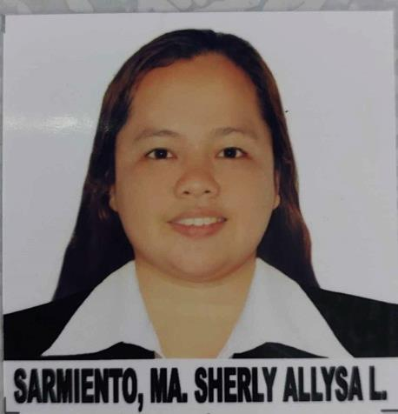

Attach Here
2x2
Colored Picture
Jw Diokno Street
Zone 7, Taal Batangas
Phone No. : 09367105360
Mobile No.: 09367105360
Email Add: msallysasarmiento@gmail.com

BASIC INFORMATION

Gender : Female
Date of Birth : April 14, 1994
Age : 29
Birth Place : Taal, Batangas
Marital Status : single
Citizenship : Filipino
Height : 5’1 ft.
Weight : 75 Kilos
Religion : Roman Catholic
Passport Number : P6900993A
Passport Expiry : 2028-04-28

WORK EXPERIENCE

Position : Butcher
Company : San Pablo Slaughterhouse - Annex
Address : San Pablo, Batangas City
Duration : July 20, 2019 - Present

Duties and Responsibilities
- I clean and sanitize my tools and working station before to proceed to slaughtering procedure to avoid any contamination.
- Cleaning the food animal prior to slaughter, then I put into the restrainer to limits its movement.
- To make the food animal unconscious I use electric stunner at 350 amperes in compliance with animal welfare act.
- I use proper tools and knives for the food animal and prepare for sticking process.
- Dehairing proper process in a scalding bath.
- After totally free from second dehairing then I proceed to the next procedure in the gambrelling table.
- Evisceration process begins at the pelvic region by removing internal organs according to the procedure.
- Dividing the carcass into two equal parts with the use of a circular splitting saw.
- Conduct a Trimming as the next procedure to the carcass and wash thoroughly with clean water.

Position : MEAT STORE VENDOR
Company : RUEL MEAT STALL
Address : Taal, Batangas
Duration : February 10, 2017 TO July 17, 2019

DUTIES AND RESPONSIBILITIES:
- Sharpen and adjust knives and cutting equipment
- Receive, inspect, and store meat upon delivery
- Cut, and grind pieces of meat
- Weigh, wrap, and display meat or meat products
- Cut or prepare meats to specification or customers’ orders
- Store meats in refrigerators or freezers at the required temperature
- Clean equipment and work areas to maintain health and sanitation standards

FAMILY DETAILS

Son’s Name : Ramos, Seb Martin Ellee S.
Birth Date : September 28, 2017
Highest Level of Education : Pre-school
Civil Status : Single

Daughter’s Name : Ramos, Ma. Sia Elleesse S.
Birth Date : December 08, 2021
Highest Level of Education : N/A
Civil Status : Single

EDUCATIONAL BACKGROUND

Elementary Year [From] – [To]

School: Our Lady of Caysasay Academy 2001 – 2007

Address: Taal, Batangas

Secondary

School: Our Lady of Caysasay Academy 2008 – 2012

Address: Taal, Batangas

SKILLS

- Ability to EXECUTE a task related to butchery and meat cutting.
- Knife / sharpening skills.
- Ability to communicate effectively with superiors, colleagues, and team is essential.
- Inter personal relation with the Coworkers, superior and clients with proper relationship and character.
- Excellent communication.

CHARACTER REFERENCES

LYDA S. MAÑALAC Admin Personel
San Pablo Slaughterhoouse, San Pablo, Batangas
Contact Number – 08981002903

Klen Aljohn Montenegro Butcher Meat cutter
San Pablo Slaughterhoouse, San Pablo, Batangas
Contact Number – 09662065296

_________________________
Applicant’s Signature

