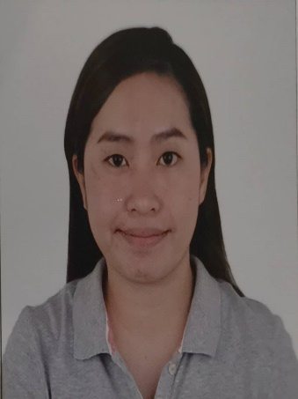
CURRICULUM VITAE
Picture white background

Name : Grecyl Mae Halasan Amparo
Phone : +639-165265168
E-Mail : grecylmaehalasan@gmail.com

PERSONAL DETAILS

Date of Birth : 27 April 1991
Nationality : Filipino
Gender : Female
Marital Status : Married
No. & Age of Children (if any) : NA
Religion : Roman Catholic
Height : 152 cm
Weight : 57 kg
BMI : 24.5
Permanent Address : Purok 1 Barangay Guinsularan Duero Bohol, 6309
Languages Known : English, Filipino

PASSPORT DETAILS

Passport No. : P2211897B
Place of Issue : DFA Cebu City
Date of Issue : 20 May 2019
Date of Expiry : 19 May 2029

EDUCATIONAL DETAILS

College/University Attended : Cebu Doctors’ University Hospital
Qualification : Bachelor of Science in Nursing
Graduation Date : 10 April 2011

REGISTRATION DETAILS

Registration Authority : Professional Regulation Commission
Registration No. : 0779087
Registration Date : 25 September 2012
Validity Date : 27 April 2024

EXPERIENCE SUMMARY

Name of Employer : Teodoro B. Galagar District Hospital
Bed Capacity : 75
Area of Exposure : Delivery Room/Operating Room
Position : Nurse
Duration : 1 August 2021 to present

Duties and Responsibilities

DELIVERY ROOM
- Sits with and monitors patient throughout (before/during/after) the labor
- Monitors contractions and helps patient with breathing techniques
- Performs basic IV and line skills
- Administers pain medication as ordered; administers other meds to address specific medical conditions such as hypertension and diabetes
- Takes and records patient’s vital signs, ascertains if problematic
- Reads fetal monitor & ascertains if there is a problem with baby’s heart rate
- Identifies & manages life-sustaining physiological functions in unstable patients
- Checks patient’s cervix periodically to monitor progression/lack of dilation
- Ensures patient’s bed is kept dry & clean; cleans up bodily fluids expelled before & after the birthing process
- Ensures patient is in proper position for delivery & all monitoring equipment is functioning properly
- Aids doctor with drapes, gloves, gowns, etc.; hands doctor delivery instruments as needed during birthing process
- Encourages patient to push at proper time(s)
- Records time of birth and Immediate care of newborn (clean, unang yakap, weigh, etc.)

OPERATING ROOM
- Assess patients prior to surgery (e.g. NPO status) and alleviate their concerns
- Gather all supplies needed for the operation
- Assume responsibility of keeping the operating room sterilized
- Position and prepare patient on operating table
- Pass medical instruments or other objects to the surgeon during operation
- Monitor patient’s vital signs to detect anomalies
- Evaluate patient in postoperative phases
- Adhere to safety standards and precautions
- Assume duties within or out of the sterile field as assigned
- Performs other related functions as maybe assigned.

Name of Employer : Cebu Doctors’ Hospital
Area of Exposure : Delivery Room/ Neonatal ICU
Position : Nurse
Duration : 3 March 2013 to 14 February 2020

Duties and Responsibilities
- Performs basic IV and line skills
- Administers pain medication as ordered; administers other meds to address specific medical conditions such as hypertension and diabetes
- Takes and records patient’s vital signs, ascertains if problematic
- Reads fetal monitor & ascertains if there is a problem with baby’s heart rate
- Identifies & manages life-sustaining physiological functions in unstable patients
- Ensures patient’s bed is kept dry & clean; cleans up bodily fluids expelled before & after the birthing process
- Ensures patient is in proper position for delivery & all monitoring equipment is functioning properly
- Aids doctor with drapes, gloves, gowns, etc.; hands doctor delivery instruments as needed during birthing process
- Records time of birth
- Monitor patients during postpartum care
- Initiate and assist in Breastfeeding
- Assist the NICU physicians in medical procedures and treatments
- Use and adjust specialized medical equipment
- Provide round the clock care to premature and severely ill newborn infants
- Care for the basic needs of infants like feeding, changing diapers and keeping them warm and dry
- Encourage and assist mother and or father in kangaroo care
- Formulate nursing plans and evaluate the effectiveness of treatments
- Comfort sick newborns and anxious parents and family members
- Offer support to parents and educate them on the at-home care of their newborn

REFERENCES
- Complete Name : Augustina Bayocot, RN
Designation : Operating and Delivery room supervisor
Employer : Teodoro B. Galagar District Hospital
Contact No : +639-128418840

- Complete Name : Maridel Tan, RN MAN
Designation : Chief Nurse
Employer : Teodoro B. Galagar District Hospital
Contact No : +639-253039648

