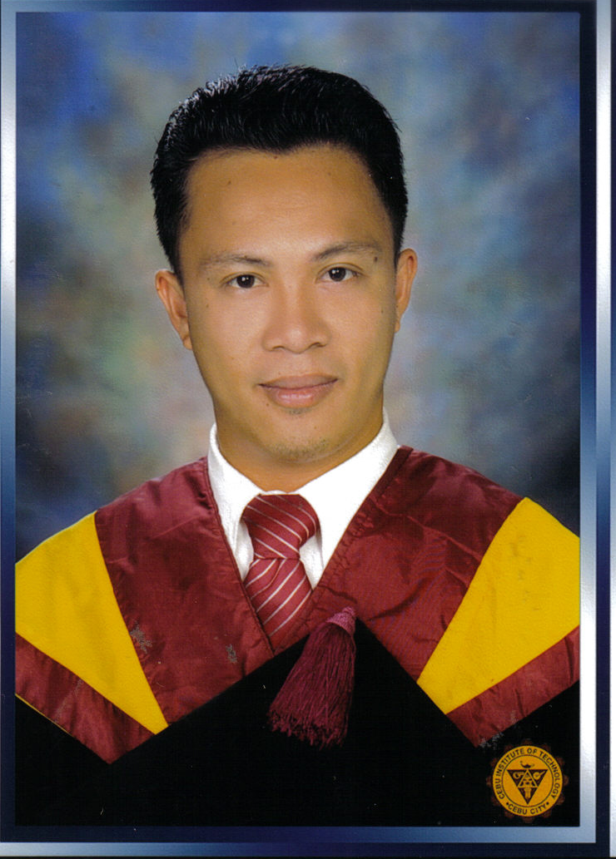
Bukid-bukid, Pajac, Lapu-lapu City
Cebu Philippines 6015
Tel. No.: (63) (32) 340-5447loc.1226
Mobile No. : +639194736901
Email : dennis_rustia@yahoo.com / dennis.rustia@teradyne.com

Rustia, Dennis Batanay

EMPLOYMENT HISTORY

1. Company Name : Teradyne Philippines Ltd.
Cebu Light Industrial Park, Basak, Lapu-lapu City, Cebu Philippines 6015
Position : Board Repair Specialist
Date Joined : 16 April 2007 to present

Job Description

- Previous repairs of A5XX boards (Teradyne System).
Precision Low Frequency option
High Frequency option

- Assign for product transfer from customer Analog Device for more than2 months from November 22, 2009 to January 31, 2010

- Assign for Onsite repair for Analog Device for almost 2 years February 2010 to December 2011.

- Member of CTS5400 System transfer from General Trias Cavite to MEPZ2 Cebu which enable customer to save $42K quarterly.

- Repair and troubleshooting of CTS5400 boards( Analog Device System), and do system repair.

- Assign/Support for Onsite repair for Analog Device in General Trias Cavite for three months last September 23, 2013 to December 29, 2013.
- Assign/Support for Onsite repair for Analog Device in General Trias Cavite for five months last July15, 2015 to December 29, 2015.
- Assign/Support for Onsite repair for Analog Device in General Trias Cavite for three months last December 17, 2017 to March 18, 2017.
- Assign/Support for Onsite repair for Analog Device in General Trias Cavite for three months last August 10, 2019 to November 9, 2019.
- Assign/Support for Onsite repair for Analog Device in General Trias Cavite for six months last May 28, 2021 to November 26, 2021. After COVID-19 Pandemic
- Assign/Support for Onsite repair for Analog Device in General Trias Cavite for three months last December 11, 2023 to March 9, 2024.

2. Company Name : Lexmark International (Philippines), Incorporated
Sinulog Drive, MEPZ II, Basak, Lapu-lapu City, Cebu Philippines 6015
Position : Equipment Technician I
Department : Equipment Engineering
Industry : IT/Manufacturing
Date Joined : 11 June 2001 to April 2007

Job Description

- Maintenance, troubleshooting, and repair of the following Lexmark Inkjet Printers:
- Lexmark 5700, 7000, Z51, Z52, Z53, Z45, Z815, Z816, Z33, Z35 Inkjet Printers
- Execjet IIc Inkjet Printer

- Modification and enhancement of the mechanisms as well as the control system of the Lexmark printers to extend its life for use in the functional testing of the Lexmark inkjet cartridges

- Install and test printer drivers for the functional testing operations (Lab Ex software)

- Perform troubleshooting, repair, maintenance, enhancement and development of the following industrial equipment and machineries:

- Camalot Dispenser 3800 (SpeedLine)
- Pinstamp Marker
- EFOS Ultra Cure
- Tab Attach Machine (ATS)
- Bosch Conveyor System
- ATS Dispenser Machine

- Provide daily production line support to manufacturing department.

- Monitor equipment performance and find solutions and remedies to avoid repeated breakdown.

- Equipment spare parts monitoring using Centralize Maintenance System (MP2 software).

- Trains a group of OJT students to equip them with the basic and advance maintenance systems engineering

Award/ Achievement
- Perfect Attendance Awardee

3. Company Name : Muramoto Audio-Visual Philippines Inc.
Position : Maintenance Technician
Industry : Manufacturing
Date Joined : June 1999 to June 2001

Job Description

- Provide support to production line
- Responsible for jig designing & making used in production
- Conduct total Preventive Maintenance of the machines

EDUCATIONAL BACKGROUND

Highest Education
Level : Bachelors Degree Graduate
Field of Study : Engineering
Major : Electronics Engineer
Name of Institution : Cebu Institute of Technology (www.cit.edu)
Graduation Date : May 2006

Second Highest Education
Level : Three- year Technology Graduate
Field of Study : Industrial Technology
Major : Electronics Technology
Name of Institution : CITE Technical Institute (www.cite.edu.ph)
Graduation Date : 26 May 1999

ACHIEVEMENTS/ AWARDS RECEIVED

- Graduated TOP 5 during secondary years
- Awarded Mathematician of the year (1995)
- CITE- Meralco Foundation Scholar (1996-1999)
- Lexmark Scholar (2001-2006)

SKILLS

- System design, installation and maintenance of pneumatics, sensorics, electro-pneumatics, and PLC’s
- Machine shop technology
- Microsoft Office Applications
- Lotus Notes 5.0, MP2, Internet
- Printer Repair and maintenance
- Microcontroller programming (PIC16f84A)
- Arduino Programming

SEMINARS/ TRAININGS

Inkjet Printer Technology Maintenance and Troubleshooting by Lexmark Engineering
- Vision System Training at Lexmark by Inspect personnel

PERSONAL PARTICULARS

Position Desired : Electronics Technician / Electronics Engineer
Provincial Address : Lapu-lapu City, Cebu Philippines 6015
Date of birth : 10 November 1978
Place of Birth : Cebu City
Citizenship : Filipino
Height : 5 ft 3 in
Weight : 140 lbs.
Religion : Roman Catholic
Sex : Male
Civil Status : Married
Name of Wife : Roselyn G. Rustia
Address : Pajac, Lapu-lapu City Cebu Philippines 6015
Father’s Name : Juan E. Rustia
Mother’s Name : Gloria B. Rustia
Parents Address : Purok Orchids, Opao, Mandaue City
Language : English, Tagalog, Cebuano
SSS Number :06-1801405-1
TIN :203-877-698

Person to be contacted in case of emergency :

Roselyn G. Rustia
Pajac, Lapu-lapu City, Cebu Philippines 6015
Tel. No. 09658911783

CHARACTER REFERENCES

Name : Janine Acosta-Martinez
Position : Sales Engineer
Company/Department : Teradyne Semi Sales - Philippines (092852)

Name : Ivan Paler
Telephone : 3405447
Position : Manager
Company : Teradyne Philippines Ltd.

Name : Vivencio Caringal Jr.
Telephone : 3405447
Position : Technical Manager
Company : Teradyne Philippines Ltd.

I hereby certify that the above information is true and correct to the best of my knowledge and belief.

Dennis B. Rustia
Applicant’s Signature

