Rhea Jade D. De Mesa
Teacher
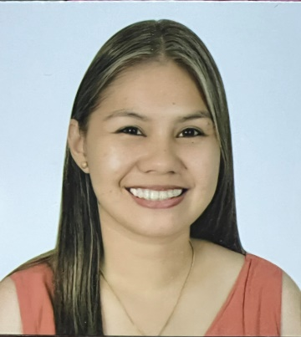
Passionate Teacher with experience developing and implementing diverse curriculums covering wide range of subjects. Highly skilled at motivating students through positive encouragement and reinforcement of concepts via interactive classroom instruction and observation. Successful in helping students develop strong literacy, numeracy, social and learning skills. Compassionate, creative and effective Teacher with valuable experience in classroom administration, professional development and project planning. Equipped with extensive background in versatile education environment. Competent at performing independently or as member of teaching team. Well-versed in classroom and online technologies.
Work History
_______________________________________________________________
2017-01- Teacher
Current Deparment Of Education, Sarangani Davao Occidental
- Mentored new teachers, sharing best practices and providing guidance to help them adapt to their new roles successfully.
- Developed and administered tests for students to measure academic proficiency and understanding.
Contact
___________
Address
Sarangani Davao Occidental, Phillipines 8015

Phone
09171525512

E-mail
rheajadedearce@gmail.com

Skills
_____________

Small Group Instruction
Student Engagement
Group Instruction
Classroom Instruction
- Incorporated exciting and engaging activities to achieve student participation and hands-on learning.
- Supported student physical, mental, and social development using classroom games and activities.
- Worked cooperatively with other teachers, administrators, and parents to help students reach learning objectives.
- Supported student teachers by mentoring on classroom management, lesson planning, and activity organization.
2014- 09- Kindergarten and Grade Two Teacher
2016- 03 University Of Immaculate Conception, Davao City
- Supports students in developing social skills through structured activities and positive reinforcement techniques.
- Developed and implemented classroom routines to address varying student needs.
- Shifted between formal and informal methods of teaching to keep students engaged.
- Helped students explore concepts with engaging, learning-focused activities.
2013- 05 - Enumerator
2013- 05 Deparment Of Social Welfare And Development, Davao City
- Travelled door-to-door in assigned communities and requested participation in census interview, clearly explaining process, and purpose.
- Coded data from participant interviews.
- Obtained updated contact information from all subjects and verified data for accuracy.
Education
_______________________________________________
2016- 06 - NCIII: Visual and Graphic Design
2016- 07 - Southern Mindanao Computer College- Digos City

2009-06- Bachelor Of Elementary Education: Generalist
2014- 03- University Of Immaculate Conception – Davao City

2019- 05- Master Of Education
2022- 03- East West Mindanao Colleges, Inc. – Kamasi, Ampatuan, Maguindanao

