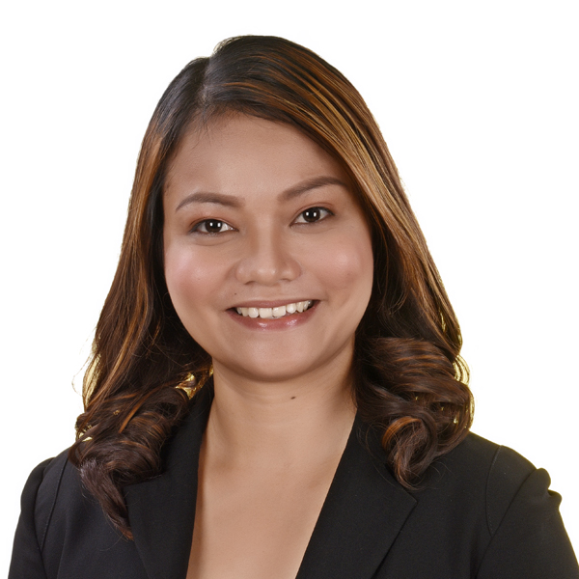 |  | Llanabelle O. laÑohan
Profile  Name : Llanabelle O. Lañohan  Age : 34  Birthdate : December 5, 1989  Birthplace : Sipalay City, Negros Occidental  Sex : Female  Civil Status : Single  Religion : Roman Catholic  Mother : Gemma Ortega  Lañohan  Father : Jose Done Lañohan  Address : BF Country Homes  Pajac, Lapu-Lapu City  Mobile number: 09291579671  E-mail Address: lanohanllanabelle@gmail.com |  | EDUCATION  Graduate School  2017 - ongoing  Cebu Technological University  Main Campus, R. Palma St. Cebu City  Doctor in Development Education  Yoga Alliance  2021  Mindful Yoga Cebu School  Cebu Yacht Club, Mactan  Certified Aerial Yoga Teacher  Yoga Alliance  2018  Mindful Yoga Cebu School  Cebu Yacht Club, Mactan  Certified Vinyasa Yoga Teacher  Graduate School  2011 - 2016  Cebu Technological University  Main Campus, R. Palma St. Cebu City  Master of Arts in Education Major in English Teaching  Tertiary  2006-2011  University of Cebu-Lapulapu and Mandaue  A.C. Cortes Ave. Looc Mandaue City  Bachelor of Secondary Education Major in English  Secondary  2002-2006  Cabarrus Catholic College  Brgy. San Jose, Sipalay City, Negros Occidental  Elementary  1996-2002  Binulig Elementary School  Brgy. San Jose, Sipalay City, Negros Occidental

EXPERIENCE:
Chilworks Learning Center  (Pre-School, Elementary & High School)  -Basic Education Teacher | -manages day to day classroom activities, including structured lessons, free play, bathroom breaks, lunch time and rest time, and assist them in their other personal care  - creates activities that are fun and educational for children  -develops and maintain a constructive and ongoing rapport with the children and parents | November 2010 – May 2013
University of Cebu Lapu-Lapu and Mandaue (College of Teacher Education & Gen. Ed)  -College Instructor | - Prepares/updates/ submits Syllabi  - Conducts classes (giving lectures on professional subjects for College of Teacher education, BEED, including Childhood and Adolescent Development, Facilitating Learning, Curriculum Development, Field Study, and Special Topics; and major subjects such as Children’s Literature, Language, and Speech Communication )  - Prepares and submits test  questions and Table of  Specifications (TOS) or alternative  assessment activities  - Involvement in Productivity Enhancement Program (Research and Community Extension) | June 2013- 2017
Cebu Technological University, Daanbantayan campus Tabogon Extension  -College Instructor in  College of Teacher Education  (2017-2023)  -Library Designate  (2021-2023)  -Chairman for Instruction  (2022-2023)  -Director of Campus Journalism  (2021-2023) | -Prepares/updates/ submits Syllabi  - Conduct of classes (giving lectures on professional subjects for College of Teacher education, BEED, including Childhood and Adolescent Development, Facilitating Learning, Curriculum Development, Field Study, and Special Topics; and major subjects such as Children’s Literature, Language, and Speech Communication)  - Prepares and submits test  questions and Table of  Specifications (TOS) or alternative  assessment activities  - Involvement in Productivity Enhancement Program (Research and Community Extension)  -performs regular audits of information and inventory on file  - oversees the check-out process of books and other resource materials  -clarifies the use of library amenities ad provides information about library policies  -Serves as a curriculum leader by assisting in the  review of lesson plans, and in the development of  curriculum, goals and philosophies.  - Coordinates departmental duties including preparation  of reports, agendas, minutes and surveys.  - Serves as a communications liaison between the  teachers of the department, the campus director, and other  school groups.  -produces research proposal for Center for publication  -monitors the social media platforms used by the campus  -Coordinates with the campus journalism directors in the external campuses  -Promotes the Cebu Technological University through various social media platforms | 2017- 2023
Cebu Technological University-Main Campus  -College Instructor, College of Arts and Sciences  (2023-present)  - Designated Executive Assistant of the Office of the University President  (August 2023- January 2024) | -Prepares/updates/ submits Syllabi  - Conducts classes (giving lectures on GEC-Purposive Communication, GEE-Functional English, Research subject in Literature, Language of Non-literary Texts  -Handles Student teaching/Practicum, BAEL-English Language Studies  -Applies technical competencies  -Works closely and effectively with the University President to keep him well informed of the upcoming commitments and responsibilities.  -Maintains confidence and protects operations of the office by keeping information confidential when University President instructs  -Undertakes other related duties and projects that maybe assigned from time to time | 2023-present

Certificates and Seminars”

Participation during the PAFTE VII Regional Assembly with the theme, “Enhancing the Future of Education through AI-Enabled Instructional Innovations”
Venue: Metrocentre Hotel, Tagbilaran City, Bohol
Date: April 12-13, 2024

Conducting a talk on “Mindfulness”
Venue: KYOCERA Document Solutions Development Philippines, Inc.
Date: December 14, 2023

Participation in the Seminar on “Breaking the Silence on Pre-Menstrual Dysphoric Disorder (PMDD): A Seminar for Women”, The Husband’s Guide to Supporting His Wife with PMDD” and “Nutrition and Therapeutic Movement for Midlife”
Venue: Hagnaya Beach Resort, Hagnaya, San Remegio, Cebu
Date: May 26-27, 2023

Service rendered as Resource Person during Post Women’s Month Celebration Seminar on Relaxation and Breathing Techniques for Faculty and Staff
Venue: Cebu Technological University, Bantayan Extension
Date: May 3, 2023

Participation during the PAFTE VII Regional Assembly with the theme, “Instructional and Research Transition Toward Education for Sustainable Development”
Venue: CebuTech Gymnatorium, Cebu Technological University-Main Campus
Date: April 13-14, 2023

Participation during the Seminar-Workshop on Research Publication and Proposal Writing
Venue: Harolds Evotel Cebu, Kamputhaw, Cebu City
Date: March 14-17, 2023

Participation in the Seminar on “Engendering Gender Equality in the Workplace”
Venue: Hagnaya Beach Resort, Hagnaya, San Remegio, Cebu
Date: December 16, 2022

Resource Person on the session “Tools to Prevent Alzheimer’s Disease during the conduct of One-Day Alzheimer’s Awareness for Senior Citizen Personnel of Schools Division Office”
Venue: Mardale Hotel Convention Center, Pagadian City
Date: September 30, 2022

Resource Person on the session: Relaxation and Breathing Techniques/Mindfulness, during the conduct of One-Day Capacity Building on Mental Health Program for Guidance Advocates/Mental Health Coordinators
Venue: Hotel Guillermo, Pagadian City
Date: September 29, 2022

AFFILIATIONS:

PAFTE member
Certified Yoga Instructor (under Yoga Alliance)

REFERENCES:

Dr. Geraldine Olmillo Education Program Specialist
09206985196
gedvinne@gmail.com

Mr. Mikhail Ybanez
ybanezmikhail@gmail.com

