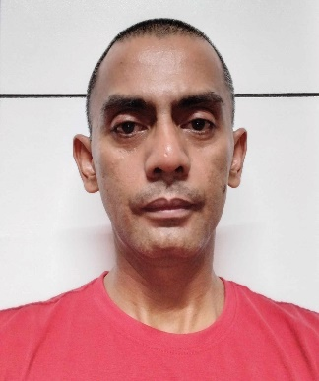
Christopher Mark B. Manubay
Purok04
Villa Ceferina, Sinsayon, Santiago City
09171649855
manubaychristophermark@gmail.com

OBJECTIVE:

Any position that commensurate in my application

HIGHLIGHTS OF QUALIFICATIONS:

. Dependable and determined. I can work long hours.
. I have extreme patience that you can rely on and full of strength.

SKILLS:

Goal Oriented
Team Player

WORK HISTORY:

- Merchandiser

Grupo Marilen Incorporated
Mabini, Santiago City
May 2001-December 2002

Duties and Responsibilities:

- As merchandiser

- Sales Representative

Santiago City Public Market
Santiago City
March, 2003-November, 2007

Duties and Responsibilities:

- As Sales Representative.

- Police Officer I
Tuguegarao City
Police Regional Office
June, 2008-July, 2010

- As Police Officer I

- Police Officer I
Santiago City
Police Office
August, 2010-May, 2016

- As Police Officer I

- Police Officer II
Santiago City
Police Office
June, 2016-February, 2019

- As Police Officer II

- Police Staff Sargeant
Santiago City
Police Office
March, 2019-up to present

EDUCATIONAL BACKGROUND:

College – University of La Salette, Santiago City
Bachelor of Science and Criminology
June, 1997- March, 2001

High School – University of La Salette, Santiago City
June, 1993 – March, 1997

Elementary – La Salette Elementary School, Santiago City
June, 1987 – March, 1993

TRAININGS:

Philippine National Police Scout
Human Rights and Gender Development
Seminar on Anti-illegal Operations and Investigation
Public Safety and Junior Leadership Course

REFERENCES:
- Rex Pascua- Administrative Officer, Santiago City Police Office
- Sherman Miguel- Santiago City Counselor
- Ponciano Pablo- Businessman

CHRISTOPHER MARK B. MANUBAY

Applicant

RESUME

RESUME

RESUME

RESUME

