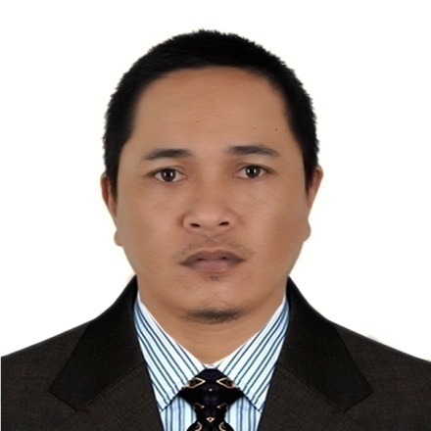
RICHARD B. MAJORENOS
Position Applied: ELECTRICAL TECHNICIAN
# 23H D Cruz St. Brgy. Rosario, Pasig City, Philippines
+966559460789/+639108528524
Email add: (majorenosrichard1976@gmailcom)

CAREER OBJECTIVE:
- To work in a dynamic company and help promote its mission, vision and objective to the full of my potential.

WORKING EXPERIENCE:

Company: AL- BABTAIN CONTRCTING COMPANY
Address: Al-malaz Riyadh, Saudi Arabia
Position: Electrical Technician
HV Cable Jointer& Termination
Inclusive Dates: November 2014 - Present

Duties and Responsibilities:

* My duties and responsibility in working as electrician must wear PPE first in all time and all places based to the safety rules

* We also prepare exact drawing plan before start working

* Preparation of all kind of tools and materials needed,

* Base with my experience I will do my best to work hard in your good company

* We need to work to all places or surrounding must be clean with safety before start working and always keep housekeeping before and after working….

* Safety begins me….

JOB DESCRIPTION:

* Lay out,
* Installation of different kind of Conduit pipe, switches, outlet, lighting fixture, etc..
* Installation of different kind of panel, Breakers, Motors, VFD, VSD
* Erection of Switchgear panel, MCC panel, LCC panel, Transformer
* Cable tray, Cable Ladder, Installation
* Cable pulling, Wiring
* Loop checking/testing

Company: ELECTRICAL EQUIPMENT AND SYSTEM INTEGRATION (EESI)
Address: West Avenue, Quezon City
Position: Electrical Technician
Inclusive Dates: July 2008 – November 2014
JOB DESCRIPTION:

- Lay-out of PLC Panel and others
- Wiring and termination of PLC Panel and MCC Panel
- Wiring and termination of VFD, Soft starter, motorized valve and other instrument
- Loop checking and troubleshooting
- Testing and commissioning

Company: A.M. TOMULVA CONSTRUCTION AND DEVT. CORPORATION
Address: Iligan Cement Corporation – (Lafarge, Iligan City)
Position: Industrial Electrician
Inclusive Dates: January 2007 – February 2008

JOB DESCRIPTION:

- Lay-out of panel
- Installation of different kinds of control panel
- Piping installation
- Cable tray installation and cable pulling
- Termination of different kinds of motor
- Testing / Loop checking

Company: RC BARRETO GENERAL SERVICES INCORPORATED
Address: Iligan Cement Corporation – (Lafarge, Iligan City)
Position: Industrial Electrician
Inclusive Dates: July - December 2006

JOB DESCRIPTION:

- Lay-out of different kinds of control panel
- Cable tray installation
- Cable pulling and termination
- Troubleshooting
- Testing / Loop checking

EDUCATIONAL ATTAINMENT:

Tertiary: Maigo School of Arts and Trades (MSAT)
Course: Electrical Technology
1994 – 1995

Secondary: Maigo School of Arts and Trades (MSAT)
1988 – 1992

Primary: Maigo Elementary Central School (MECS)
1987 – 1988

TRAININGS / SEMINARS ATTENDED:

- Construction Safety Training – LAFARGE (Iligan City)
December 27-28, 2007
- World Safety Organization – WSO (Teresa, Rizal)
March 3, 2011
- Electrical Installation and Maintenance NC II – TESDA (Cainta, Rizal)
August 2011
- Safety Olympic of the Philippines, Inc. – SOPI (Don Bosco, Kalentong, Mandaluyong City)
April 14, 2012
- Instrumentation and Control Servicing NC II – TESDA (ISTTI)
September 2- October 5, 2013
. HV Cable jointer & Termination (132 KV 1200mm/2000mm XLPE) – Taihan, Korea
November 01 – 30, 2016
. Scaffolding Erector at (ABC Head Office Training Room)
October 10 – 11, 2020
. HV Cable Jointer & Termination (132 KV1200mm/2000mmXLPA) – LS Company, Korea
November 5, 2023 – November 15, 2023

PERSONAL INFORMATION:

Birth date: January 22, 1976
Age: 48 yrs. old
Height: 5’4”
Weight: 75kls.
Civil Status: Single
Religion: Roman Catholic

CHARACTER REFERENCES:

Mr. Robert Tapic
Electrical Foreman
Al Babtain Contracting Company, KSA

Mr. Ricky Carpio
Supervisor
Electrical Equipment and System Integration (EESI) Q.C

Mr. Salvador Morado
Electrician
Extrastaff LTD, New Zealand

Mr. Wilson Bartilit
Electrician
Extrastaff LTD, New Zealand

Richard B Majorenos
Applicant

