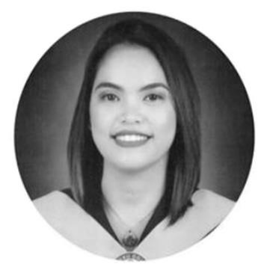 |  | KEZIAH P. ENDRIGA  WORK EXPERIENCES  MCDONALD - DIGOS  Promoted to Marketing Manager (Guest Experience Manager)  August 2022 until present  - Plan and execute sales building activities  - Take charge of Quality, Service, and Cleanliness assurance within the restaurant operations  - Supervise store operations, cash control, and shift management  - Manage a high-performance team and develop their talents  - Drive recruitment, training, and marketing campaigns  MCDONALD - DIGOS  Service Crew  March-August 2021  - A Guest Experience Leader  - Belong to the marketing department of the store  - Giving store initiatives to have more sales  - Handling customer’s request, suggestions and complaints  - Taking accurate orders  - Detail oriented  Fabian’s Catering Services – 01/2013 to 03/2015  - Responsible for providing courteous and efficient food and beverage to the guest  - Attend guest’ needs promptly and professionally  - Prepares services wares and restores them accordingly  Trainee at Seda Abreeza Hotel- 11/2018 to 02/2019  - Present menu, take orders and suggest dishes  - Experience dealing with customers and their general enquiries, personal and telephone  - Work cooperatively with others to ensure job accomplished Service  SEMINARS ATTENDED  - BASIC PEOPLE LEARNING PROGRAM VERIFICATION  - FOOD SAFETY CLASS  REFERENCES  Concepcion Lonzaga  Account Receivable Clerk, REACT – Humboldt, SK  (+1) 639.535.0431  Jennifer M. Caballes  HR Coordinator, JBS Food Canada ULC  4039528195  Cleofe Crispino  Proprietor, Fabian’s Catering Services, Philippines (+63) 933.826.3371  cleofecrispino@fabianscatering.com  CARMELO LLENA  Restaurant Manager at McDonald’s Digos Highway  +63 948 861 3972
I have 5+ years' experience in food industries including the well-known food chain of the works-McDonald’s. As I work in this industry, many skills have sprouted, learned and enhanced especially in editing videos, invitations, posting on social media for marketing purposes. Creating presentations as assigned. Accommodating customer and provide them the good service. Giving their expectations to the highest level.
CONTACT
PHONE:
+63 995 205 2123
ADDRESS:
0416 Biak na bato St. Barangay Zone III Digos City Philippines
EMAIL: keziahpendriga@gmail.com
SKILLS
- Decision making Skills
- Organizational Skills
- Customer Service Skills
- Communication Skills
- Interpersonal Skills
- Event Set-up
- People Smart
- Basic Photoshop Video Editing
- Researching and Marketing skills
- Product and Content Uploading
EDUCATIONAL ATTAINMENT
Bachelor of Science in Hotel and
Restaurant Management
Cor Jesu College, Digos City 2019

