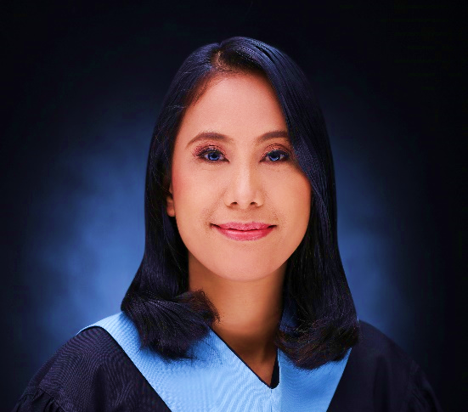

HEATHER M. SIKAT

09654696489 ™

heathersikat42889@gmail.com

Block 12 Lot 37 Shekel St. Westbay Homes Daang Bukid Bacoor Cavite

JOB OBJECTIVES:

- Creative and resourceful teacher with knowledgeable experience in handling children with special needs and striving to enhance child's educational performance and looking for a position as a Special Education/Regular teacher to use my strong passion for teaching. With my skills and experience, which will enable me to make a significant difference at your school, I want to share the best in me as a teacher and learn new things from the people I work with.

PERSONAL INFO:

Birthday: 28th of April 1989
Gender: Female
Age: 35 years old
Citizenship: Filipino
Religion: Roman Catholic
Father’s Name: Benjamin M. Sikat
Occupation: House Husband
Mother’s Name: Belen M. Sikat
Occupation: Housewife
Brother’s/Sister’s Name: 1. Jacqueline S. Dela Cruz
2. Justine M. Sikat

SKILLS:

- Proficient with the use of Microsoft Office
- Critical Thinking
- Classroom Management
- With expertise in lesson planning and creating teaching modules

EDUCATIONAL ATTAINMENT:

Program | Name of School | Location | Yr. Completed
Elementary | Vergonville Elementary School | Las Piñas City, Metro Manila | (1995-2002)
Secondary | Las Piñas North National High School | Las Piñas City, Metro Manila | (2002-2007)
Vocational | Las Piñas City Manpower Training Center (TESDA) | Padre Diego Cera Ave., Pulanglupa 1 Las Piñas City | (October-December 2007)
Tertiary | University of Perpetual Help System DALTA- Las Piñas | Alabang-Zapote Rd., Las Piñas, City, 1740 Metro Manila | (2014-2019)

SEMINARS ATTENDED:

- Seminar Workshop "Interactive and Innovative Teaching Strategies"
University of Perpetual Help System DALTA Las Piñas Campus, Ernesto Palanca Crisostomo Hall
July 30, 2016

- “Enhancing the Teacher’s Knowledge on the Entry and Exit of Special Education”
University of Perpetual Help System DALTA Las Piñas Campus
September 19, 2017

- Assistance Volunteer "Special Olympics Philippines NCR-South Friendship Games Our Lady of Pilar Montessori Center Campus
March 03, 2018
- Student Enrichment Seminar "Applied Behavior Analysis: A Behavioural Program in Special Education"
University of Perpetual Help System DALTA Las Piñas Campus, Ernesto Palanca Crisostomo Hall
August 02, 2018

- Enrichment Seminar "Competency Framework for Southeast Asian Teachers"
University of Perpetual Help System DALTA Las Piñas Campus, Ernesto Palanca Crisostomo Hall
September 21, 2018

- Enrichment Seminar "Preparing 21st Century Teacher in Inclusion Model"
University of Perpetual Help System DALTA Las Piñas Campus, Ernesto Palanca Crisostomo Hall
October 22, 2018

- A Creeping Disaster: Distorded History Trends in Philippines Social Media
St. Jude Parish School, San Agustin, Gov. Drive, Trece Martires City, Cavite
February 26, 2022

- The DICES Adaptive Design for Learning (ADL) Program
St. Jude Parish School, San Agustin, Gov. Drive, Trece Martires City, Cavite
April 4 – June 4, 2022

- Learning Recovery to Learning Resilience in the Classrooms through Effective Teaching Strategies for Grade School M.A.P.E.H
Theresian School of Cavite
March 25, 2023

MY AWARDS/ACHIEVEMENTS:

- Assistance as Volunteer "Exceptional Sports Pilot Event"
Our Lady of Pliar Montessori Center Campus
September 29, 2018

- Awarded as Elected Public Relation Officer of Third Year-Section C presented during the “General Assembly and Presentation of Officers 2017”
University of Perpetual Help System DALTA Las Piñas Campus, Ernesto Palanca Crisostomo Hall
August 3, 2017
- Awarded for being one of the Most Active Participants in Extra-curricular Activities and External Affairs during the 2nd Semester 2018-2019 University of Perpetual Help System DALTA Las Piñas Campus, CIHM Lobby April 21, 2019

EXPERIENCES:

- Attended various seminars and trainings for education students.

- 1 year of Teaching at Augustinian Abbey School, Inc.
Gov. Licaros cor. Sekiat Sts. B.F., Resort Village, Las Piñas City
Grade 4 Adviser
(Departmentalized Teaching in Science and Computer Subject – Grade 1, 2, 3 & 4)

- 2 years of Teaching at St. Michael’s Institute of Bacoor, Inc.
Gen. Evangelista St., Tabing Dagat, Poblacion, Bacoor City, Cavite
Grade 3 and Kinder Adviser
(Departmentalized Teaching in MTB-MLE and MAPEH – Grade 1, 2 & 3)
September 1, 2021 – June 30, 2023

- J.K Tutorial Services
(February 10, 2021 – June 12, 2021)
C5 Quirino Hi-way, Quezon City

- Private Tutor with Elementary Students in Las Piñas City
(June 2019 – March 2020)

- Food and Beverage Services Training
(October-December 2007)
Florlina Dela Cruz Cor., Ma. Conception Roa St., BFRV, Talon Dos, Las Piñas City

SKILLS:

- Proficient with the use of Microsoft Office
- Critical Thinking
- Classroom Management
- With expertise in lesson planning and creating teaching modules

CHARACTER REFERENCES:

Patricia Samantha F. Ignacio
Coordinator, Office for Curriculum and Instruction – Elementary of St. Michael’s Institute of Bacoor, Inc.
Gen. Evangelista St., Tabing Dagat, Poblacion, Bacoor City, Cavite
09454179564

Ramina Pastrana Adviento
Secretary - Elementary Department
University of Perpetual Help System DALTA-Las Piñas Campus
09158142403

Benjamin C. Siy Jr., MA Ed., PhD
Professor SPED Coordinator Faculty
University of Perpetual Help System DALTA-Las Piñas Campus
09228596578

