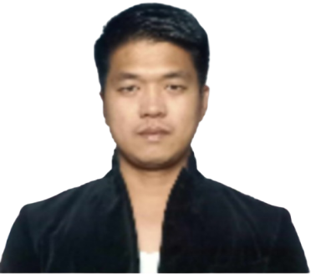

RANIER ROCAMORA YU
Phone: 09626780798/09946520538
Email: ranieryu17@gmail.com
Address: 060 J. P Rizal St. Tarcan, Baliwag, Bulacan

CAREER OBJECTIVE
To abilities, education and potential can be most productive utilized toward the achievement of both .To look for a growth-oriented career position where a company and personal goals.

PERSONAL INFORMATION
Age : 39 years old
Gender : Male
Birthday : February 09, 1985
Civil Status : Married
Height : 5'7"
Citizenship : Filipino
Place of Birth : Metro Manila
Religion : Iglesia Ni Cristo (INC)

EDUCATIONAL BACKGROUND

Bachelor of Science in Criminology (2003-2005)
City College of Manila
Escolta Sta.Cruz Manila
2003-2005 3RD year

Lakandula High School
Juan Luna corner Cavite Street Tondo Manila
1998-2001

Lakandula Elementary School
Solis Street Gagalangin Tondo Manila
1992-1998

WORK EXPERIENCE
Driver GRAB PHILIPPINES
October 2023 - Present
• Drive company vehicles to pick or drop employees
• Deliver important documents and parcels to required destinations
• Ensure that all deliveries have been signed and delivered to the correct recipient
• Keep vehicle clean and maintained at all times
• Perform preventative and regular maintenance on vehicle
Scaffolding ASUKA KOGYO CO., Ltd.
Hiroshima-Ken Fukuyama-shi (Japan)
April 4, 2022-Sept 2023
Truck Driver RJYU TRUCKING SERVICES
Navotas City
July 2019 - March 2022
Scaffolding ASUKA KOGYO CO., Ltd.
Hiroshima-Ken Fukuyama-shi (Japan)

June 2016- June 2019
- Erect and dismantle temporary metal scaffolding on structures and building sites
- Set up scaffolding around a structure, or inside a building undergoing construction.
DRIVER MANILA CITY HALL

Department of Engineering and Public Work
September 2012 - June 2016
- Loader Operator
- Truck Driver
- Dump Truck Driver
GENERAL JOSE ABAD SANTOS HOSPITAL
- AMBULANCE DRIVER
- FIRST AID STAFF

CHARACTER REFERENCE

Ely Sadiasa
706 Townsite Road Nanaimo Britist Columba Canada
V9S1L5

Karla -Gwn Garay Retanan
Unit 702 399 32nd St. West Prince Albert SK S6V6S1
30693000206

Randy Ranario
6-8-22 Nishifukatsu-cho, Fukuyama City Shima Prefecture

---------------------
RANIER ROCAMORA YU Applicant

