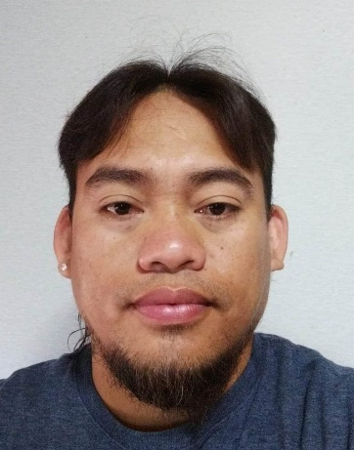
RESUME
Name : Lemwel Lape Batomalaque
Address : Centro Arpili, Balamban, Cebu
Contact No : 0995-773-3369
Email Add : lemuelbigstone14@gmail.com

Position Applied: FCAW/SMAW WELDER

Birth Date : April 14, 1984
Birth Place : Balamban Cebu
Age : 39
Gender : Male
Civil Status : Married
Religion : Roman Catholic
Height : 5’6
Weight : 75kl

Educational Background
LEVEL | NAME OF SCHOOL | PERIOD OF ATTENDANCE | HIGHEST LEVEL/ COURSE
COLLEGE | CEBU INSTITUTE OF TECHNOLOGY | 2001-2007 | UNDERGRAD/BACHELOR OF SCIENCE IN INDUSTRIAL ENGINEERING
HIGH SCHOOL | ST. FRANCIS ACADEMY | 1997-2001 | GRADUATED
ELEMENTARY | PONDOL ELEMENTARY SCHOOL | 1992-1997 | GRADUATED

Employment Background
- Company : TSUNEISHI HEAVY INDUSTRIES
Contractor : RMD DIAMOND SERVICES
Address : BUANOY, BALAMBAN, CEBU
Position : WELDER FCAW
Department :Hull Fabrication
Date :September 9, 2011 – May 14, 2014 (full time)
Duties and Responsibilities
- Install formwork components
- Weld and repair welding defects.
- Weld and shell plate double bottom
- Weld butt joint on blocks
- Weld lifting eye for an equivalent ton of blocks
- Weld carbon steel plate
- Perform grinding
- Abide with company safety rules and regulation
- Can weld plate with thickness of 5mm to 50mm

Welding process and positions can perform
- Smaw 1F-4F
- Fcaw 1F-4F/1G-4G

- Company : I-S SHIPYARD Co.LTD
Contractor : SAWAMURA KOGYO
Project : Bulk Carrier, Passenger and Cargo vessel
Address : Imabari Shi, Ehime, Japan
Position : Pipe/Plate Welder (FCAW/SMAW) Date : August 1, 2018 - October 17, 2023 (full time)
Duties and Responsibilities
- Repair and Grinding welding defects
- Weld flanged pipe using (fcaw/smaw)
- Weld ballast pipe in double bottom using(fcaw/smaw)
- Weld galvanized pipe using (fcaw/smaw)
- Weld stainless steel pipe using (fcaw/smaw)
- Weld carbon steel pipe
- Weld fillet joint on blocks
- Perform proper welding procedure to ensure good quality outcome
- Weld ship ladders and doors
- Weld ship railings and ladder protector
Welding process and positions perform
- Smaw 1G-6G
- Fcaw 1G-6G/1F-4F
Training/ Achievements/ Certificate
- TESDA Smaw(NC2)
- Japanese Language (300 hrs) Fast Inc.
- 2 hours seminar on Training Block Orientation (simulation based safety training)
- JWES (Japan welding engineering society)

Character References:
Bernardo Caparoso Piamonte
Welder
Pert Australia
0966-451-7458
Dale Andrew Copas
Fitter
Ehime Ken Imabari City Japan
080-2989-4565

