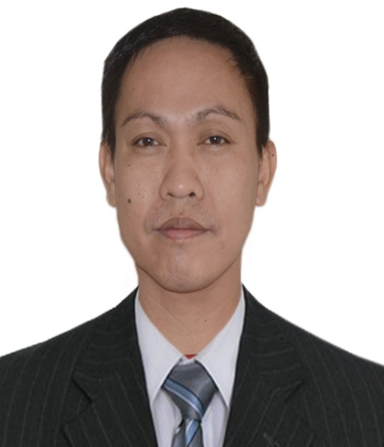
WINSTON BARROGA LEAL
SECONDARY SCIENCE TEACHER
PROFESSIONAL QUALIFICATION
PASSER / LICENSURE EXAMINATION FOR TEACHERS 2012 (NO. 1135811)
CONTACT INFORMATION:
Address: 10100 Baymeadows Rd Apt# 0617 Jacksonville, Florida 32256
Email Address: winstonleal0205@gmail.com
Contact Number: +19045815597
Skype Name: Winston Leal
Religion: Born Again Christian

INTRODUCTION
My primary role as a classroom teacher is to deliver classroom instruction that helps students learn using differentiated instruction in the teaching-learning process. To accomplish this, I will must prepare effective lessons, grade student work and offer feedback, manage classroom materials, productively navigate the curriculum, and collaborate with other staff. And, it is my responsibility to maintain a positive learning environment in the classroom, develop positive student interaction and take immediate action when problems arise.

AREAS OF EXPERTISE
*Profound knowledge in the field of General/Physical Sciences and Research.
*Proficiency in handling computer aided tools/instructions.
*Observe high standard of personal and professional work ethics.

WORK EXPERIENCES
Lake Shore Middle School, Jacksonville, Florida, USA 32210
Email: lealW@duvalschools.org
Science Teacher, teaching Science, 8th Grade Students

*North Luzon Philippines State College / May 2017 – Present
Email: nlpsc_candon@yahoo.com
Science Teacher, teaching Chemistry and Physics
-BEED 2 (Maj 7 Teaching Science in Elementary Grade) Instructor
-BSE 1 (Analytical Chemistry) Instructor
-BS Midwifery (Research) Instructor
-BS Criminology (Forensic Chemistry and Toxicology) Instructor
Chairman, Research Ethics Committee (REC)
*North Luzon Philippines State College / January 2020 – Present
-Developed guidelines for the establishment and management of RECs and standardization of research ethics review.

*Coordinator, Research and Extension, College of Teacher Education Department / August 2018 – December 2019
- Coordinated the day-to-day activities of any technical support staff specifically engaged in the carrying out of research/clinical protocol, as appropriate to the position required in accordance with specified program objectives.

SCIENCE TEACHER
Ambalayat Integrated School / June 2013 – March 2016
-Grade 9 and 10 Science Teacher teaching Biology, Physics, Chemistry and Earth Science topics under the K to 12 Curriculums
-Grade 7 TLE and Araling Panlipunan Teacher
-Grade 11 Contemporary Arts Teacher
-Coordinator YES-O and Science Club Adviser
-Facilitated Achievers classes in Grade 9 and 10; a program exclusively offered to the top performing students in Science.
-Trained students for an academic competition in Science.
-Helped students in the completion of their investigative researches /investigatory projects.

Christ’s Servants Academy of Tagudin, Inc. / June 2011 - March 2013
-Grade 1 Classroom Teacher, teaching all subjects implemented by the Department of Education on K to 12 Basic Education Curriculum.

SEMINARS ATTENDED
Lecture-Workshop on Fundamentals of Biosafety and Biosecurity / September 18-20, 2019

Good Research Practice Training / August 7-8, 2019

National Seminar -Workshop on Mathematics and Science Education in the K to 12 Curriculum / August 25-27, 2017

Regional Mass Training of Grade 9 & 10 Teachers of the K to 12 Basic Education Curriculum (Science) / May 20-25, 2015
ACADEMIC HISTORY
Don Mariano Marcos Memorial State University- Mid La Union Campus
Doctor of Philosophy in Science Education (Ph.D) May 2016 – January 2020
Wrote a Dissertation on: Hypolipidemic Effects of Antidesma bunius L. (Bignay) and Averrhoa bilimbi L. (Kamias) on Hyperlipidemic Rats
Don Mariano Marcos Memorial State University- Mid La Union Campus
Master of Arts in Science Education (MASE) June 2012 – May 2016
Wrote a Thesis on: Antibacterial Activity of Acacia (Samanea saman Linn.) Bark and Leaves Extracts against Escherichia coli and Bacillus cereus
Ilocos Sur Polytechnic State College – Tagudin, Ilocos Sur
Bachelor in Secondary Education
Major: General Science / June 1998 – March 2002

Character References:

1. AILEEN A. GALANG, MAEd
Program Head, BEED
Contact No.: +639063039662
Email: aileenabayag@gmail.com

2. RUBY A. GABOR, MAED
Instructor, College of Teacher Education
Contact No.: +639368615033
Email: ruby.gabor@nlpsc.edu.ph

3. MARIBEL M. GAGTO, Ph.D.
Director, Quality Assurance and Accreditation
Contact No.: +639175012231
Email: maribelgagto@yahoo.com.ph

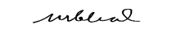
WINSTON BARROGA LEAL
Applicant

