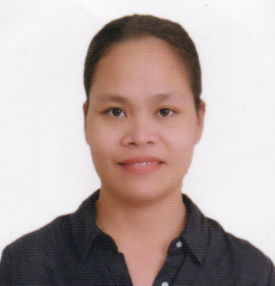
CATHERINE JEAN A. BARBON-LUCERO, RN
PUROK PAGASA BARANGAY LIBAS, TANTANGAN, SOUTH COTABATO, PHILIPPINES
PRC LICENSE: 0535502
+639660680560
cjblucero1987@gmail.com

QUALIFICATION SUMMARY
- Able to work harmoniously with a group/team
- Dedicated and passionate with work
- Willing to learn new things
- Open to criticism and improvement
- With good moral character
- Good computer skills(Microsoft power point, microsoft word, microsoft excel)
- Good english communication

EMPLOYMENT HISTORY

Cardiac/Medical Sonographer April 2019 up to present
Dr. Arturo P. Pingoy Medical Center
Gensan Drive Brgy. Zone IV Koronadal South
Cotabato, Philippines, 9506
Contact number: (083)228-2202 loc. 219

Cardiac/Medical Sonographer March 2016 - March 2019
Koronadal Diagnostic Center INC.
Corner Judge Alba and Aguinaldo St. Koronadal City
South Cotabato, Philippines, 9506

Clinical instructor June 2014-February 2015
(Caregiver students and practical nursing students)
Davao City, Philippines

Staff nurse, School Nurse, June 2009-December 2009
Rural Health Nurse Glan Sarangani Province, Philippines

PROFESSIONAL QUALIFICATION

Education
College: Bachelor of Science in Nursing
> University of Perpetual Help System Dalta - Molino Campus 2004-2008
> Pass the Nursing licensure examination - 2009
Highschool: Glan School of Arts and Trades - 2000-2004
Elementary: Plaza Central Elementary School - 1994-2000

CHARACTER REFERENCES

Jansen R. Mancera, MD, FPCP,FPCC
Adult Cardiologist - Heartstation
Head of Internal Medicine Department - Dr. Arturo P. Pingoy Medical Center
Echocardiographer
+639173014783

Eleazar Victor R. Millendez, MD, FPCP,FPCC
Adult Cardiologist - Heartstation
Echocardiographer
+639177934391

