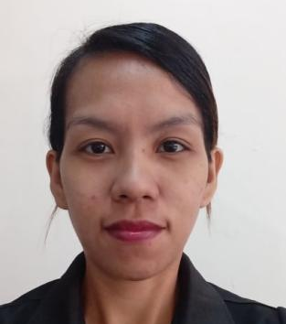
DHIANALYN CADALIN PICARDAL
CADAWINONAN, DUMAGUETE CITY
NEGROS ORIENTAL
09970623804
dcpicardal0830@gmail.com
OBJECTIVES:
To get an opportunity where I can make the best of my potential and contribute to the organization's growth. Seeking a position in a company where I can launch my career and build a valuable skill set.
WORK EXPERIENCES:

PICARDAL TAILORING
Manjuyod, Negros Oriental
Co-Owner - 2012 to present
Duties and Responsibilities
- Provide solutions to issues (e.g. profit decline, employee conflicts, loss of business to competitors)
- Oversee day-to-day operations
- Ensure employees work productively and develop professionally
- Ordering supplies and materials needed for projects, including fabric, buttons, thread, and other materials.
- Communicating with clients about design details, fabric options, and pricing information

DS FINANCE CORPORATION - DUMAGUETE BRANCH
Dumaguete, Negros Oriental
Admin Officer - October 2021 to present
Duties and Responsibilities
- Manage office supplies stock and place orders.
- Prepare regular reports on expenses and office budgets.
- Maintain and update company databases.
- Organize a filing system for important and confidential company documents.
- Answer queries by employees and clients.
- Update office policies as needed.

SAN ISIDRO BARANGAY HALL - LIVELIHOOD PROGRAM
San Isidro, Parañaque City
Livelihood Staff - September 2019 to January 2021
Duties and Responsibilities
- Supervises and coordinates activities of workers engaged in sewing, pressing, and inspecting garments in one department of manufacturing establishment.
- Inspect work for adherence to specifications.
- Notifies mechanic when machine malfunction.Making sample product.

SENGAEKI ENTERPRISES
Country Side, Parañaque City
Office Staff - February 2013 to July 2016
Duties and Responsibilities
- Responsible for purchasing stocks in different supplier.
- Answering phone calls.
- Making quotation of inquiries.
- Sorting and filling of data.
GLOBAL NEXUS CORPORATION
Malate, Metro Manila
Accounting/Inventory Clerk - October 2010 to August 2012
Duties and Responsibilities
- Responsible for making delivery receipts.
- Reporting discrepancies between physical counts and computer records.
- Developing or improving upon inventory management procedures.
- Maintaining and updating stocks.
- Performs routine clerical duties, including data entry, answering telephones and assisting co-employee.
EDUCATIONAL BACKGROUND:
Tertiary : Rizal Technological University
Bachelor of Science in Office Administration Major in Office Management
2006 - 2010
Secondary : Dr. Arcadio Santos National High School
Parañaque City
2002 - 2006

SKILLS:
- Extensive experience ing Microsoft word, Excel, Power point and Internet Explorer.
- Social Media Manager.
- Bsic Knowwledge in Stenography.
- Operates different kinds of Industrial sewing machine.
- Critical thinking and problem solving.

PERSONAL DATA:
Age : 33 yrs. Old
Date of Birth : August 30, 1990
Citizenship : Filipino
Gender : Female
Place of Birth : Muntinlupa, Metro Manila
Religion : Roman Catholic

CHARACTER REFERENCES:
Rosina Sanico
Assistant Supervisor - Metro Index Garments
Parañaque City
09154306382

Arlene Colorico
Domestic Helper - Hongkong
Parañaque
0918329470

Reymar Garcia
Remedial Officer - DS Finance Corporation
Dumaguete City
09985495901

I hereby certify that the above information is true and correct.


Dhianalyn C. Picardal

