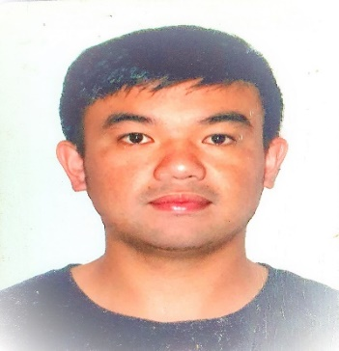
CURRICULUM VITAE

SHERWIN A. TAULI
CIVIL ENGINEER
Home Address: DAGDAG, SAGADA MOUNTAIN PROVINCE
Contact Number: 09568791723
Email Add: sherwintauli@yahoo.com
wintauli219@gmail.com
Religion: Anglican
Nationality: Filipino
Date of Birth: February 19, 1992
Passport No. P4435901B
PRC License No.0153382
CARREER OBJECTIVE
- To work with an organization/company outside my home country which I can use, apply my skills my experiences in the field of civil engineering.
- To study health related courses abroad to allow myself to explore more of my passion not just in engineering field.

EMPLOYMENT HISTORY
January 2, 2018-November 2, 2020
Company:Local Government of Sagada
Address:Patay, Sagada Mountain Province
Office: Municipal Engineering Office
Position:Engineer 1(Job order)

RESPONSIBILITIES
- Responsible in Site validation, survey, validation on proposed projects sites if it is feasible or not that was funded by different government agencies/organizations.
- Responsible in Preparing detailed engineering designs on proposed projects.
- Responsible in Prepairing detailed cost estimates on proposed projects.
- Responsible in Project monitoring on ongoing projects.
- Inspection of infrastracture projects that was finished if it was perfectly done based on detailed enginnering designs.
- Responsible in Site validations on areas that was hit, damaged by natural disasters such as typhoons and earthquakes.
- Preparing recommendations for buildings hit by earthquakes.
- Site validation on hazardous areas.

November 3,2020-Present
Company:Local Government of Sagada
Address:Patay, Sagada Mountain Province
Office:Municipal Planning and Development Coordinator
Position:Planning Officer II

RESPONSIBILITIES
- Responsible in site validation of proposed projects submitted by all barangays in the Municipality of Sagada.
- Responsible in preparing detailed cost estimates of this proposed projects by all this barangays for proper funding.
- Resposible in consolidating all Barangay plans and Municipality plans.
- Inspection of infrastracture projects that was finished if it was perfectly done based on detailed enginnering designs.

SKILLS
>Proficient in drawing using Auto cad software
>Proficient in drawing using Sketch up software
>Proficient in Microsoft Word
>Proficient in Microsoft Excel
>Proficient in Driving of all types of vehicles and small types of trucks
EDUCATIONAL BACKGROUND
Elementary:Sagada Central School 2009-2005
Patay, Sagada Mountain Province
Secondary: Sagada National High School 2005-2010
Patay, Sagada Mountain Province
Tertiary: Saint Louis University 2010-2016
Bonifacio Street, Baguio City
Bachelor of Science in Civil Engineering

