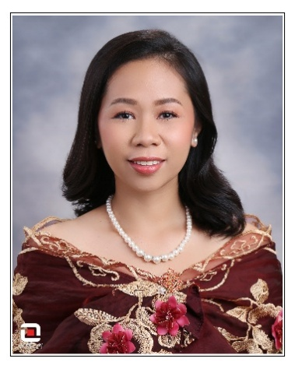
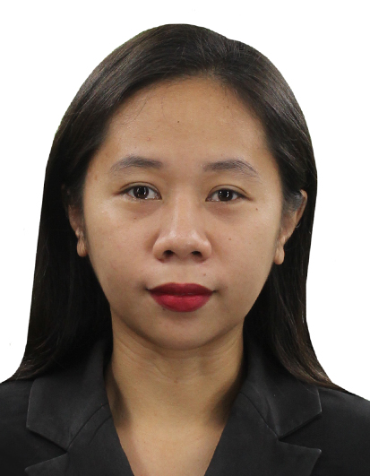
Queenie Xyra C. Batuampar
Registered Pharmacist/Certified Caregiver
#27 Gestoso Apt 296N Gonzales Compound,
Kamputhaw, Cebu City, Philippines 6000
February 19, 1996
Objectives
- To improve social interactions with others
- To learn and gain more knowledge
- To apply and improve my knowledge and skills
- To experience different scenario
- To enhance capability
Summary of Qualifications

- Board passer/PRC licensed
- Time Management
- Certified Basic Life Support Provider
- Average to fast typing skills
- Communication Skills in Patient Counseling
- Excellent interpersonal and strong organizational skills
- Good oral and written communication skills
- Vital signs skills such as blood pressure, FBS and RBS
- BPO experience
- Previously a Certified Pharmacy Technician
- Active and Great listening skills
- Excellent English grammar and spelling
- Research skills
- Medical Scribe/Transcription
- Problem-solving/Critical Thinking skills
- Attention to details/detail-oriented
- Fast learner

Education Attainment
- College: Bachelor of Science in Pharmacy
Adventist Medical Center and College
San Miguel, Iligan City SY 2012-2016
- Certificate: NC II Caregiver
UHA Caregiver Academy
Talisay City, Cebu SY 2022-2023
Seminar Attended
- Intramuscular and Subcutaneous Workshop
- AHA BLS Provider
- Philippine Pharmacist Association Immunizing Pharmacist Certification Program
- Pharmacists Partners in Adult Vaccination
- Mindanao @ Crossroads: A Situationer
- Potential Drug Interactions in the Treatment and Management of COVID-19
- Clinical Pharmacy: Taking Pharmacy Practice to the Next Level
- Drug-Drug Interaction (Drug Interactions: Good Pharmacy Practice Series No. 1)
- Ensuring Medication Safety Through Pharmacy Intervention

Experience
Optum Rx- Pharmacy Technician Generika Drugstore- Pharmacist
IT Park, Lahug, Cebu City Manolo Fortich, Bukidnon
April 2017 - September 2018 March 2019 - February 2020

Erika Pharmacy Unilab RONPD- Alphabet Soup Inc.
Don Carlos, Bukidnon Cagayan de Oro City
February 2020 - December 2020 January - August 2021

1 Source Pharma & Medical Supplies Distribution Wipro – Boston Scientific
Talisay City, Cebu Panagdait, Cebu City
September 2021 – April 2022 April 2022 – November 2023

Accenture – Nuance
IT Park, Lahug, Cebu City
November 2023 – March 2024

