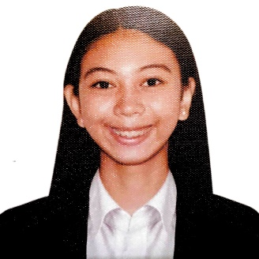
Amante, Mary Miles Casicas
1390 Maxville 7 ,Luis St. Pasig City
Cell no: 09157115573
E-mail: amantemiles11@gmail.com
OBJECTIVE
To enhance my knowledge, skills and ability by the help of this company. To give my best performance and accepting the new learning from my all supervisors/mentors at this company.

EDUCATION

TERTIARY
Pamantasan ng Lungsod ng Pasig
S.Y: 2019- 2020
SECONDARY
Jose Rizal University
80 Shaw Bouleverd, Mandaluyong City
S.Y: 2018-209
PRIMARY
Nino Jesus House of Studies Inc.
Mercedes Avenues,San Miguel Pasig City
S.Y : 2016-2017

HIGHLIGHTS OF QUALIFICATION
- Basic Tour Guiding Seminar

WORK EXPERIENCE
- Elite Recovery Solution Collection specialist (February 2020 - MARCH 2020)
- Goverment internship program (GIP) (March 2021 – April 2021 )
- Tech Mahendra (May 2021- December 2021)
- ResultCX (January 2022 – June 2023)
RECENT TRAININGS/ SEMINARS ATTENDED
- Agencies that are partner by DOT
- From first Secretary to the newest secretary of tourism department
- Tips and ways on how to be a tour guiding
- Mental health awareness
- Gender and Sensitivity
Character References
Atty . Maria Laarni N. Morallos
Concepcion Garduque
Liza Amac

