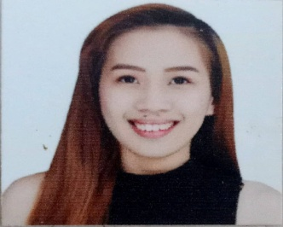
Chrislyn C. Nombre

Contact
Experience
January 2022 – January 2023
Chilltop Restobar / Manila City
Waitress / Reservationist

- answering calls from customers inquiring or reserving a KTV room.
- I escort the customers to their tables or rooms that they have reserved
- I take their orders and I deliver foods and drinks to the customers
- I always check and make sure that the food is clean and hot when I serve it.

May 2021 – December 2021
Department of Labor and employment / Manila City
COVID-19 Contact Tracer

- We are going around in different barangays to get information and interview the suspected Covid-19 patients who are being reported
- When the suspect patient became confirmed patient we immediately call an ambulance so that they can be taken to the Covid-19 Facilities
- I encode information about the patient such as when his/her cough, colds, and fever started and who he/she interacted with inside or outside the house. After that I will forward it into the district office and Manila City Hall.
February 2020 – July 2020 (Kopiko)
Brand Ambassador
- I sell the product that I introduced to the customers
- I conduct product sampling and giving some testers or freebies
- I give them some Ideas or knowledge about the products
- I always make sure that I maintain the positive image of the brand

October 2019 – December 2019 (Tokyo White)
Brand Ambassador
- I sell the product that I introduced to the customers
- I conduct product sampling and giving some testers or freebies
- I give them some Ideas or knowledge about the products
- I always make sure that I maintain the positive image of the brand

E-mail Address
chuakreng@gmail.com

Contact Number
0956-538-7954
0976-533-

Home Address
2420 Kalimbas St, Sta. Cruz Manila

Educational

2020 – 2021
NCII Barista (TESDA)
Powerlink Center for
AdvanceTechnical Skills and
Development, Inc.

2015 – 2016
Bachelor of Public Administration
Eulogio “Amang” Rodriguez
Institute in Science and Technology

2010 – 2014
Manila High School

Skills

- Active listening
- Excellent Communication
- Adaptability and Flexibility
- Positive attitude

Language
- Filipino
- English

___________________________________
Chrislyn C. Nombre
July 2017 - December 2017 (Alhambra Brandy)
Brand Ambassador
- I sell the product that I introduced to the customers
- I conduct product sampling and giving some testers or freebies
- I give them some Ideas or knowledge about the products
- I always make sure that I maintain the positive image of the brand

Reference

Mary Duave M. Ramirez
Sales Officer, Simia Trading
Phone #: 0917-883-3409

Erika Jo Ferrer
CSR Sagility
Phone #: 0991-716-1005

Lorelay Dedoro
Marketing Assistant, Super Value INC.
Phone #: 0995-412-6059

