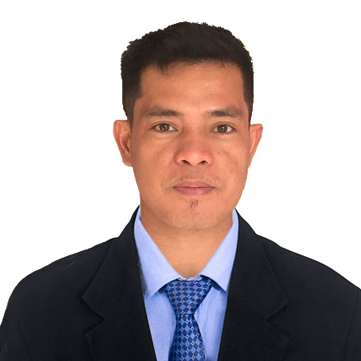

ARJAY BICOMONG FLORES
Phone: 09075598495/ 09300439683
Email: arjayflores_14@yahoo.om
Address: #210 prk4 Lourdes, Lubao Pampanga

CAREER OBJECTIVE
Secure a responsible career opportunity to fully utilize my training and skills, while making significant contribution to the success of the company.

PERSONAL INFORMATION
AGE : 33 years old
SEX : Male
Status : Single
Language : Tagalog, English, Mandarin
Height : 5’10
Weight : 165 lbs.
BIRTH DATE : April 14, 1989
BIRTH PLACE : Lubao, Pampanga
RELIGION : Christian catholic

EDUCATIONAL BACKGROUND
SECONDARY : San Pablo 2nd National High School
San Pablo 2nd Lubao, Pampanga
2002- 2006
PRIMARY : Lauc Pao Elementary School
Lourdes (Lauc Pao) Lubao, Pampanga
1996-2002
WORKING EXPERIENCE

- Ardic Construction and trading
#23 sitio Maligaya Sta.Cruz, Lubao, Pampanga
July 2006- November 2008
Electrical technician
- Samko International co. w.l.l Doha, Qatar
July 4, 2009 - February 3, 2012
Electrical Technician
- Subic Bay Freeport Grain Terminal Services inc.
August 1, 2012- January 1, 2013
Utility Worker

- Sumi Philippines Wiring System Corporation
February 2013 – April 2015
Palihan Hermosa, Bataan
Production Operator

- Chung- Rhy special paper mfg. co., ltd
737,sec.3, Zhongshan rd., puli Town, nantou county and no.982, nan huan rd. puli town, nantou county
May 15, 2015 – May 15, 2021
Electrical Maintenance and Mechanical Maintenance

JOB DESCRIPTION

- Maintain and repair electrical and mechanical equipment.
- Control, document and update all equipment PLC, drives and control systems
- Perform PLC program evaluations, troubleshooting and changes.
- Ensure operation of electrical system and equipment by completing preventive maintenance requirement on conveyors, programmable controllers, transformers, voltage regulators and machinery wiring.
- Ability to read electrical plan.
- Ability to use electrical instruments and equipment such as VOM tester, clamp0 tester and merger.
- Termination and wiring installation of control panels (power and lightning circuits and low current circuits.

Training and Seminars
- Technical Education and Skills Development Authority
Wire Harness Assembly
1,200 hours
August 2013

Additional Skills
- Welder
- Mechanical skills
- Plumbing/Pipe Fitter
- Operate lathe machine
- Electrical Technician

Character References

- Renato Quioc
Production Manager-SPWS Phils.

- Yhuli Cheng
Supervisor-Chungrhy Specialty Paper
0930669543

I hereby certify that the facts contained in this resume are true and complete to the best of my knowledge.
Arjay B. Flores
Applicant Signature

