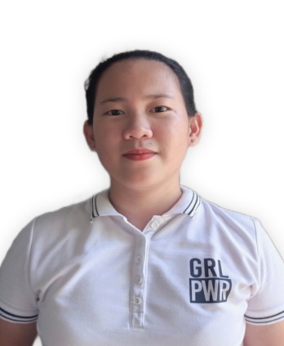
CHEMARIE REMETICADO MEGALLON
Greenhills, San Fernando, Cebu
Contact No: 0991-722-8318
Email Address: chemarie678@gmail.com

CAREER OBJECTIVE:
To share and enhance the knowledge and skills I have that fits in the position I am applying to in your company.

EDUCATIONAL ATTAINMENT:
Greenhills Elementary School 2009-2010
Greenhills, San Fernando, Cebu
Greenhills National High School 2013-2014
Greenhills, San Fernando, Cebu
Carcar City College 2017-2018
Luan-luan, Poblacion 1, Carcar City, Cebu

QUALIFICATIONS:
- Proficient in Microsoft (Word, PowerPoint, Excel)
- Fluent in English, Filipino and Cebuano Visayan
- Graduate of Bachelor of Science in Agriculture
- Board passer in Licensure Examination for Agriculturists
- Good communication and comprehension skills
- Attended Training for Hybrid Rice Production Technology

WORK EXPERIENCES:
- EGG PRODUCTION (INTERN/OJT)
Twin Tower Farms Corporation
April 2017
- CONVENTIONAL FARMING (INTERN/0JT)
Lozada’s Farm
May 2017
- STORE MANAGER
Jm Poultry & Livestock Supply, Inc. Dalaguete Branch
April 2019 – June 2022

- CUSTOMER SERVICE REPRESENTATIVE
TELEPERFORMANCE Cebu Insular
December 13, 2022 – January 18, 2023

- AGRICULTURAL TECHNOLOGIST
Department of Agriculture Region 7
March 06, 2023 - Present

CHARACTER REFERENCES:
Mr. Elmer P. Alcoseba
Agricultural Technologist – DA-RFO 7
Contact No.: 0953-227-2333

Ms. Ma. Vicenta R. Macairan
Registered Nurse – ZENNYA Field Nurse, and Medical Operations Team
Contact No.: 0912-446-5481

Mr. Joebert Alforque
Extension Service Man – Jm Poultry & Livestock Supply, Inc.
Contact No.: 0918-247-7664

Ms. May Angel M. Rodela
Virtual Assistant
Contact No.: 0928-927-0205

