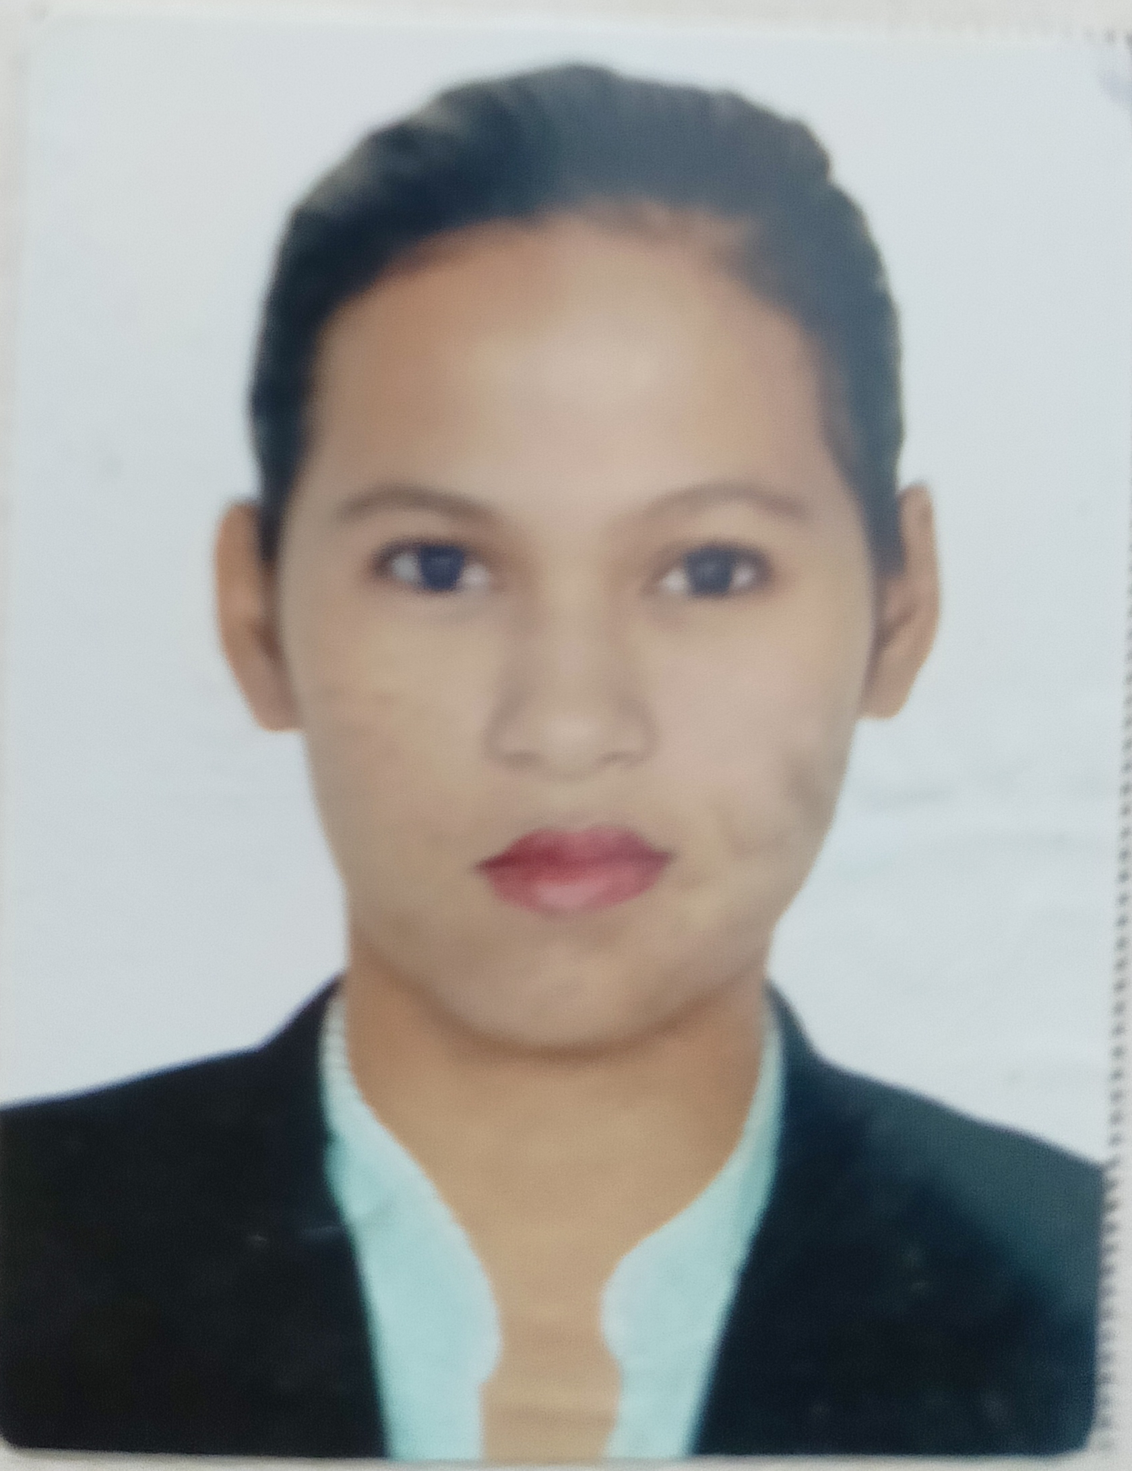
YAÑEZ, ROXANNE LOPEZ
Blk. 17 Lot 48 Golden Horizon Homes, Brgy. Hugo Perez
Trece Martires Cavite City 4109
Mobile #: 09774664067
E-mail: yanezroxanne22gmail.com

OBJECTIVES:

To obtain a position that will enable me to use my strong organizational skills, educational background, and ability to work well with people.

- Mega Web Technologies Inc.
Admin Assistant - Metropolitan,Pasay City
January 9, 2019 - March 15, 2021

- Footwear Specialty Retailers Inc. (PAYLESS SHOESOURCE)
Customer Sales Associate – Lucky Chinatown Mall
September 11, 2013 – February 10, 2014

- Finest Living Co. Inc. (JUST-G)
Customer Sales Associate – JUST-G Boutique Market Market
January 17, 2013 – June 30, 2013

- Lifestyle Concept Co. Inc. (GINGERSNAPS)
Customer Sales Associate (Seasonal) – Rustans Dept. Store
December 01 – 31 ,2012

- Macro Global Trade (CARTER)
Sales Promo (Seasonal) – SM Mall of Asia Dept. Store
May 2, 2012 – June 23, 2012

- Massage 2 Go (M2G) Home Services Massage
Massage Therapist
March 25, 2009 – April 01, 2010

- SM Prime Holdings Inc.
Usher/Porter - SM Mall of Asia Cinemas
October 30, 2008 – March 20, 2009

- Terminal Fluid Bar @ Restaurant
Service Crew
August 10, 2007 –September 20, 2008

- Manila International Airport Authority (MIAA)
Public Assistant - Airport Summer Work Program
April 19, 2006 – June 2, 2006

SKILLS:

- Knowledge in Facial, Body Treatments & Massages Techniques
Massages (Swedish, Shiatzu)
- Knows how to weld using carbon steel plates and pipes using Shielded Metal Arc Welding
- and Gas metal arc welding.
- Hardworking and fast learner.

TRAINING ATTENDED:

- Shielded Metal Arc Welding ( NC I & NC II )
- Follow the welding procedure and safety standards as per company requirements.
- Prepare the welding materials and hand tools.
- Able to weld carbon steel plates and pipes using shielded metal arc welding.

- Gas Metal Arc Welding (GMAW NC II )
- Follow the welding procedure and safety standards as per company requirements.
- Prepare the welding materials and hand tools.
- Able to weld carbon steel plates and pipes using gas metal arc welding.

PERSONAL PROFILE:

Age : 37 years old
Sex : Female
Height : 5’3/162 cm.
Civil Status : Single
Religion : Catholic
Birthdate : January 27, 1987
Birthplace : Parañaque City
Language : Tagalog/English
Nationality : Filipino

EDUCATIONAL ATTAINMENT:

Vocational : Sunport School of Security and Technology,Inc. (2014-2015)
Shielded Metal Arc Welding (SMAW NC I & NC II)

: TESDA WOMENS CENTER GAS METAL ARC WELDING
(GMAW NC II) 2015

College : Datamex Collage of St. Adeline (2004-2006)
Associates in Computer Secretarial

On the Job Training. : Leslie Corporation/ HR Assistant 300 hrs.
(July – October 2005)

Secondary : San Bartolome High School Quezon City (2003-2004)

Primary : Parañaque La Huerta Elementary School (1999-2000)

CHARACTER REFFERENCES:

Loreto Pepe - Marine Technician/SapuraKencana Petroleum

Josh Cristino - Nursing Attendant/Alberta Health Services

Chito Inson - Brokers/ Royal Cargo

I hereby certify that the above information is true and correct with the best of my knowledge & belief.

Roxanne L. Yañez

