
CARIN0, ALBERT FORONDA
Mechanical Engineer License No.: 0080925
Saudi Council of Engineers Accreditation No.: 726016
Mobile no.: +966560844069
Email Address: Albert.carino@yahoo.com

Objective

Highly passionate Registered Mechanical Engineer with more than 10 years’ experience in various engineering field, to be in a dynamic and ever challenging mechanical engineering profession where all my knowledge and capabilities can be exploited properly by that I find myself contributing effectively to growth and success at the organization and to render my service to the fullest of my ability.

Work Experience

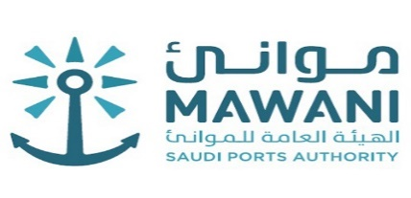
Title: MECHANICAL ENGINEER Duration: 24/11/2021 - Present
Jeraissy Computer and Communication Services
(MAWANI PROJECTS)

Roles:

- Directly report to the chain Coordinator, Operation Manager and Company General Manager.
- Coordinated with station Managers and Power-HVAC Technicians.
- General maintenance of 500KW Diesel Power Plant, disassembled generators from main engine for trouble shooting, major maintenance, replacement of bearings, rectifier diodes/assembly, AVR, PMG and related controls.
- Directly performed diesel engine overhaul on diesel generators (VTA-1710 Cummins and Deutz F3L912), genset tune-up commissioning and control electromechanical troubleshooting.
- Performed Project Study for the proposal of upgrading of Chiller, HVAC and Generator sets.
- Design Chiller and HVAC for operation building, and supervise installation and maintenance.
- Design and Layout power room for installation of 500kw diesel engine generators.
- Extensive stations visit nationwide for necessary corrective measures on Power and HVAC problems as well as inspections.
- Rectify other mechanical equipment’s; Continental air filter system, Penn Cebtrex intake and Aero vent exhaust fans, deep well water pumps and pressurized water tank.

Title: MAINTENANCE ENGINEER
Duration: 16/11/2016 – 11/11/2021
Medical and Cosmetic Pharmaceutical Company
(Riyadh Pharma)

Roles:
- Deals with Manufacturing Machines, in Granulation, Compression, Encapsulation, Blending Machine and Coating.
- Ensuring safe working systems and practices are followed using permit to work and lock out tag out systems.
- Ensure maintenance work is accurately recorded.
- Have involvement in the scope and execution of planning the preventive maintenance schedule.
- Be involved in continuous improvement initiatives.
- Executes procedures as per GMP to complete tasks in a safe and efficient manner.
- Works in collaboration with others as part of a team and assists with on the job training of other production trainees and operators.
- Determines methods and procedures on new assignments and may provide assistance to other support personnel.
- Adheres to all GMPs, compliance/regulatory mandates and quality requirements.
- Assists in the identification and implementation of continuous improvement opportunities.
- Performs other related duties as assigned to meet departmental and Company objectives.
- Provide maintenance of the mechanical equipment to ensure continued optimum operation
Of Solid Department.

Title: Mechanical Maintenance Supervisor Duration: 18/05/2014- 17/05/2016
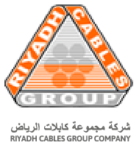
Riyadh Cable Group of Companies

Roles:

- Ensures operation of machinery and mechanical equipment
- Locates sources of problems by observing mechanical devices in operation
- Removes defective parts by dismantling devices
- Determines changes in dimensional requirements of parts by inspecting used parts
- Adjusts functional parts of devices and control instruments
- Fabricates repair parts by using machine shop instrumentation and equipment.
- Prepares mechanical maintenance reports by collecting, analyzing, and summarizing information and trends.
- Maintains technical knowledge by attending educational workshops
- Maintains continuity among work teams by documenting and communicating actions, irregularities, and continuing needs
- Maintains safe and clean working environment by complying with procedures, rules, and regulations.

Title: Plant Mechanic Duration: 08/07/2013 – 09/12/2013

Oleo –Fats INC.

Role
- Operated electric and propane forklifts inside and outside facility.
- Machined parts using a mill and lathe.
- Used ability to stick weld to maintain equipment.
- Maintenance and equipment upkeep including pneumatic systems and plumbing.
- Repair industrial equipment including pumps, gearboxes, hydraulic rams, and other metal working equipment.
- Performs rim and face alignment using dial indicators and preventative maintenance of manufacturing equipment.
- Facilitate vendor maintenance repairs and ensure repairs are performed in accordance to maintenance contract.
- Document all maintenance activities and repairs and provide maintenance supervisor with daily log book
- Effectively perform all job related activities in accordance with the Plant's safely Lock out Tag Out equipment power procedure.

PROFESSIONAL LICENCES AND SOCIETIES:



REGISTERED MECHANICAL ENGINEER IN THE PHILLIPPINES

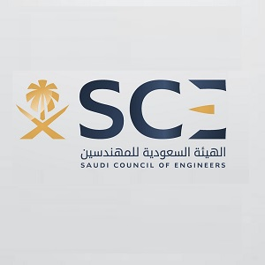

SAUDI COUNCIL OF ENGINEERS

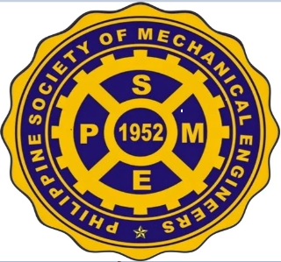

PHILIPPINE SOCIETY OF MECHANICAL ENGINEERS


COMPUTER SOCIETY OF FILIPINOS INTERNATIONAL INC.
(COMSOFIL) RIYADH, KINGDOM OF SAUDI ARABIA


Educational Background:

Degree: Graduate
Course: Bachelor of Science Major in Mechanical Engineering
Admission Date: First Semester, 2007-2008

Graduation Date: 03/06/2012
Institution: Don Mariano Marcos Memorial State University

Skills

• Communication (English Proficient)
• Time management & prioritization
• Microsoft Office/ Microsoft Power Point
• Motor Vehicle Driving (more than 5years.)
• Microsoft Excel
• HVAC technician
• Auto Cad

Trainings:

Good Documentation Practices 09/02/2020
NFPA 25 Inspection, Testing & Maintenance
Of Fire Sprinkler 18/082021
Mechanical Design and Fabrication 29/08/2021
Facilities Maintenance Management 06/09/2021
Good Manufacturing Practices 07/09/2021
Panning Engineering Tools and Framework 09/12/2021 (9 pm)
Gear Couplings 09/12/2021 (9 am)
Refrigeration Air-conditioning 17/12/2021
Basic Electrical 17/12/2021
Basic HVAC Design Part 1 25/01/2022
Basic HVAC Design Part 2 27/01/2022
Advance Workshop Design Part 1 08/02/2022
Advance Workshop Design Part 2 10/02/2022
Advance HVAC Design Part 1 08/02/2022
Advance HVAC Design Part 2 10/02/2022

Personal Data:

Birth Date: 24/12/1989
Nationality: Filipino
Gender: Male
Marital Status: Married

